
Week beginning 15th June 2020

This weeks topic is responsible consumption.
We have a project for the children this week that focuses on food waste.
We would like the children to think about how they could try to reduce food waste in their own homes.
- One way of doing this is to plan meals for a week (or a few days) in advance so they only buy what they need. Involve the children in meal plan. They can write this out (using their phonics and capital letters and full stops!)
- Children can write a shopping list.
- Help with preparing meals possibly reading and following recipes.
- Think about what they are doing with any food waste. Can you reuse any left overs in another meal/ feed pets animals with it/ compost or put in green bin rather than staright in the bin bag.
What does responsible mean?
What does consumption mean?
Responsible consumption means only buy or take what you need and only throw away anything that you can’t reuse. Watch this video to see what Thomas can tell you about responsible consumption.
https://www.youtube.com/watch?v=paZdt73joYI
After you have watched the video perhaps you can have a discussion using these sentence starters
1. What kinds of things do people throw away?
2. How can we reuse things at home?
3. What can we make from recycled materials?
4. What happens to all the waste?
5. Should we throw away old toys? What should we do with them?
Children might also like to think about how they can reuse and recycle other things such clothing that they have grown out of or packaging. (A perfect time for some junk modelling!).

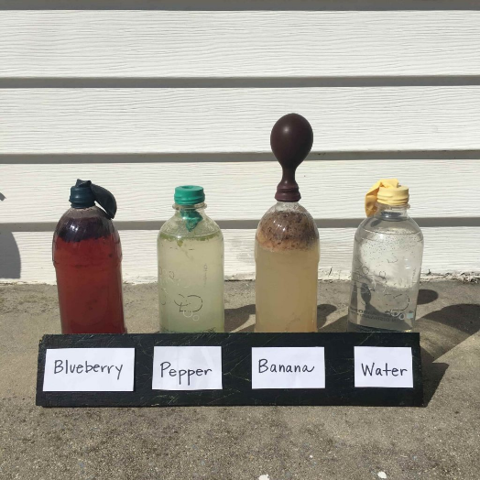
Food waste that goes to a landfill site will produce methane gas which contributes to global warming. It is better if food is allowed to decompose naturally in the open air with oxygen e.g. an apple core rotting on the floor.
To explore how different foods produce different amounts of methane when they decompose set up this experiment.
Fill plastic bottles with water to eliminate air from the bottles.
Add a different fruit or vegetable waste to each bottle.
Put a ballonn on the top of the bottle to catch any gas that is produced.
Which is the worst fruit or vegetable to send to the landfill site?

Think carefully about what this means, Reduce Reuse and Recycle

- Reduce
Can you think of ways that you can reduce waste
e.g. don’t buy food that has a lot of plastic packaging
don’t waste food and put it on the compost heap instead
- Reuse
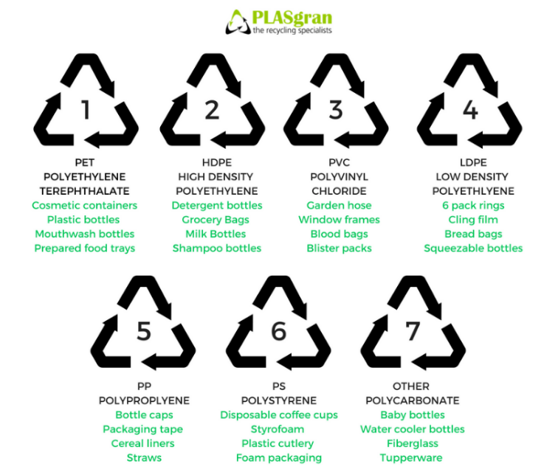
Can you find another use for something that you have finished with (see Art activities below)
- Recycle
What can be recycled and what can’t?

Explore your recycling with an adult and see if you can find these symbols:

