15.06.20
Good Morning,

This week’s theme for our learning is Responsible consumption. Make sure you have fun!

Task 1 | AM 20 min | Maths lesson
Task 2 | AM 20 min | English lesson
10:30 Snack time
Task 3 | AM and PM 2 x 20 min | TT Rockstars/Rodocodo/SPAG
12:30 Lunchtime
Task 4 | PM 20 min | Art activity
Task 5 | PM 20 min | History/Geography
Task 6 | PM 20 min | French/Skills Builder/RE
2:00 Snack time
Task 7 | PM 20 min | Science
Task 8 | PM 20 min | This could be finishing an activity from earlier or an activity from the general list.
Daily journal and reading

Mathematics Task 1 (20 min)
The activities listed below are key Mathematical areas that the children need to practise every week, they do not need to do them all every day, but pick one or two per day. These will be ongoing and you can complete them in any fun ways you can.
Key Mathematical areas;
Number - count in multiples of 6, 7, 9, 25 and 1000
Times tables recall multiplication and division facts for multiplication tables up to 12 × 12
Measures - Convert between different units of measure - kilometre to metre; hour to minute]
Money - estimate costs, compare costs and calculate amounts in £ and p
Time - read, write and convert time between analogue and digital 12- and 24-hour clocks
convert from hours to minutes; minutes to seconds; years to months; weeks to days.

Make sure you are practising your timestables as much as you can.
Abacus - The children can access this resource via the website https://www.activelearnprimary.co.uk
The password is year 4 and the school code kmm7 in the bottom box.

PLEASE NOTE YOU DO NOT NEED TO PRINT THESE SHEETS, YOU CAN ANSWER THEM ON PAPER.
Task 1 – Task 1 Maths lesson video. Part 1 https://youtu.be/7gxP8n0vExo7
Part 2 https://youtu.be/EnGGQGl3ceQ
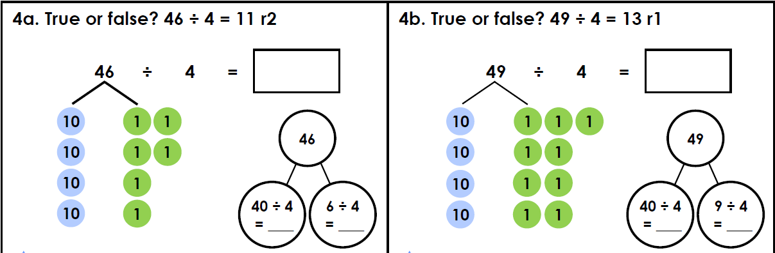
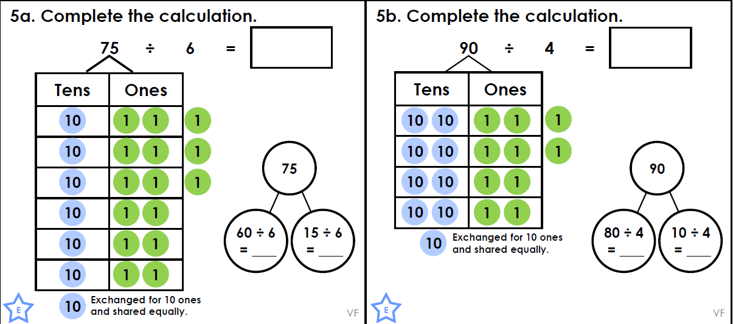
Answers

Task 2 – Task 2 Maths lesson. https://youtu.be/UvZ8jEUjCbk
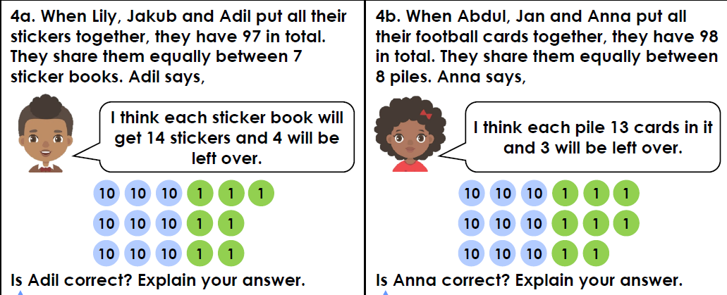
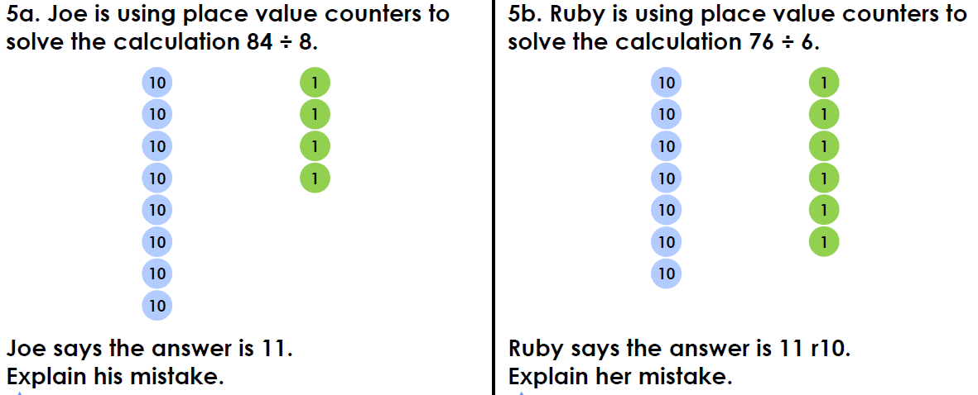
Answers
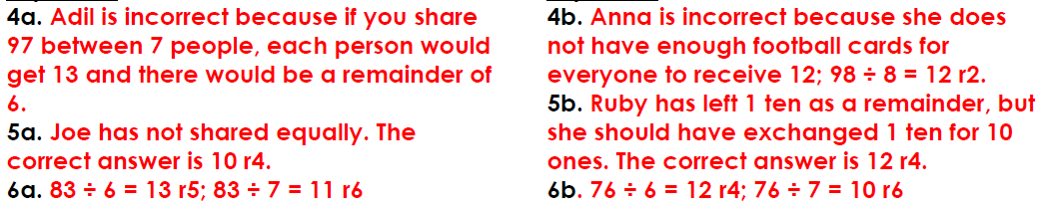

Task 3 – Task 3 Maths lesson. https://youtu.be/0BEvRYBTQUQ
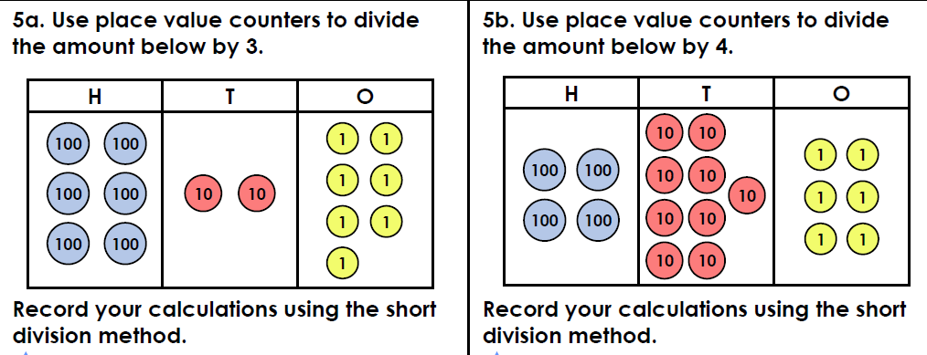
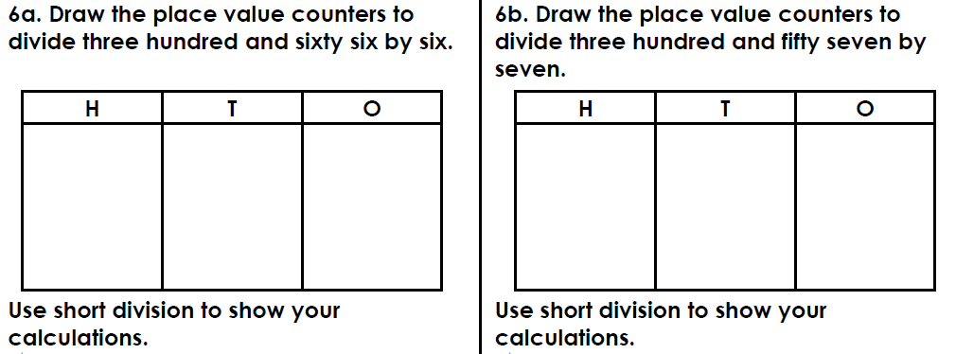
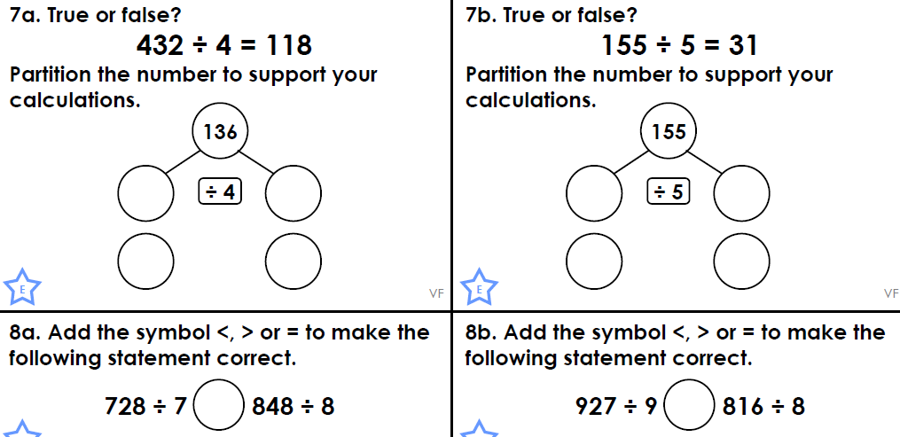

Answers
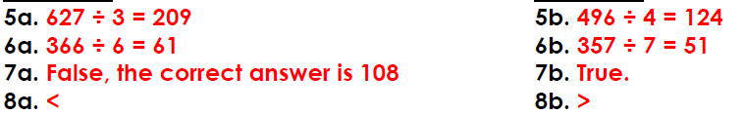
Task 4 – Choose a learning objective from the key Mathematical area list.
Task 5 – Timetable booklet
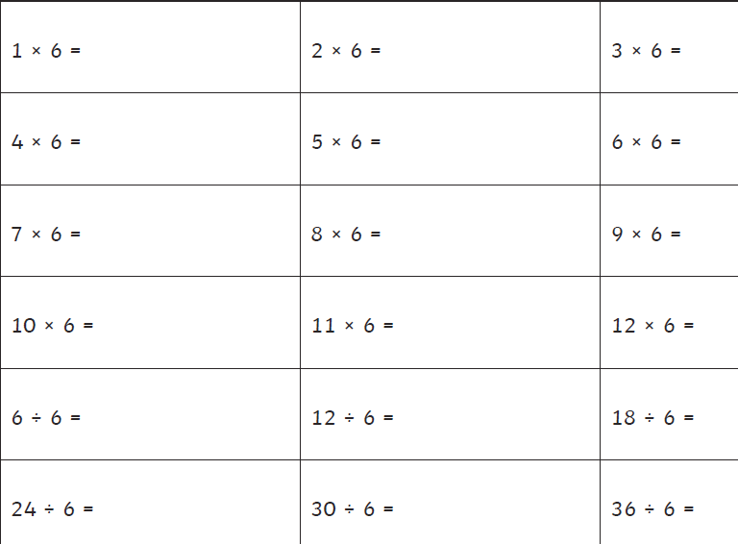

English Task 2 (20 min)
Task 1 - Power of reading, English lesson video. https://youtu.be/9Ry2aIvCPSs
Task 2 - Power of reading, English lesson video. https://youtu.be/iy2wy2mYf-k
Task 3 – SPAG, English lesson video. https://youtu.be/izM2Q9WSfoY 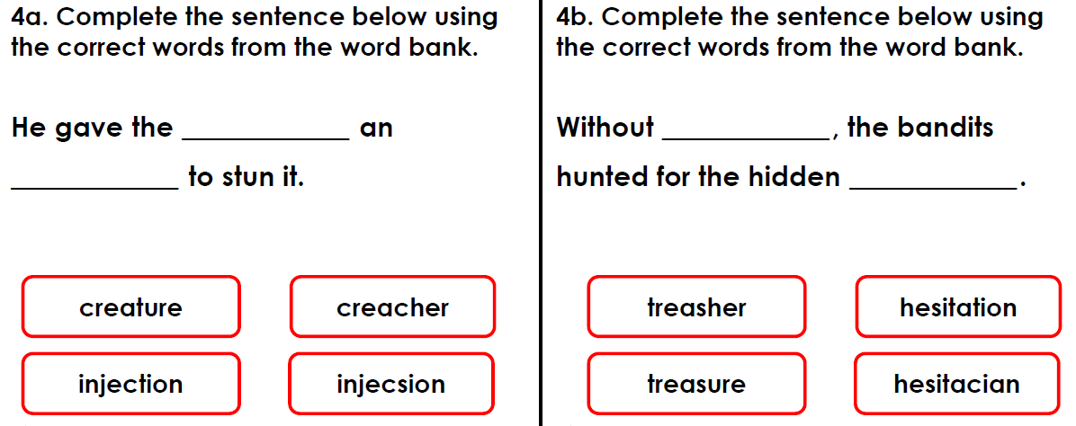
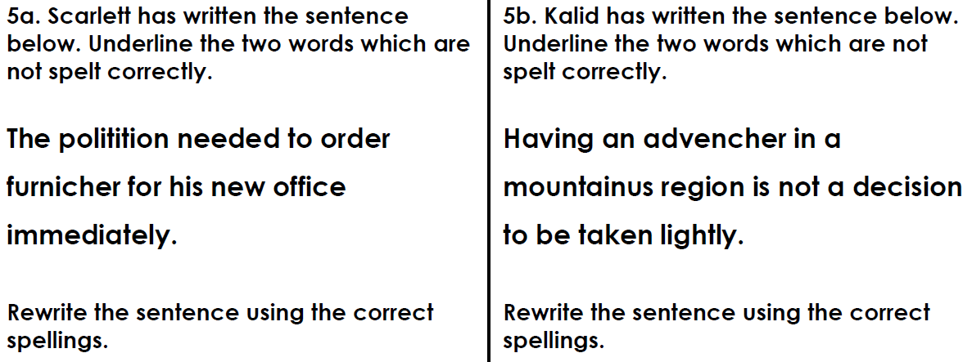
Answers
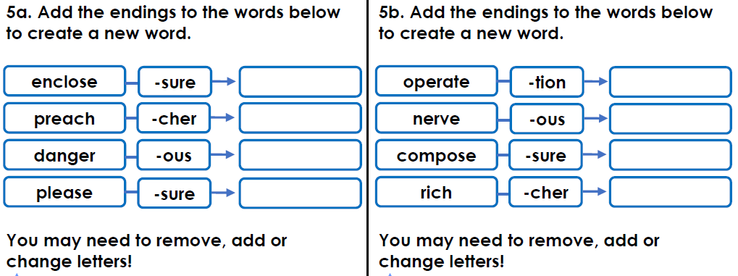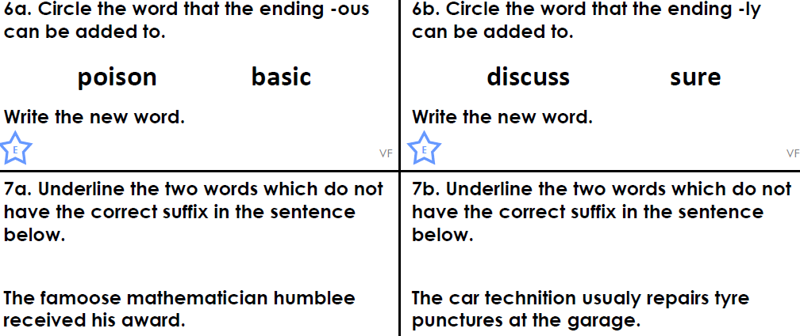
Answers
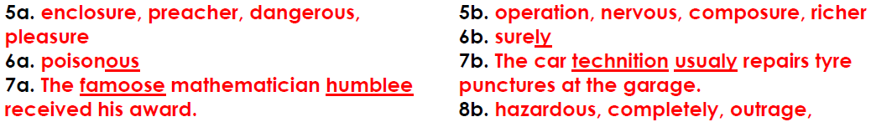

Task 4 – Comprehension – Read the attached Fracking sheet and answer these questions;
- Which two fossil fuels does fracking release?
- What is renewable energy?
- Give two examples of renewable sources of energy.
- Why does water used in fracking need to be at a high pressure?
- Why might areas of the Midlands and Northern England face fracking soon?
- Which company is set to make the most money from fracking?
- Give three ways in which fracking could benefit the UK.
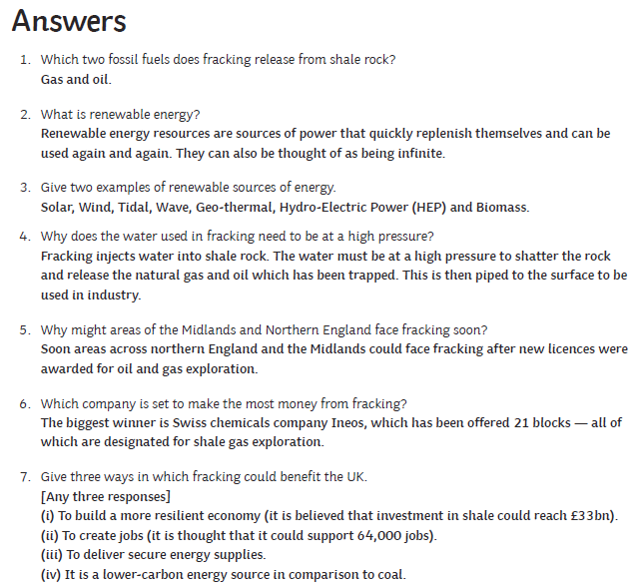
Task 5 – Spelling fun! Different ways to practise your spellings. You could write silly sentences with your spellings in, alphabetise your spellings, make a word search with your spellings, write them in your neatest handwriting, write them in rainbow colours, write them backwards, make a cross word, write them in a silly recipe, write the consonants and vowels in different colours or write them in different shapes.
Reading
Remember to read EVERYDAY.
The Accelerated Reader (AR) programme is also accessible from home during this time too, so once you’ve finished your books make sure you log on and take a quiz. https://ukhosted43.renlearn.co.uk/2152328/default.aspx
Nessy - https://www.nessy.com/uk/
Task 3 (20 min)
Time Tables Rock Star - https://play.ttrockstars.com/auth/school/student/76329
Rodocodo - https://game.rodocodo.com/
SPAG – http://www.crickweb.co.uk/ks2literacy.html
Art/DT Task 4 (20 min)
Create a food collage using up items in your cupboard.
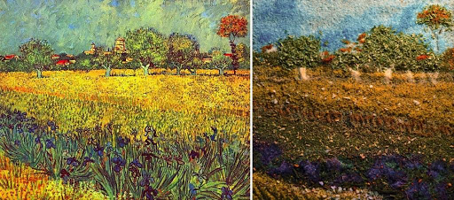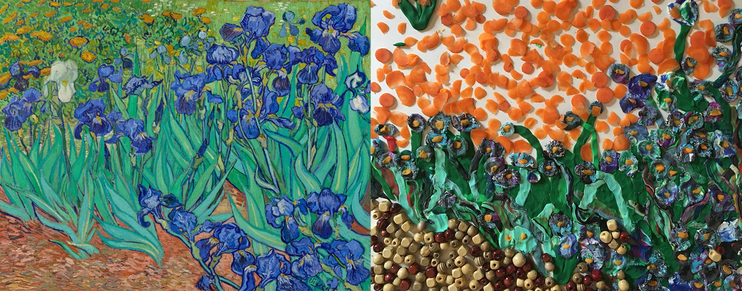

History/Geography Task 5 (20 min)
Research Fracking in the United Kingdom.
Make it a focus throughout your household to have as little food waste as you can. Design your own compost bin and sustainable garden.
Have a look at where your food comes from – look in your cupboards at your food packaging and locate where it is from in an atlas.
Research how some companies reuse their used cooking oil to fuel the transportation of goods.

Task 6 (20 min)
French - (Log in – Username - Buckden Password – Starfish)
https://www.linguascope.com/
Skill Builder -
https://www.skillsbuilder.org/resources/rocketing-resolutions
GenR8

Science Task 7 (20 min)
Try making an Ecobrick for the school, see attached sheet for details.
Living things and their habitats – Grouping living things – write the animals (found on the attached sheet) in the correct part of the diagrams.
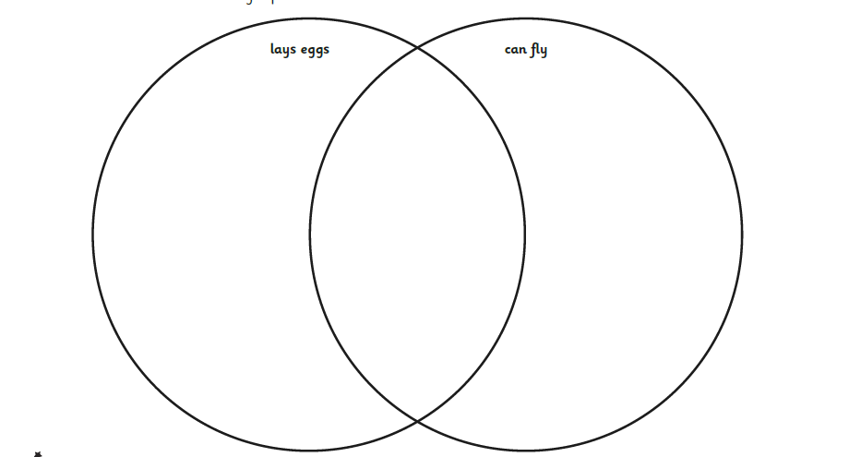
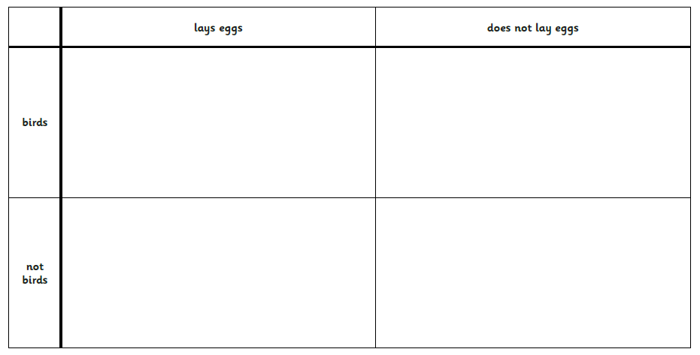
General activities
Remember to keep active!
- Yoga
- PE - Join Joe Wicks for a PE lesson. He is on YouTube every weekday.
https://www.youtube.com/watch?v=lEWcBIvqjDk
- Touchtyping - https://www.bbc.co.uk/bitesize/topics/zf2f9j6/articles/z3c6tfr
- Coding - https://scratch.mit.edu/
- Get in touch with a friend or family member
- Be mindful, about your waste at home. Consider your use of electric, water and how you are traveling.
- https://www.skulduggerypleasant.co.uk/books/
- https://www.anglianwater.co.uk/in-the-community/schools/learning-at-home/
In your journal you write:
- How you are feeling,
- What you have done (this can be any of the work you have done from the blog and anything that you have done whilst at home),
- What you have enjoyed each day.

