Responsible Consumption
Hi everyone, we hope you and your family are well and staying safe.
Here are some ideas for you to be working on whilst you are at home this week.
Please continue with your daily journal to capture what you are doing at home during this time. In your daily journal you write:
- How you are feeling.
- What you have done. This can be any of the work you have done from the blog and anything that you have done whilst at home.
- What you have enjoyed each day.
Below is a table suggesting how much learning to do over a day with a year 5 child. These slots add up to 4 hours of learning, split into small chunks with breaks. Of course what is important is that you do what works best with your family. The work listed below is more than enough for 5 days of 4hr learning so choose the tasks that you would prefer to do.
Please also ensure that you include some daily physical activity, Joe Wicks uploads a PE lesson on YouTube every day, these are good fun and you can access these when you would like to.
We also expect that you read daily, whether this be a story, magazine, information book or poetry. You can complete AR quizzes using this link: https://ukhosted43.renlearn.co.uk/2152328/default.aspx

am 45 min | Maths activity
am 45 min | English activity
10:30 | Snack time
am 2 x 30min | TT Rockstars/Rodocodo/Nessy
12:30 | Lunchtime
pm 45 min | Something unfinished from the morning or maybe some art
pm 45 min | An activity from general activities list

Maths
Task 1 (45min a day)
Choose an area of maths from the list below, you only need to choose one area a day, you do not need to do all of them every day. Use this time at home to practise some real life math skills. By practising these skills, other areas of maths will become easier for you as well.
Numbers - read, write, order and compare numbers to at least 1 000 000.
You could read some different numbers that you find in books, newspapers. Write the numbers using numerals and words.
Measures - convert between different units of metric measure - kilometre and metre; centimetre and metre; centimetre and millimetre; gram and kilogram; litre and millilitre
Could you measure your garden, Bedroom, kitchen? What if you wanted to plant a new flower bed or build a den in your bedroom, how much space would it take up? How long would it be? If you go out for a daily walk, how far do you walk in metres? Kilometres?
Could you help in the kitchen to bake or cook dinner? Measure your ingredients carefully.
Times tables - Know multiplication and division facts up to 12 x 12
Money - estimate costs, add and calculate change in £ and p.
Can you calculate the cost of the weekly shop? What about change if you didn’t have the exact amount?
Time - tell the time using analogue, digital, 12 and 24 hour clocks.
Read the clock at different times of the day. What time do you wake up, have lunch, dinner, bedtime? Can you give those times using analogue, digital, 12 and 24 hour clocks.
Read and interpret a variety of time tables including, bus, train and tv guides. What time do your favourite programs start? How long do they last? Could you take a train from St Neots to London? How long is the journey? What time are the trains? etc

Task 2 (2 x 30 min per week)
TT rockstars https://ttrockstars.com/

Video tasks:
Lesson 1: https://www.youtube.com/watch?v=sB63cRhOqo4
Independent tasks for you to complete after watching the video lesson 1:
- Complete the table:
Number | Rounded to nearest whole number | Rounded to the nearest tenth
1.19
10.19
0.75
100.75
100.03
100.037
(answers to Q1 can be found at the end of this document)
Can you complete questions 2 and 3 and email your answers to us?
- Mia has to round 2.76 to one decimal place. She says, ‘The hundredths digit is greater than five, so the tenths digit increases by 1. The answer is 2.86’. Explain Mia’s mistake to her.
- I am thinking of a number. Rounded to the nearest whole number, it is 8. Rounded to the nearest tenth, it is 8.5. Describe or show the different numbers it could be.
Lesson 2: https://www.youtube.com/watch?v=5V91-3iMcGw
Independent tasks for you to complete after watching video lesson 2:
- A plant is 24.8cm tall. In the following week it grows a further 17.5cm. How tall is the plant at the end of the week?
- Jodie walks 8.275km in the morning and 6.185km in the afternoon. How far has she walked altogether?
- A motorbike weighs 529.88kg. Its rider weighs 78.134kg. What is the combined weight of the bike and rider?
- A large bag of flour weighs 4.25kg. A smaller bag weighs 1.75kg less. What is the weight of the smaller bag?
- The 18 hole golf course is 6.307km long. The 9 hole course is 2.955km long. How much longer is the 18 hole course?
- A bag of compost holds 73.5kg. 8.825kg is used. How much is left?
Lesson 3: https://www.youtube.com/watch?v=22LhsHYb-Ak
Independent tasks for you to complete after watching video lesson 3:
- Toshi drives 26.3km to work. He then drives 6.85km to his gran’s house. How far does he drive in total?
- A bucket has 8.751 litres of water in it. Amal pours a further 7.5 litres into the bucket. 1.27 litres of water spill out because the bucket is full. How much water does the bucket hold?
- When added together two numbers total 9.2. One of the cards is 4.59. What is the difference between the two cards?
- Write a problem solving question with the answer 3.21kg.

English
Task 3 (5x 30 min)
Read every day
Video tasks:
Lesson 1: https://www.youtube.com/watch?v=oDmXyktIGwI&t=3s
Lesson 2: https://www.youtube.com/watch?v=PGymIMT78H4
Lesson 3: https://www.youtube.com/watch?v=J429RK9iGss
Questions for you to complete after watching video Lesson 3:
Re-write the sentences below so that they don’t contain double negatives and therefore the meaning is clear.
- I don’t want no sugar in my tea.
- I’m not going nowhere this morning.
- I don’t know nothing about computers.
- Holly’s not talking to nobody today.
- I never saw no lorry outside.
- I don’t trust none of them.
Extension: Write 3 sentences using negative words to give warnings (remember to avoid double negatives).

Geography
Looking at clothes in your wardrobe and asking members of your family to check the labels of their clothes, you need to find out where theirs and your clothes come from. Write a list of these places.
This list will show you all the different countries that have been traded with. Using a map of the world, mark off the countries where your clothes have come from. You can use this map below to mark where your clothes have come from if you’d like.
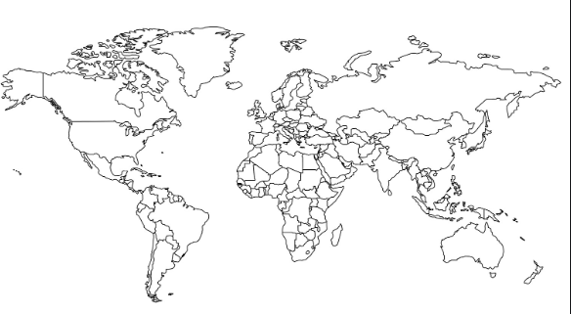

Now draw a graph to show the most common countries of manufacture.

Science
Water
- Less than 3% of the world’s water is fresh (drinkable), 2.5% is frozen in the Antarctica, Arctic and glaciers. We can then only rely on 0.5% for all of the water that we need.
- Humans are polluting water in rivers and lakes faster than nature can recycle it.
- More than 1 billion people still do not have access to fresh water.
- People are overusing water.
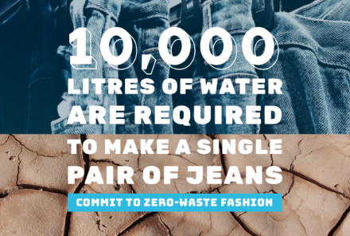
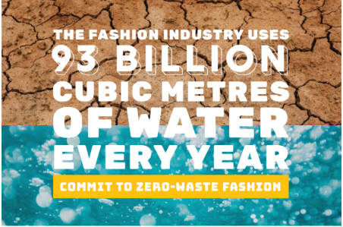
- The fashion industry alone produces 20% of our wastewater, the pictures below show how much water is used by the fashion industry in a year and how much water is used to make just ONE pair of jeans.

Think about how much water you and your family use in an average week in your homes and gardens.
- Produce a table showing the different uses e.g. flushing loo, brushing teeth, cooking, watering garden.
- Alongside each one, can you think of a way you and your family could reduce how much water your household uses.
- Can you create a way of measuring the amount of water wasted if you left the tap running when you are brushing your teeth? (Clue: you might need something to ‘catch’ the running water and something to measure it with)
Making an Ecobrick
An ecobrick is a plastic bottle stuffed solid with non-biological waste to create a reusable building block.
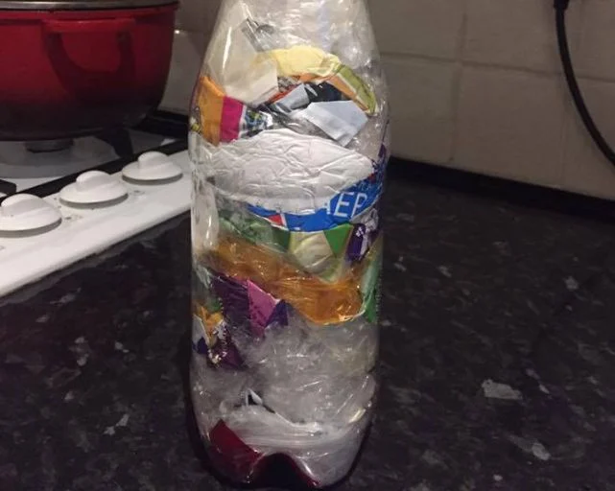

If you would like to donate your ecobrick to a school project, once you have made it please clean your bottle with soapy water and place it in a carrier bag. The bottles can then be dropped off in the collection box outside the school office.
If we get enough ecobricks we will try to make a raised bed either at school or at the school allotment to repurpose all of this unwanted plastic.
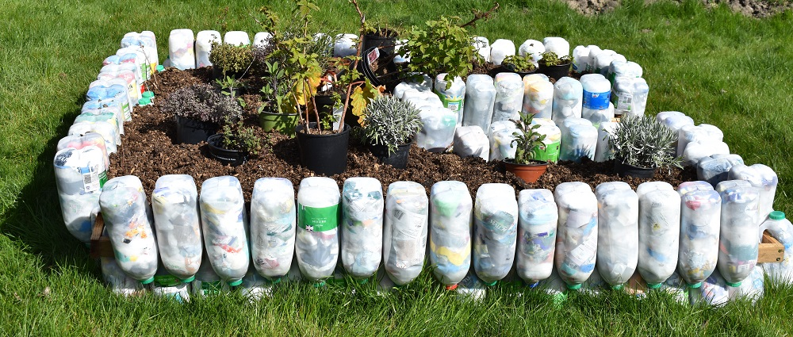
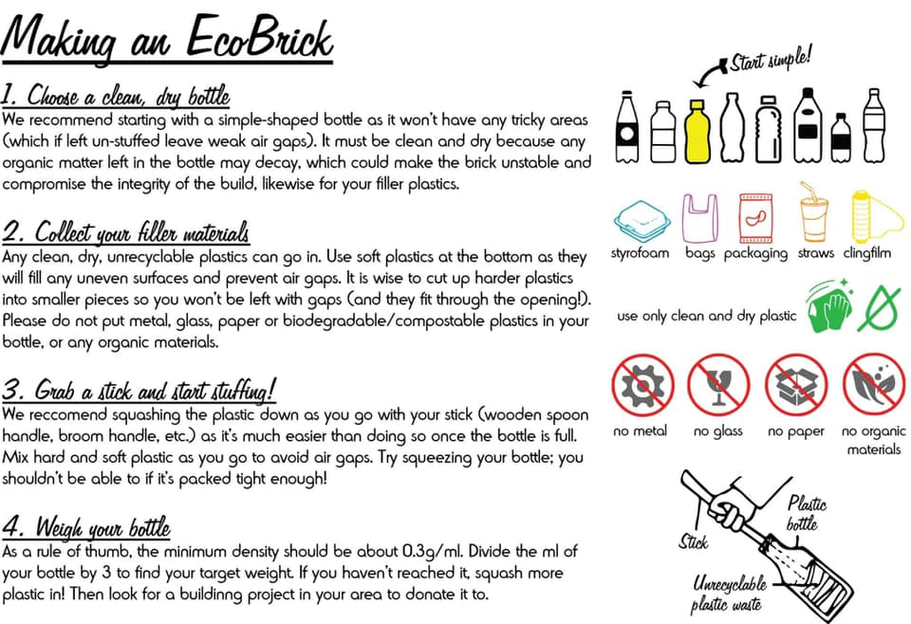

Art/DT
As it said before, the fashion industry uses a lot of water, even just to make one item of clothing. Often when we’ve finished wearing out clothes, we give them to other people (pass them down to younger brothers/sisters/friends/cousins) but often people just throw them in the bin. This is very wasteful. What if there was another use for them……
If you are able to, why not recycle an old t-shirt into a tote bag. You can then decorate it however you’d like and then use it when shopping. Below is a step by step image of how to make this.
If you can’t do this, look in your recycling bin, can you reuse any of the items for something else useful around the house? Maybe a tin can be reused to make a flower pot that you decorate, or a large pop bottle can be used to make a bird feeder. Be as creative as you like.
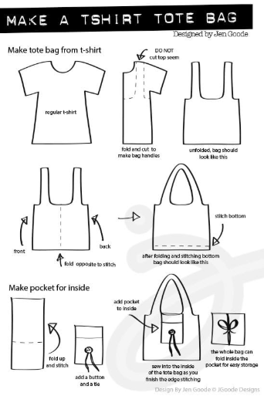

Maths – Lesson 1 Answers
Number | Rounded to nearest whole number | Rounded to the nearest tenth
1.19 | 1 | 1.2
10.19 | 10 | 10.2
0.75 | 1 | 0.8
100.75 | 100 | 100.8
100.03 | 100 | 100
100.037 | 100 | 100

Maths - Lesson 2 (answers)
- 42.3cm
- 14.46km
- 608.014kg
- 2.5kg
- 2.352km
- 64.675kg

Maths - Lesson 3 (answers)
- 33.15km
- 14.981litres
- 0.01

