08.06.20
Good Morning Usain Bolt,

This week’s theme for our learning is linked to our sustainable development goal - Life on Land. Make sure you have fun!

Task 1 | AM 20 min | Maths lesson
Task 2 | AM 20 min | English lesson
10:30 Snack time
Task 3 | AM and PM 2 x 20 min | TT Rockstars/Rodocodo/SPAG
12:30 Lunchtime
Task 4 | PM 20 min | Art activity
Task 5 | PM 20 min | History/Geography
Task 6 | PM 20 min | Skills Builder – daily challenge
2:00 Snack time
Task 7 | PM 20 min | Science
Task 8 | PM 20 min | This could be finishing an activity from earlier or an activity from the general list.
Daily journal and reading

Mathematics Task 1 (20 min)
The activities listed below are key Mathematical areas that the children need to practise every week, they do not need to do them all every day, but pick one or two per day. These will be ongoing and you can complete them in any fun ways you can.
Key Mathematical areas;
Number - count in multiples of 6, 7, 9, 25 and 1000
Times tables recall multiplication and division facts for multiplication tables up to 12 × 12
Measures - Convert between different units of measure - kilometre to metre; hour to minute]
Money - estimate costs, compare costs and calculate amounts in £ and p
Time - read, write and convert time between analogue and digital 12- and 24-hour clocks
convert from hours to minutes; minutes to seconds; years to months; weeks to days.

Make sure you are practising your timestables as much as you can.
Abacus - The children can access this resource via the website https://www.activelearnprimary.co.uk
The password is year 4 and the school code kmm7 in the bottom box.

PLEASE NOTE YOU DO NOT NEED TO PRINT THESE SHEETS, YOU CAN ANSWER THEM ON PAPER.
Task 1 – Multiply more than two numbers. Task 1 Maths lesson video. https://youtu.be/BRvbImatff4
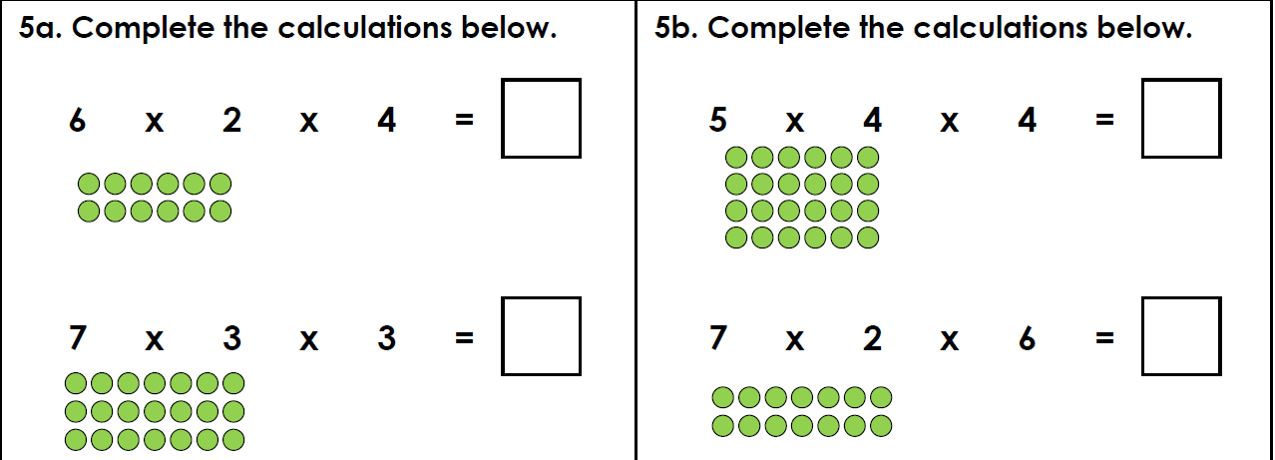
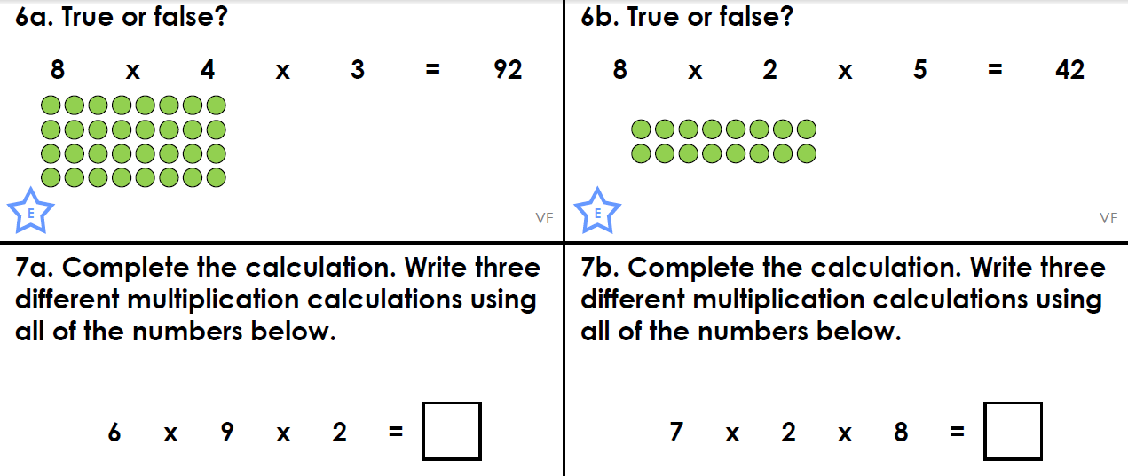
Task 2 – Multiply more than two numbers. Task 2 Maths lesson. https://youtu.be/Mk81tb9v4sU
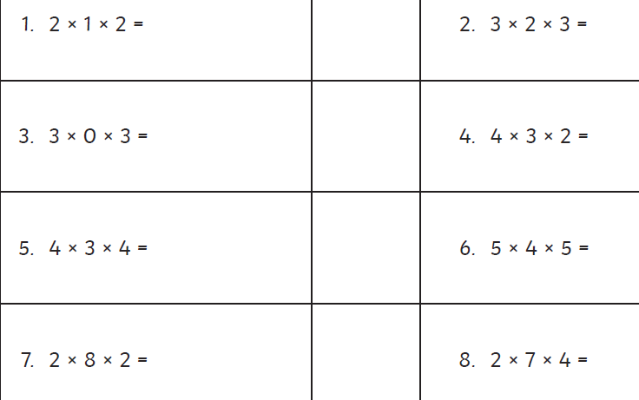
Task 3 – Divide a 2-digit number by a 1-digit number. Task 3 Maths lesson. https://youtu.be/8__6GSai5EM
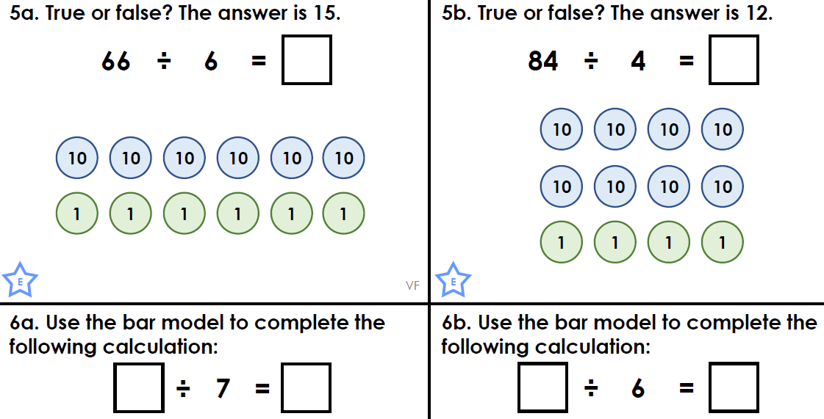
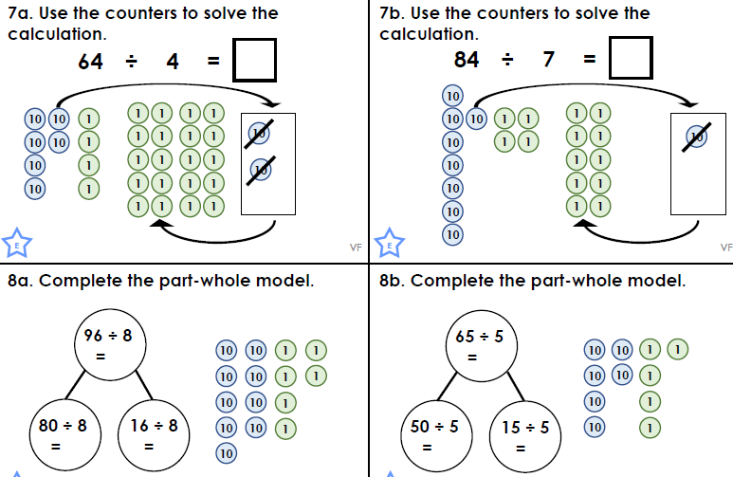
Task 4 – Choose a learning objective from the key Mathematical area list.
Task 5 - Design a bee board game including multiplication and division calculations.
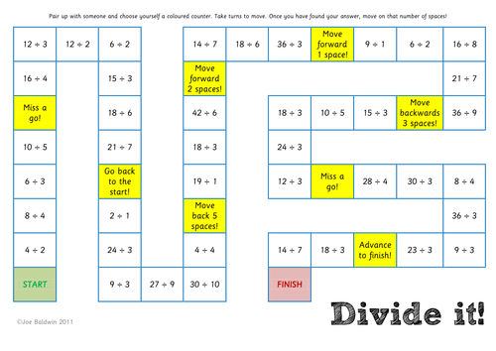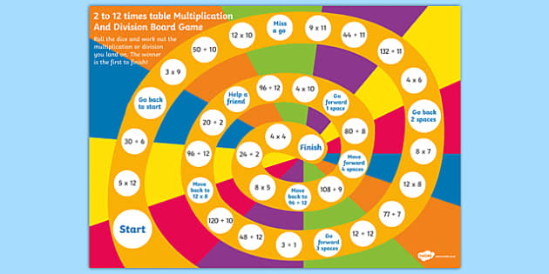
English Task 2 (20 min)
Task 1 – Power of reading, English lesson video. https://youtu.be/d86wa2sD6jU
Task 2 – Power of reading, English lesson video. https://youtu.be/SG9eUGwTJ0I
Task 3 – SPAG, English lesson video. https://youtu.be/QJ0hYydvrJM
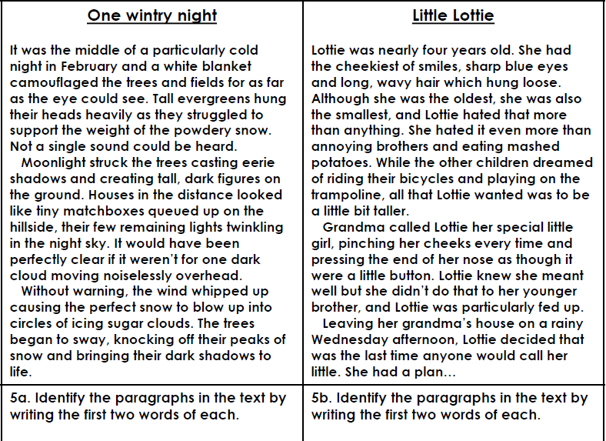
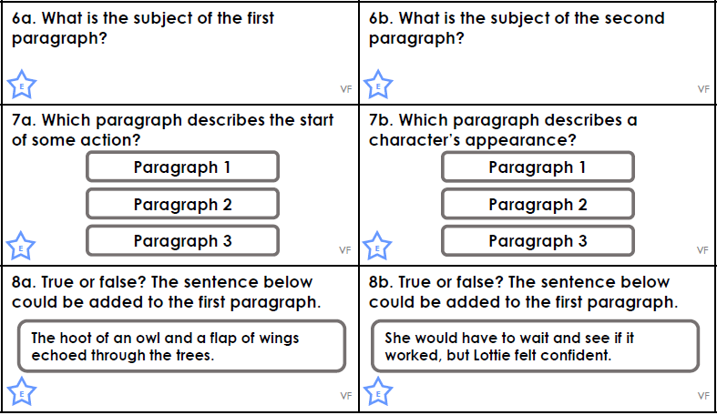
Task 4 – Choose 1 or 2 of the following activities;
Find out what different jobs do bees do inside the hive. How do bees communicate? https://www.natgeokids.com/uk/discover/animals/insects/honey-bees/
Find out the relationship between bees and the food humans eat. Make a poster or video to make people aware of why bees are under threat and what they can do to help them.
Tell the story about how a flower turns into honey and find out some facts about honey.
Bee newspaper article activity.
Task 5 – Spellings – look at the Year 4 spelling list and test yourself. You can practise these using chalks on the path, use a chalk pen on the windows or even write them in mud.
Reading
Remember to read EVERYDAY.
The Accelerated Reader (AR) programme is also accessible from home during this time too, so once you’ve finished your books make sure you log on and take a quiz. https://ukhosted43.renlearn.co.uk/2152328/default.aspx
Nessy - https://www.nessy.com/uk/
Task 3 (20 min)
Time Tables Rock Star - https://play.ttrockstars.com/auth/school/student/76329
Rodocodo - https://game.rodocodo.com/
SPAG – https://www.bbc.co.uk/bitesize/topics/zhrrd2p
Art/DT Task 4 (20 min)
Create a bee themed piece of art work.
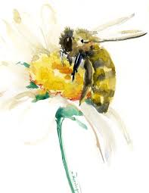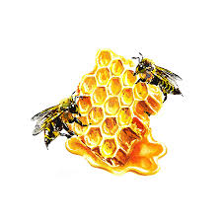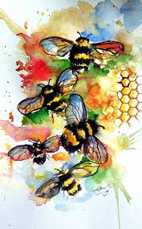
Make a bee hotel to put out for the bees.
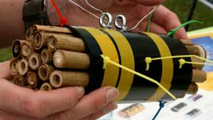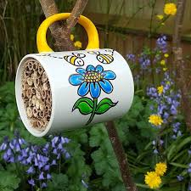

History/Geography Task 5 (20 min)
Make a bee map of the world.
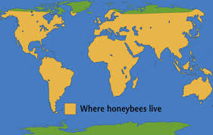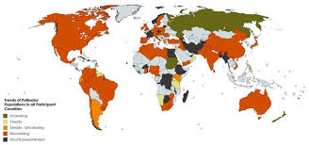

Task 6 (20 min) Skill Builder
https://www.skillsbuilder.org/resources/rocketing-resolutions
Science Task 7 (20 min)
Food chain worksheet
Draw and label different part of a bee.
Find out how many different types of bees there are.
General activities
Try painting with coffee.
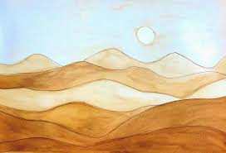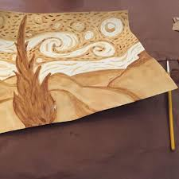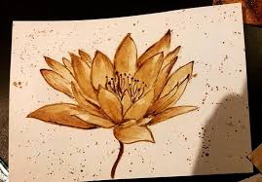
Make a bee with your recycling materials – can you make its wings move.
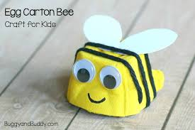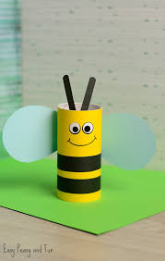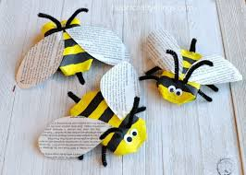
Remember to keep active!
- Yoga
- PE - Join Joe Wicks for a PE lesson. He is on YouTube every weekday.
https://www.youtube.com/watch?v=lEWcBIvqjDk
- Touchtyping - https://www.bbc.co.uk/bitesize/topics/zf2f9j6/articles/z3c6tfr
- Coding - https://scratch.mit.edu/
- Get in touch with a friend or family member
- Be mindful, mindful tasting. Taste some different types of honey.
- https://www.skulduggerypleasant.co.uk/books/
- https://www.anglianwater.co.uk/in-the-community/schools/learning-at-home/
In your journal you write:
- How you are feeling,
- What you have done (this can be any of the work you have done from the blog and anything that you have done whilst at home),
- What you have enjoyed each day.

