8th June
Dear Year 2,
Hello everyone! Hope you all had a lovely half term holiday. It was lovely to speak to you all again this week. The theme for the blog this week is ‘Life on Land’ I hope you enjoy some of these activities.
I hope you are enjoying writing your daily journals to capture what you are doing at home during this time. Remember to write in your journal:
- How you are feeling
- What you have done. This can be any of the work you have done from the blog and anything that you have done whilst at home.
- What you have enjoyed each day.
I can’t wait to see your journals which will be shared upon our return to school with your classmates!
If you would like to take some photos of your work to show, me you can send them to the school office! I have loved seeing the videos/photos/work that you have been sending in.
Take care and stay safe
Hopefully I will see you all soon
Mrs Jaynes and Mrs Tarpey
x
This is a suggestion of how much learning to do over a day with a year 2 child. These slots add up to 2 hours of learning, split into small chunks with breaks. Of course what is important is that you do what works best with your family. The work listed below is more than enough for 5 days of 2hr learning so please choose the tasks that you would prefer to do with your child. Also don’t forget to do some exercise and read every day!
am 20 min | Maths activity
am 20 min | English activity
10:30 | Snack time
am 2 x 20 min | TT Rockstars/Nessy
12:30 | Lunchtime
pm 20 min | Something unfinished from the morning or maybe some art
pm 20 min | An activity from general activities list

Life on land

Maths

Task 1
Recap addition learning using a numberline
Watch the video clip and complete the calculations
https://youtu.be/bZU3XkWqd2Q
Alternatively use a number line to add these:
24+10=
33+10=
26+12=
34+18=

Task 2
Watch the video clip and complete the calculations on screen
https://youtu.be/Oh6Qo6f9xBo
If you finish these and are feeling confident, try to fill in the missing numbers on these:
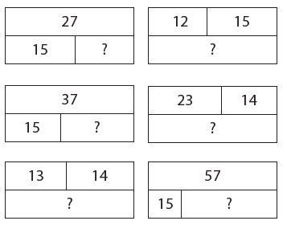
Ext: Can you use the calculations from the video and show them in a bar model.
Task 3
Watch the video clip
https://youtu.be/Ga-epyqMOR0
Ext: If you have any dice at home, roll them to generate two 2 digit numbers that you can add together using the method.
If you complete all of these, have a go at these problems:
Fill in the missing numbers
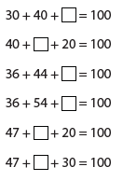
Can you work out what my number is?
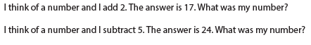
Write down your answers and your reason. Test out your theory with at least 4 different combinations.
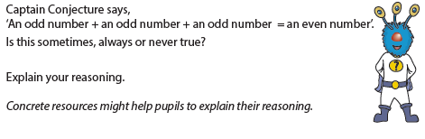
Task (20 min a day)
The following activities are ongoing tasks and should be practised every week at times that would suit you best. You do not need to do them all every day, pick one or two per day.
Number - count in steps of 2, 3, and 5 from 0, and in tens from any number, forwards and backwards
Know number bonds to 20
Times tables - recall and use multiplication and division facts for the 2, 5 and 10 multiplication tables (Try making mini times tables booklets)
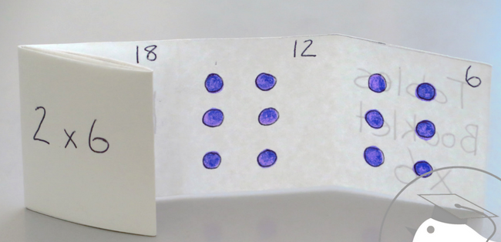
Time - tell and write the time to five minutes, including quarter past/to the hour (on an analogue clock)
Know the number of minutes in an hour and the number of hours in a day.
Money - Recognise different monetary coins, find different combinations of coins that equal the same amounts of money
Measure - measure items in cm/m, kg/g, l/ml

Task (2 x 20 min per week)
TT Rockstars https://ttrockstars.com/

Task (2 x 20 min per week)
Abacus https://www.activelearnprimary.co.uk/login?c=0

English
Remember to read every day

Task 1
Watch the clip
https://youtu.be/T3x_L6IiQUo
Alternatively all of the information contained in the videos is written below.
Can you find an egg box at home? Ideally this would be a 6 egg box. Look at the box from a variety of different angles. Open the box, close the box, turn it upside down etc.
What could you make out of the box? Either have a go at making your idea or draw your idea down.

Task 2
Watch the clip
https://youtu.be/3HND0_H1DpU
Alternatively all of the information contained in the videos is written below.
Read the first page of our new book (this is saved as a file in this weeks blog post. It is labelled ‘first page of the book)
What do you think the text is describing? Re-read the passage or ask an adult to read it to you. Close your eyes and begin to use your imagination.
Now you could draw, paint or even junk model what it is that is being described in the book. Make sure that you use lots of colour.

Task 3
Watch the clip
https://youtu.be/TKw6Z7v8xAE
Alternatively all of the information contained in the videos is written below.
A little recap on nouns and adjectives.
Noun = the name of a person, place or thing
Adjective = a describing word
See attached files labelled noun phrases for an activity to complete

Task 4
Watch the clip
https://youtu.be/3dNVhE1sRz8
Alternatively all of the information contained in the videos is written below.
Either use your picture of a dragon or find a picture of a dragon. Linking back to the previous task about nouns and adjectives. Can you think of some adjective phrases to help describe the dragon? Eg sharp pointy tail.
Now turn these phrases into complete sentences, remembering your full stops and capital letters.

Task (if you have a password 2 x 20 min)
Nessy https://www.nessy.com/uk/

Spelling
The silent ‘w’ at the beginning of a word
write, written, wrote, wrong, wrap

History
Sir David Attenborough
Task (2 x 20 min)
Read the reading comprehension text attached and answer the questions.
Find out 6 facts about Sir David Attenborough. You could use the reading comprehension text or this website to help you
https://www.natgeokids.com/uk/discover/science/nature/david-attenborough-facts/

Watch a clip of a David Attenborough programme and enjoy it!

Science
Task
Create your own minibeast habitat observation station. Find an empty cardboard box (a shoe box would be perfect, alternatively a cereal box or other cardboard box would work). Separate your box into 4 equal sections (good recap of fractions). Think about the different conditions that minibeasts would like. For example, could you have one section that is in the dark and dry, then another one on the dark but this time add some wet grass/leaves. Set up the other 2 sections so that they are light and dry and light and with wet grass etc.
Leave your box somewhere in the garden. Observe the box over the course of the week. Hopefully you will see a variety of different minibeasts appearing in the different sections.

Geography
Task 1
Go for a walk around the your village. Take a piece of paper and count up the number of bins that you can see on your walk. How can you show your results? Are there enough bins in your village? If you don’t think that there is, write a letter to persuade your local MP to put more bins in.

Task 2
Whilst out walking recap and discuss positional language. Ensure that you understand near, far, left and right.

Task 3
Create a poster encouraging people to put their litter in the bin.

Art
Task 1 (1x 20 min sessions)
Leaf Sewing
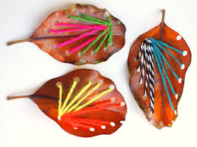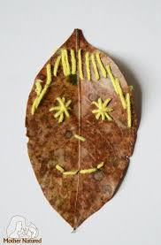

Task 2 (1 x 20 min sessions)
Have some fun turning your leaf into a brand new character. You could even write a little story or adventure that your character may go on.
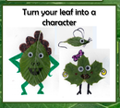

Task 3 (1 x 20 min sessions)
Leaf rubbing
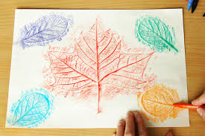

Computing
https://www.rodocodo.com/

