Dear Year 6,
It was fantastic to see so many of your smiling faces at our Zoom meeting earlier this week. I really enjoyed listening to what you have been up to and sharing all your news. I am looking forward to seeing you again later this week.
In the meantime, here is our home learning for this week – the theme of the week is ‘Life on Land’.
Take care, Mrs Masters x

Suggested Timetable:

45 mins | PE/Walk/Cycle Ride
45 mins | Maths Activity
10.30am | Break
45 mins | English Activity
45 mins | Online Learning Games/Activities
12.30am | Lunch
30 mins | Reading
45 mins | Global Learning Activity

Reading
It is really important that you try to read every day. There is some additional guidance for your parents to support your reading at home (attached to the blog).
Remember you can read silently to yourself, listen to audiobooks or ask your parents to read to you.
AR Quizzes
I have looked at and updated your reading targets on AR. Well done to those of you who have taken quizzes
The login for you to take AR quizzes is accessible for you from home and is:
https://ukhosted43.renlearn.co.uk/2152328/default.aspx
You will need your login and password which you should know. Email the office if you can’t remember them and I will send them out to you.

Maths Activities
The areas of Maths that you need to practise every week are listed below. You do not need to do them all every day; pick one or two per day. These will be ongoing and you can complete them in any fun ways you can. Some ideas are suggested in brackets for you to try.

Number:
- read, write, order and compare numbers up to 10 000 000

(practise reading and writing large numbers; put large values in order, e.g. house prices – which is the most expensive?)

Times Tables:
- know multiplication and division facts up to 12 x 12

(use online apps and websites such as Hit the Button and Times Tables Rockstars; have a ‘table of the week’ and put post-it notes up around the house with this table on them – constantly recite and practise them and then get an adult to test you – reward yourself with a treat if you get them all right; time yourself to write out or recite your tables – can you get faster each week?)

Measures :
- convert between different units of metric measure - kilometre and metre; centimetre and metre; centimetre and millimetre; gram and kilogram; litre and millilitre
- convert between miles and kilometres
(a great excuse for lots of cooking and baking – convert the values given in recipes; plan a day trip out for when lockdown is over – how far will you travel in miles/km?)

Money:
- estimate costs, add and calculate change in £ and p
- when shopping, calculate 10%, 20%, 25% and 50% off amounts

(use an online grocery website to plan a week of family shopping – can you stick to a budget? Can you use estimation to predict what your final bill will be? How much of your budget would be left over?; Plan a family holiday – where would you like to go? Plan a budget for travel, accommodation & food. Add up the total cost of your holiday.)

Time:
- tell the time using analogue, digital, 12 and 24 hour clocks.
- read and interpret a variety of timetables including, bus, train and TV guides

(practise telling the time, all the time! – work out how long it will be until TV time/bedtime; plan a train journey from St Neots – use online timetables to work out the times of your trains, where you would need to change trains and how long you would have to wait at each station?; plan a family 12-hour telethon using the TV planner – what could you watch and when?)

Maths Videos
Use the following links to access two Maths videos that I have created to support your learning this week. The focus is to help develop your problem solving skills in preparation for your move to secondary school:
Jumping Frogs (Maths Video 1)
https://www.youtube.com/watch?v=xvc267N0hx0
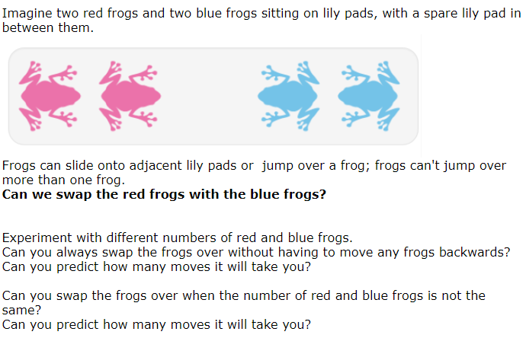

Magic Squares (Maths Video 2)
https://www.youtube.com/watch?v=AQ0qUr3va20

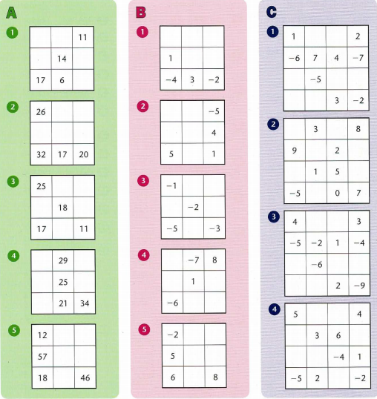

(answers are at the end of the blog)
English Activities
Task 1:
Continue with your daily journal to capture what you are doing during these unprecedented times.
In your daily journal, you could write:
- How you are feeling.
- What you have done at home - this might be any of the work you have done from the blog or anything else that you have done with your family.
- What you have enjoyed about each day.
You might want to include photographs and drawings to decorate your writing.

English Videos
Use the following links to access two English videos that I have created to support your learning this week. They are based on the book ‘Shackleton’s Journey’ by William Grill.
Ernest Shackleton (English Video 1)
https://www.youtube.com/watch?v=WzvOMRgUmIA
Find out and write all about Ernest Shackleton – present your research in a fact file, an information text or a poster.

Journeys (English Video 2)
https://www.youtube.com/watch?v=t2QZCeSqGSo
Write an account of a journey you have been on – think about the purpose of your journey and your feelings whilst you were travelling. Focus particularly on your opening paragraph – how can you engage your reader straight away?

Online Learning Games/Activities
Times Tables
https://ttrockstars.com/
https://www.timestables.co.uk/

Power Maths
https://www.activelearnprimary.co.uk/login?c=0
All the activities for Year 6 are now unlocked and available.
Remember the password is: year6 and the school code is: kmm7

French (you can also use this to practise spellings and vocabulary in English)
https://www.linguascope.com/
Username - buckden Password – starfish

Coding
https://www.rodocodo.com/
All the activities are now unlocked and available. Remember the password is Radcliffe.
You might also want to look at:
https://scratch.mit.edu/

Global Learning Activities
Task 1
Create a piece of art work based on the front cover of the book: ‘Shackleton’s Journey’.
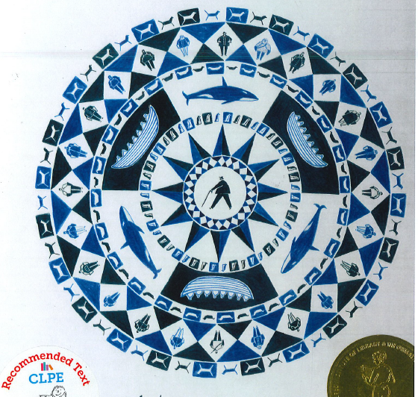
Focus on creating an image that uses a recurring (repeating) pattern to produce an image that contains the same features, e.g. men, boats, animals around a central figure. You might want to use coloured paper to create a mosaic effect – or use pastels/paints or crayons to draw your ideas.

Task 2:
Design a simple moving animal toy. You could research different examples of moving toys – these images might help you with ideas:
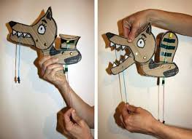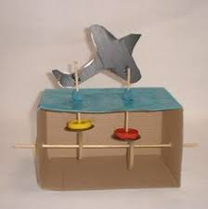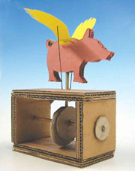
Think about the materials you could use and how you could make some parts of your toy move.
If you are able to, you might want to have a go at making your toy. Please email me any photos of the toys that you manage to make. Have a think about any improvements you could make to your design.
Task 3:
Listen to some of the pieces from ‘The Carnival of Animals’ by Sans-Saen:
The Elephant:
https://www.youtube.com/watch?v=f1nVDoCnsNk
The Kangaroo:
https://www.youtube.com/watch?v=8gjNhJ7l7Mk
The Swan:
https://www.youtube.com/watch?v=a9KDRS97P4k
Create a piece of music to represent an animal of your choice. If you play an instrument, you can use that; if not, think about how you can create sounds using household objects or things you can find in nature.

Task 4:
Research about Antarctica – find out about the physical features you might find there.
What is a glacier? https://nsidc.org/cryosphere/glaciers
What impact might global warming have on Antarctica? Can you find out why this might be a problem?

Task 5:
Prepare a speech to explain why rainforests are important to you. You might want to record your speech – don’t forget to email them to me to watch!
Use the following guidance to help you:
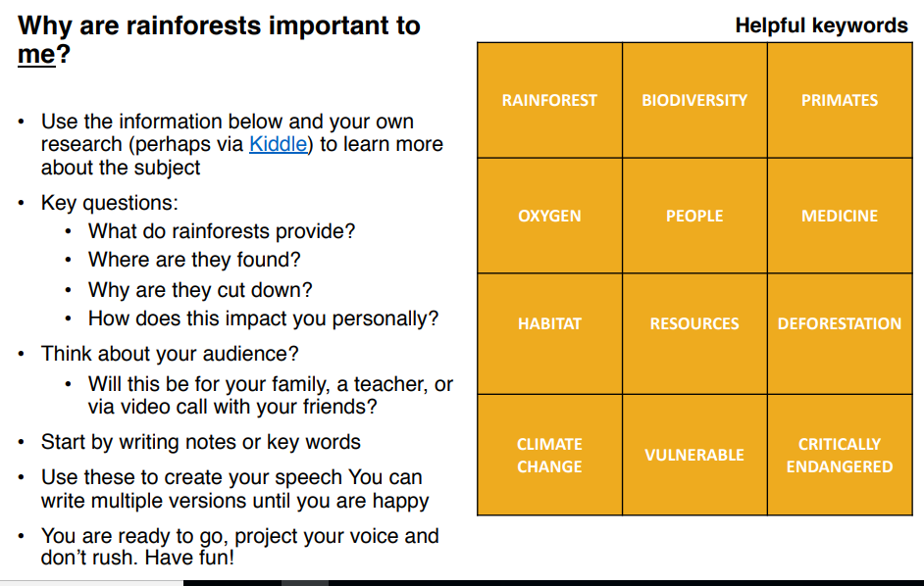
Magic Square Answers:



