Life on Land
Hi everyone, we hope you and your family are well and staying safe.
Here are some ideas for you to be working on whilst you are at home this week.
Please continue with your daily journal to capture what you are doing at home during this time. In your daily journal you write:
- How you are feeling.
- What you have done. This can be any of the work you have done from the blog and anything that you have done whilst at home.
- What you have enjoyed each day.
Below is a table suggesting how much learning to do over a day with a year 5 child. These slots add up to 4 hours of learning, split into small chunks with breaks. Of course what is important is that you do what works best with your family. The work listed below is more than enough for 5 days of 4hr learning so choose the tasks that you would prefer to do.
Please also ensure that you include some daily physical activity, Joe Wicks uploads a PE lesson on YouTube every day, these are good fun and you can access these when you would like to.
We also expect that you read daily, whether this be a story, magazine, information book or poetry. You can complete AR quizzes using this link: https://ukhosted43.renlearn.co.uk/2152328/default.aspx

am 45 min | Maths activity
am 45 min | English activity
10:30 | Snack time
am 2 x 30min | TT Rockstars/Rodocodo/Nessy
12:30 | Lunchtime
pm 45 min | Something unfinished from the morning or maybe some art
pm 45 min | An activity from general activities list

Maths
Task 1 (45min a day)
Choose an area of maths from the list below, you only need to choose one area a day, you do not need to do all of them every day. Use this time at home to practise some real life math skills. By practising these skills, other areas of maths will become easier for you as well.
Numbers - read, write, order and compare numbers to at least 1 000 000.
You could read some different numbers that you find in books, newspapers. Write the numbers using numerals and words.
Measures - convert between different units of metric measure - kilometre and metre; centimetre and metre; centimetre and millimetre; gram and kilogram; litre and millilitre
Could you measure your garden, Bedroom, kitchen? What if you wanted to plant a new flower bed or build a den in your bedroom, how much space would it take up? How long would it be? If you go out for a daily walk, how far do you walk in metres? Kilometres?
Could you help in the kitchen to bake or cook dinner? Measure your ingredients carefully.
Times tables - Know multiplication and division facts up to 12 x 12
Money - estimate costs, add and calculate change in £ and p.
Can you calculate the cost of the weekly shop? What about change if you didn’t have the exact amount?
Time - tell the time using analogue, digital, 12 and 24 hour clocks.
Read the clock at different times of the day. What time do you wake up, have lunch, dinner, bedtime? Can you give those times using analogue, digital, 12 and 24 hour clocks.
Read and interpret a variety of time tables including, bus, train and tv guides. What time do your favourite programs start? How long do they last? Could you take a train from St Neots to London? How long is the journey? What time are the trains? etc

Task 2 (2 x 30 min per week)
TT rockstars https://ttrockstars.com/
Video tasks – Mrs Purser has filmed 2 video lessons for you to watch.
This week they are based upon decimals.
Lesson 1: https://www.youtube.com/watch?v=IJq8-OoNnaY
Lesson 2: https://www.youtube.com/watch?v=sIASF6qWMjM
English
Task 4 (5x 30 min)
Read every day
Video tasks – Mrs Purser has filmed 2 video lessons for you to watch.
They are all based upon the Power of Reading book – Streetchild.
Lesson 1: https://www.youtube.com/watch?v=Bw-GE2KQ_O0
Lesson 2: https://www.youtube.com/watch?v=5x85_pI69js
For the 1st video lesson there are some links of video clips you might want to watch about life as a child in Victorian times:
https://www.youtube.com/watch?v=LVX4JhDSv2Y
https://www.bbc.co.uk/programmes/b00t6t3r
https://www.youtube.com/watch?v=-hDFEpOCBtY

ART
Task 3 (1 hour)
Making the best of limited resources – what can you do with just two materials?
- The Penan are a hunter-gatherer, nomadic people from Sarawak, a state in Malaysian Borneo. They have few possessions, carrying what they do have in backpacks made of palm leaf (rattan)

- The forest provides them with materials to build their homes, holds the ancient paths of their ancestors, and provides their food and water

- However, the rainforest is disappearing – Borneo lost 12% of its forest cover
between 2000 and 2010 alone
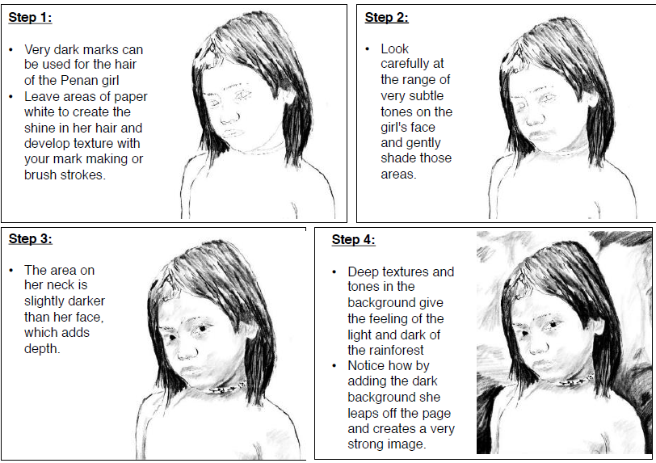
Below is a step by step guide of how to draw a girl from the Penan tribe.

Geography
Task 5 (1 hour)
Only around 6% of Earth’s land surface is rainforest – but it holds about half of all animal and plant species. The Upper and Lower Guinea rainforests of West Africa have the greatest diversity of primates in the world (60 species and sub-species, 46 of which are endemic – meaning that they are found nowhere else on Earth).
Create a speech answering this question: Why are rainforests important to me?
Use the information below and your own research to learn more:
- What do rainforests provide?
- Where are they found?
- Why are they cut down?
- How does this impact you personally?
- Think about your audience?
- Will this be for your family, or via video call with your friends?
- Start by writing notes or key words
- Use these to create your speech you can write multiple versions until you are happy
Here are some Key Words that you may like to use:
rainforest, biodiversity, primates, oxygen, people, medicine, habitat, resources, deforestation, climate change, vulnerable, critically endangered.

Science

Task 6 (1 hour)

Adaptations are special features or behaviours that make a plant or animal particularly suited to its habitat.
• A habitat is a place where a plant or animal lives. Examples include the desert, rainforest, woodland or the sea
• Adaptations are a part of the evolutionary process, examples: A tiger's stripes aren't just for looking good! They are an adaptation that helps them blend into the colours and shadows of their habitat, making them really hard to see
• Using a piece of paper, first draw a tiger in the middle – then annotate it with the other adaptions that help tigers to survive in their habitats
• Challenge: Can you colour code your adaptations into categories? Physical, Social and Behavioural adaptations.
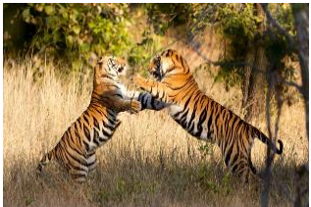

Task 7 (30 mins)
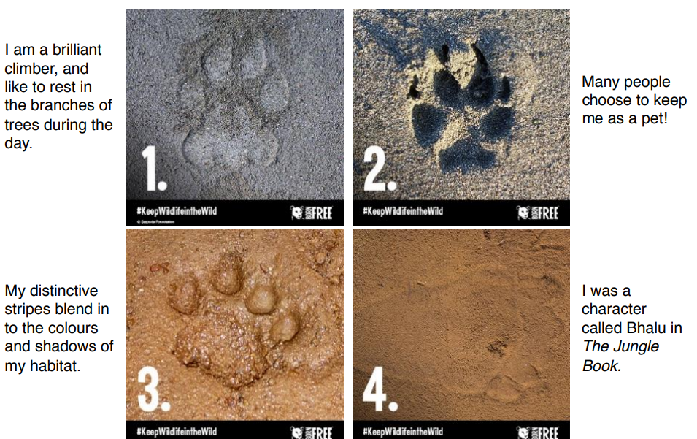
Can you identify the paw print? (answers at the bottom)

Answers
- Leopard 2. Dog 3. Tiger 4. Sloth Bear

