1st June 2020
Dear Kenny class,
Hoping you have all had fun with our first week back after half term. Hopefully you will have the opportunity to watch the videos that have been put up a long with this week’s plan. There are Maths videos, Phonics and Literacy lessons. The videos won’t be long and might need to be paused at certain times while you are asked to do something. The work you produce this week can be emailed to EYFS@buckdenacademy.org.
This is a suggestion of how much learning to do over a day with a reception child. Aim for a maximum of 2 hours focused learning interspersed with play based learning and physical activity. Of course what is important is that you do what works best with your family. The work listed below is more than enough for 5 days of learning so choose the tasks that you would prefer to do.
am 30 min | Sports/ physical activity- try Boogie Beebies for a change if you like
am 20 min | Maths activity – Halving and Sharing. Also 1 more and 1 less
am 20 min | Fine Motor control activity- like lego, puzzle, drawing, writing, cutting.
10:30 | Snack time- can you help prepare it?
am 2 x 20 min | Reading/ Sharing a story/ Phonics online game- see ideas below  Focus on Phase 3 – embed the learning.
12:30 | Lunchtime
pm 1 hour or longer if you are having fun! | An activity from the ideas below and/or independent learning through play time where your child makes choices.
Pm 20 min | Complete your journal for the day- draw and or write

Maths
Halving and Sharing-
- Using fruit that comes in bunches i.e. grapes or raspberries or strawberries. Share them between two plates evenly. Or use toys, can you tidy half your toys, then tidy the other half.
- Slicing objects in half. Could be folding/ cutting paper, food,
- Use the resources provided and sort them into the correct pile, equal or unequal
- Using construction blocks i.e lego or Duplo, build towers of either 2,4,6,8,10,12,14,16,18,20 blocks, then spit them in half, how many now (try to repeat with odd numbers and discuss that it can be done but it is very tricky – you don’t have to talk about fractions)
- Have your own teddy bear picnic, give two teddies a plate each, and distribute the food evenly.
- Play board games that lend itself to sharing objects out evenly.
- Listen to this halving and sharing story https://www.youtube.com/watch?v=hVaxiJB6Fls
- Watch this video of Number Jacks - https://www.youtube.com/watch?v=azVL530KCgA
- Listen to this song (see if you can see the pattern) - https://www.youtube.com/watch?v=VsyIB2Q6lws

Phonics- Recap phase 3 – make sure it is stuck in! Starting with j,v,w
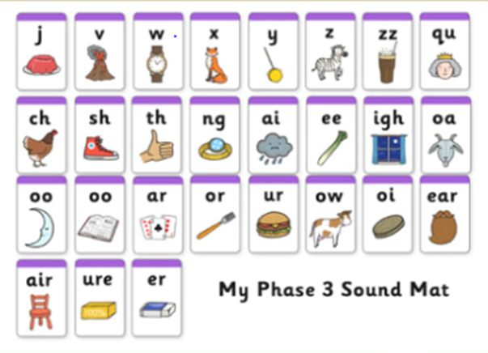
- House hunt - find objects in your house or garden, that start with the sound.
- Treasure or trash – write some words on pieces of paper, or using objects children decide whether the word starts with one of our sounds (treasure) – put these words in a ‘special box’ and if it isn’t treasure then its trash – put these words in the ‘bin.’ Alternatively, use https://www.phonicsplay.co.uk/BuriedTreasure2.html
- Sound detectives – Read through your favourite story books, find the sound, and talk about where it appears in the words.
- Word builder – using letters/sounds written on Lego blocks and joined together.
- Think of any words that have the sounds in and join together to make some silly sentences.
- Use a timer, how many times can you write the sound in 1 minute. Or repeat but writing of words containing our sounds.

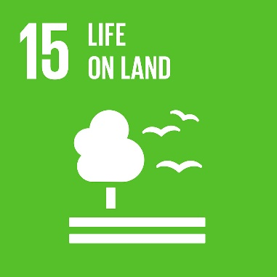
Life On Land

Idea 1
Where have you been? Which countries have you visited? Have you any family or friends that live in different countries? Can you find them on a map? Can you remember any animals or plant life you saw there?

Idea 2
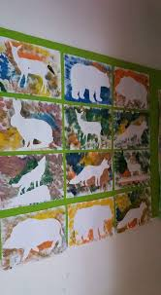
Cut out a stencil of an animal ‘stick’ it to your paper and using different colours paint/colour around the outside of your picture then remove your stencil.

Idea 3
Read Handa’s Surprise – use this link - https://www.youtube.com/watch?v=XyIV_xYi0as in case you don’t have a copy. What animals can you see? Where do you think the story is set? Can you make your own version based on animals you can find in England.

Idea 4
Learn some animal name in French.

Idea 5
Create some rubbings using nature found in your garden.

Idea 6
How many different animals can you think of? How do they move? Watch videos and copy their movements as closely as you can.

Idea 7
Using the list of animals, you thought of in idea 6 or some of the animals from idea 3, talk about and design a poster about how you would look after an animal that is not a pet. How are they looked after in zoo’s? How would the animal feel?

Idea 8
Read the attached story ‘The Adventures of a Plastic Bottle,’ Can you turn a plastic bottle into something else. How would this help our environment?

Idea 9
Using food colouring in water and a glass, put a white flower i.e. chrysanthemum or a lettuce leaf or celery stick in the solution and watch as the water is sucked up and the plant changes colour (this is not an instant experiment it takes a few days, you could chart its journey in the journal)
If this doesn’t work watch this - https://www.youtube.com/watch?v=y9hprlmck44

Idea 10
More stories to enjoy linked to the theme.
Michael Recycle - https://www.youtube.com/watch?v=pJweMxEhjlU

Idea 11
Can you learn more about animal conservation? What could you do in your own garden to encourage and conserve local wildlife. Maybe create a bug area with sticks, leaves and a damp environment or feed the birds.

Idea 12
Below is a painting by Henri Rousseau. He paints many animals in their habitats. Can you create a similar picture? You could paint, use pens, collage, printing or pencils.



