Maths Tasks 1st June 2020
This week we are going to look back at capacity and volume again. The learning objectives for year 1 are:
- Measure and begin to record capacity and volume
- Compare describe and solve practical problems for capacity and volume e.g full/empty, more than, less than
More confident children may be able to quickly compare and order weights and capacities and solve word problems using their knowledge of number facts and operations. It is important that they realise that weight and capacity are key ideas in their own right, and not just a convenient context for calculations. Challenging children to explain their work can be a good way to keep them focused on the real world context of weight and capacity.
Task 1
Talk through the picture and questions together using the language ‘full and empty’. It is always good to demonstrate the same in more practical manner so why not try getting some cups of water and asking the children the same kind of questions. Which is full which is empty and get them to order the cups from most to least amount of water. Using the vocabulary full/empty, more than, less than
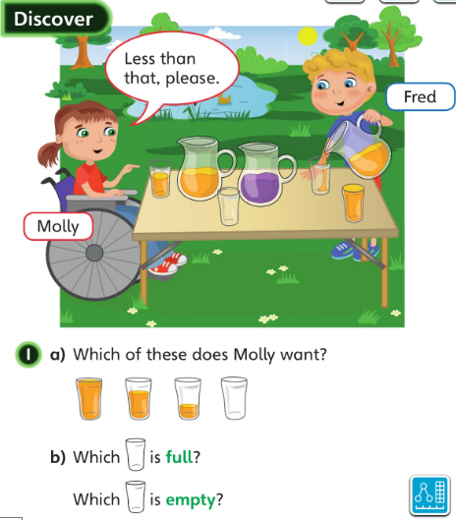

Remember to talk about how they children know that one has more than another. What did they do to work it out or what could they do to check/show someone else that what they say is correct.

Below are some worksheets you could use but getting out in the paddling pool or bath and actually filling/emptying containers, ordering the containers (of the same size) by how much water they hold and keep using the language mentioned above will help embed the learning.
https://kids.classroomsecrets.co.uk/resource/year-1-introduce-capacity-game/

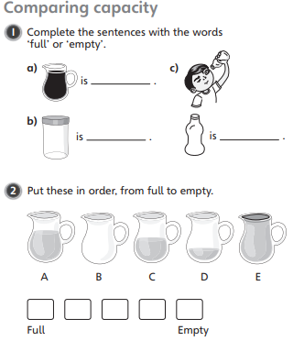
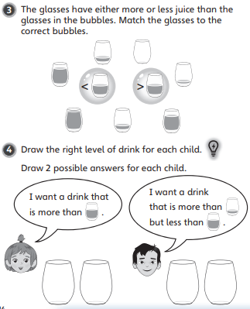

- Can children explain how to compare the differently shaped containers by pouring the volumes into identical measuring jugs and comparing the level of the liquid?
- Do children understand that a container has a maximum capacity; that any volume less than the capacity will not fill the container and any volume over the capacity will fill the container with some le- over, or fill it more than once?
https://www.bbc.co.uk/bitesize/topics/zt9k7ty/articles/zp8crdm
Task 2
In this lesson, children will estimate and measure the capacity of a range of containers, using a variety of non-standard units.
The relationship between the size of the unit and the number needed to fill a container may be difficult for children to grasp: the bigger the measure you use, the fewer you need to fill a container. Children may benefit from practical work with sand or water to make sense of this relationship.
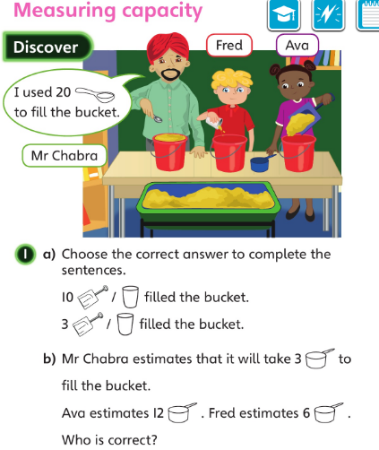
You can have lots of fun in the paddling pool/bath or sand pit working out how many cups it takes to fill the bucket and how many cups to fill the saucepan. Which holds more, the bucket or the saucepan? They key here is to experiment in real life.
There are some sheets below you could choose to complete.

Do children understand the need for units to be of a uniform size?

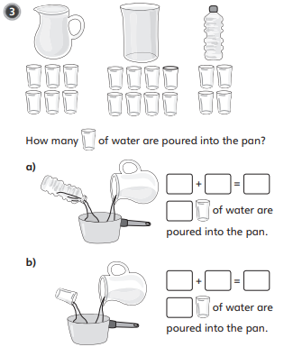

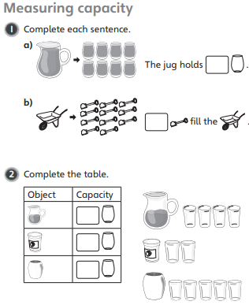

Task 3
When comparing the capacity of several containers, children may find it dicult to understand that the unit is a container like any other, but that it plays a special role and needs to fi t into the containers that are being measured a convenient number of times. This means that the unit needs to be a uniform size, and should be small enough, but not too small. Ask: I am going to measure the capacity of the pond. Should I do this using cups or buckets? Why?

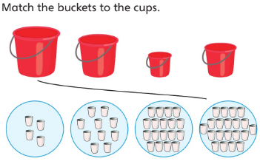
Using the same container for measuring find lots of different containers to fill. Work out how may cups (for example) fill each container then compare them and order them. Ask questions like ‘How many more cups did the first bucket need?’
Use language such as less than, more than, greater than, equal to.

Are children able to use everyday language like ‘bigger’ and ‘smaller’ in the context of capacity, for example, when placing a set of bottles in order? •
Do children understand the importance of choosing and using a suitable unit of measure to compare capacities?

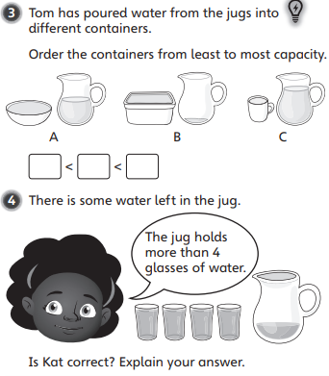

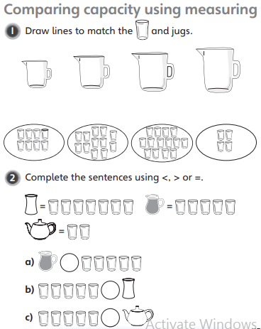

Task 4
No its time to put all that learning into practice by solving some capacity word problems.
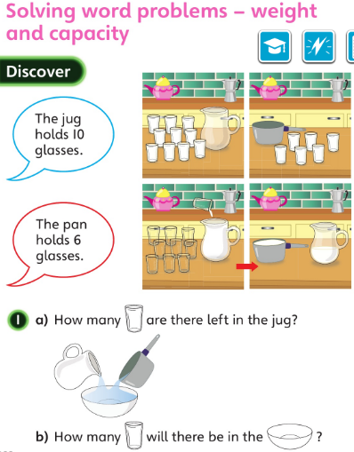

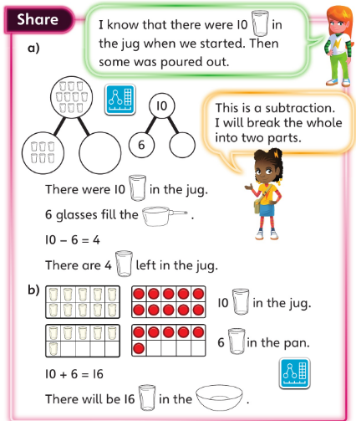

See the next page for some capacity challenge cards.

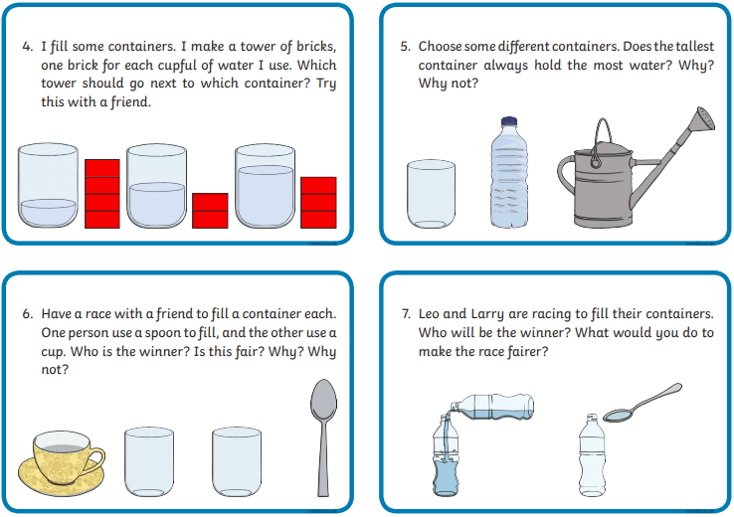
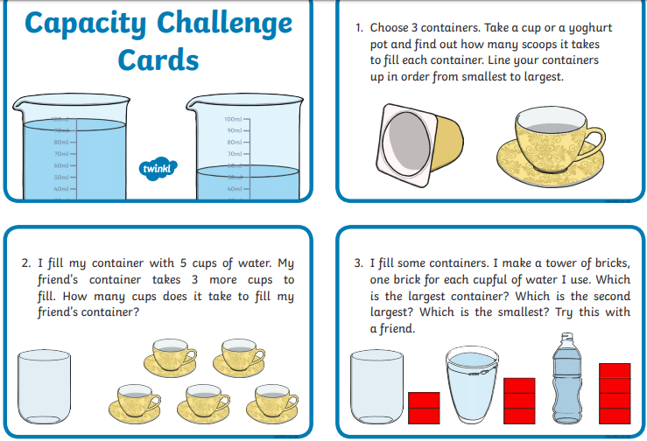

Task 5
Today is an arithmetic day, so we are going to be practicing your addition and subtraction skills.
I have put a big maths beat that sheet on the next page. At school we do this as a timed activity so we only have 30 seconds to answer as many questions as possible. Once you have done your 30 seconds get a grown up or big brother or sister to check it. How many did you get?
Now you can take your time and work out the rest that you didn’t get to yet.

Remember our top tips
- Look for those number bonds that you know really well and don’t need to work out such as number bonds to 10 and number bonds to 5.
- You don’t have to do all the ones in a row or column, if you’re finding one difficult stop and move on.



