Year 1 English tasks week 1st June
Theme: Life Below Water
Task 1
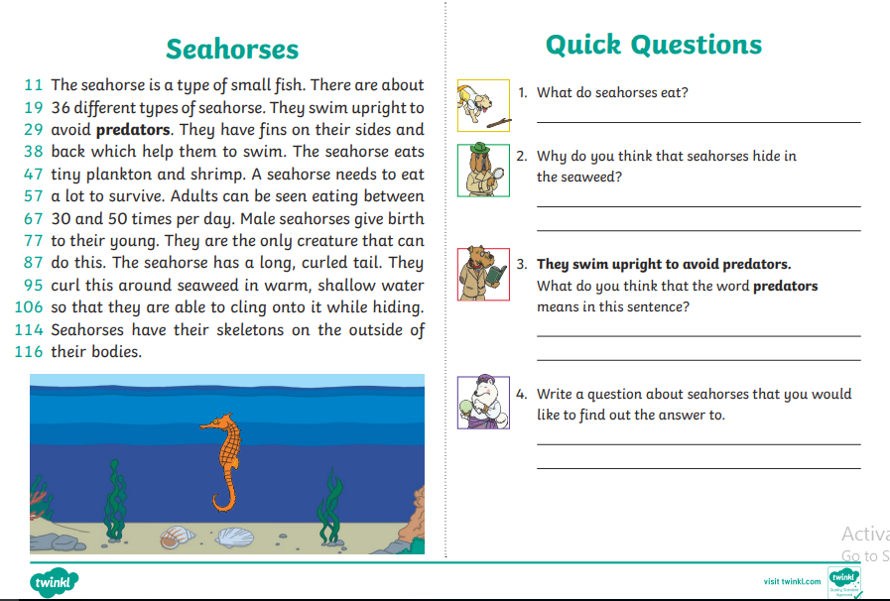
Can you read the text below and answer the questions? If the text is tricky a grown up can read it to you and ask you the questions afterwards.

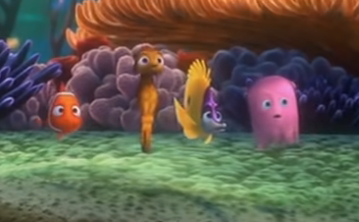
Task 2-5

This week we would like the children to write a narrative! Please write a story based on the stimulus “Finding Nemo” using this short video clip which can be watched on a TV, computer, tablet or smart phone. Click on this link to go to the video: https://www.youtube.com/watch?v=9RhX3lRJQMg
Please watch up to the part where the scuba diver scoops Nemo into the net. Try and use lots of descriptive language in your writing like adjectives, and similes. Please describe the setting (the Pacific Ocean) as clearly as you can to make the reader feel like they are there.
Below there will be some more resources to help you with your story writing.

Here is a story map that can be used like a plan to structure your story. Try to think of a little bit of writing for each picture.
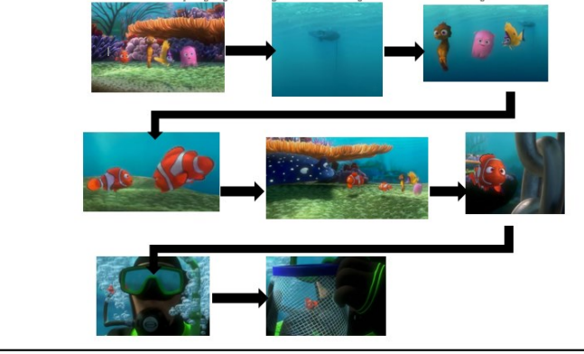

T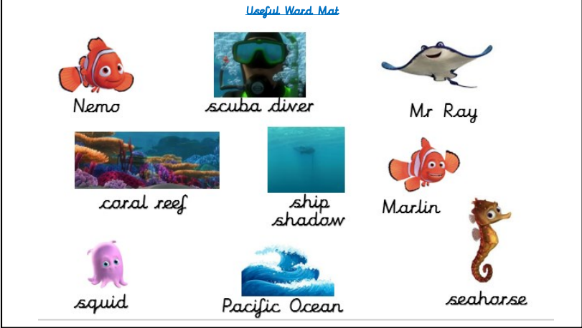

Vocabulary to use and discuss
Here is some challenging vocab to use in your stories. Talk about them with an adult and see if you can use them in your writing.
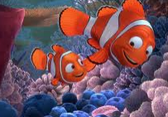
To describe the ocean: To describe feelings
vast terrified
tranquil petrified
calm furious
limitless frustrated
turquoise
crystal clear cheekily
teal sneakily
bravely

Enjoy writing your stories! Maybe with some help you could type them onto a computer.

