1st June 2020
Dear Kenny class,
Hoping you have all enjoyed the wonderful weather during the half term break and are ready for some more learning. Over the next week, we are developing a way to deliver some phonics and maths lessons by videoing your teacher for you to watch at home. Keep up those lovely journal books too as we will be sharing them.
This is a suggestion of how much learning to do over a day with a reception child. Aim for a maximum of 2 hours focused learning interspersed with play based learning and physical activity. Of course what is important is that you do what works best with your family. The work listed below is more than enough for 5 days of learning so choose the tasks that you would prefer to do.
am 30 min | Sports/ physical activity- Joe Wicks as a suggestion, Disney Zumba
am 20 min | Maths activity – Doubling. Also number bonds to 10 and learn its 1+1, 2+2, 3+3, 4+4, 5+5, 3+2 and 1+2
am 20 min | Fine Motor control activity- like lego, puzzle, drawing, writing, cutting.
10:30 | Snack time- can you help prepare it?
am 2 x 20 min | Reading/ Sharing a story/ Phonics online game- see ideas below  Focus on tricky words.
12:30 | Lunchtime
pm 1 hour or longer if you are having fun! | An activity from the ideas below and/or independent learning through play time where your child makes choices.
Pm 20 min | Complete your journal for the day- draw and or write

Maths
Doubling-
- Play games like dominoes, snap or dice games where you double the number thrown to make the total.
- Aiming games using pebbles and chalk drawn target with digits 0-6 on a dart board style target. Double the totals and create a score board.
- Painting of dots/ shapes onto one half of a piece of paper- fold it in half to print a duplicate image on opposite side of paper. Write the calculation to match the image eg. 3 + 3 = 6. 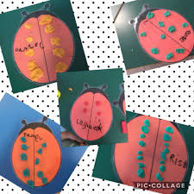
- Make a doubling machine from a cardboard box. Put in numbers one side of the machine and out the other side comes the number doubled with your child solving the calculation. 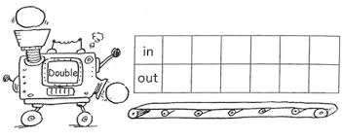
- Watch and sing along to this doubling song https://www.youtube.com/watch?v=e-KTHfrFit0
- Doubling darts game- this is quite tricky but some may like the challenge. https://www.topmarks.co.uk/Flash.aspx?f=dartboarddoublesandhalves
- Number blocks doubling episode https://www.youtube.com/watch?v=DnmPVOsOMWg

Phonics- Concentrate first on Phase 2 and 3 – these are for both reading and writing. Extension- Phase 4 – this is reading only, we do not expect them to be able to write these words yet. Don’t worry about Phase 5 for now.
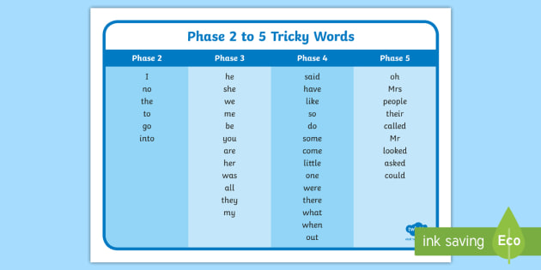
- Hide and seek, either you or your child writes some tricky words down to hide around your home for your child to find and read.
- Tricky word bingo game https://www.twinkl.co.uk/resource/T-L-020-Phase-3-Tricky-Word-Bingo Either print or write it out on paper.
- Tricky word song https://www.youtube.com/watch?v=jbKAxxvIIcg I do apologies as this will get stuck in your head!
- Tricky word detective- search through story books for the tricky words and read them within the context of the sentences.
- Tricky word noughts and crosses. Write some of the words your child finds harder on a noughts and crosses grid. Take it in turns to read a word and say it in a sentence to place your nought or cross.
- If you have Pop Up Pirates or Hungry Hippos- write some tricky words on the daggers or marbles- have to read them as you use/ collect.

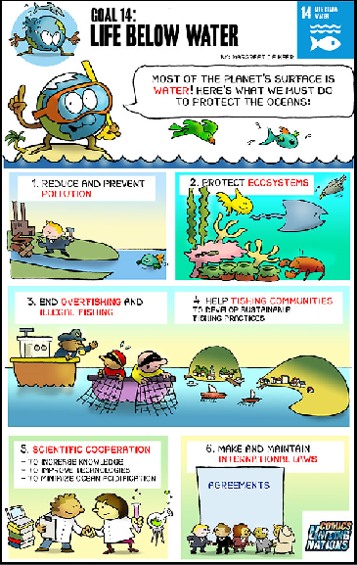 Life Below Water

Idea 1
Where in the environment is water? Ponds. Rivers. Lakes. Seas. Oceans. What do you think is under the water? Visit the river/ marina and see what you can see. Is everything in their natural and safe? Is there anything that doesn’t belong there? How can we keep our water ways free from pollution?

Idea 2
Make a picture/ painting/ drawing/ collage of under the water. Research first to learn more about the wildlife you may find there.
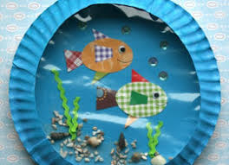

Idea 3
Read or watch the link for the story ‘A Commotion in the Ocean’. Try and remember all the creatures you met.
https://www.youtube.com/watch?v=9pRhgZ8Jffs
Can you write a page for the story yourself?
Idea 4
Create an underwater world to play in. You could add a plastic bottle to the scene and create a story of how the sea/ waterway is affected or can be saved.
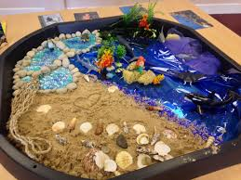
Idea 5
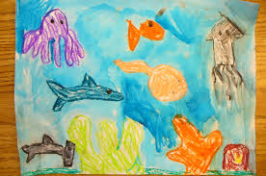
Wax resist paintings using crayons and watercolour wash.

Idea 6
Watch ‘What causes water pollution?’ video at https://www.youtube.com/watch?v=MEb7nnMLcaA. It does have some complicated vocabulary so may need some adult support. Talk about how you can make a difference to improve our water ways and seas. Ring a friend or relative to share your ideas.
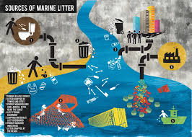
Idea 7
Explore what happens when you add different pollutants to water.
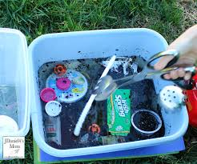 Is it possible to make the water clean again?
Here’s a hint – try using an absorbent material (ie Kitchen roll) resting between the dirty water and an empty cup

Idea 8
Write or say a prayer to help us care for our water and thank God for the beautiful creatures who live below the water’s surface.

Idea 9
More stories to enjoy linked to the theme.
- Over in the Ocean: In a Coral Reef by Marianne Berkes.
- Mister Seahorse by Eric Carle.
- I'm the Biggest Thing in the Ocean by Kevin Sherry.
- The Rainbow Fish by Marcus Pfister.
- Hello Ocean by Pam Muñoz Ryan.
- A House for Hermit Crab by Eric Carle.
Lots more ideas here too. Several have online readings of the stories on youtube https://www.booksfortopics.com/under-the-sea

