29th May
Dear Whitlock class,
Hello everyone! Hope you all had a lovely half term holiday. It was lovely to speak to you all again this week. The theme for the blog this week is ‘Life below water’ I hope you enjoy some of these activities.
I hope you are enjoying writing your daily journals to capture what you are doing at home during this time. Remember to write in your journal:
- How you are feeling
- What you have done. This can be any of the work you have done from the blog and anything that you have done whilst at home.
- What you have enjoyed each day.
I can’t wait to see your journals which will be shared upon our return to school with your classmates!
If you would like to take some photos of your work to show, me you can send them to the school office! I have loved seeing the videos/photos/work that you have been sending in.
Take care and stay safe
Hopefully I will see you all soon
Mrs Tarpey
x
This is a suggestion of how much learning to do over a day with a year 2 child. These slots add up to 2 hours of learning, split into small chunks with breaks. Of course what is important is that you do what works best with your family. The work listed below is more than enough for 5 days of 2hr learning so please choose the tasks that you would prefer to do with your child. Also don’t forget to do some exercise and read every day!
am 20 min | Maths activity
am 20 min | English activity
10:30 | Snack time
am 2 x 20 min | TT Rockstars/Nessy
12:30 | Lunchtime
pm 20 min | Something unfinished from the morning or maybe some art
pm 20 min | An activity from general activities list

What happens below water?

Maths
Task 1 (1 x 20 min a day)
How do we measure amounts of water? What units do we measure liquids in? Have a look in some recipes and see how they measure milk, water or oil. Have a look at the scale on some measuring jugs. On bottles of milk, orange juice, cordial how do you know how much liquid is in the container? Can you see it written on the packaging? Take note of the units. Are the units the same on big bottles and little bottles?

Task 2 (1 x 20 min a day) You will need a jug with a scale, some pots and a selection of containers from the recycling.
The amount of liquid a bottle holds, is the bottle’s capacity.
Using a jug measure the capacity of some bowls, pots and containers.

How much water can a mug hold?
How much water can an egg cup hold?
How much water can a margarine container hold?
How much water can a small plastic bottle hold?

Remember to record the units that you are measuring in.

Don’t forget to not waste the water afterwards and water the plants with it.

Extension: Can you remember the units you use when measuring a pencil or measuring a running track?

Task 3 (20 min a day)
The following activities are ongoing tasks and should be practised every week at times that would suit you best. You do not need to do them all every day, pick one or two per day.
Number - count in steps of 2, 3, and 5 from 0, and in tens from any number, forwards and backwards
Know number bonds to 20
Times tables - recall and use multiplication and division facts for the 2, 5 and 10 multiplication tables (Try making mini times tables booklets)
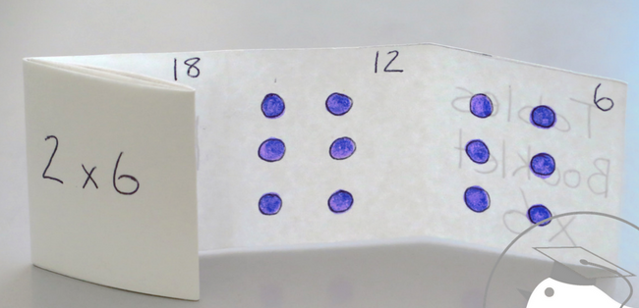
Time - tell and write the time to five minutes, including quarter past/to the hour (on an analogue clock)
Know the number of minutes in an hour and the number of hours in a day.
Money - Recognise different monetary coins, find different combinations of coins that equal the same amounts of money
Measure - measure items in cm/m, kg/g, l/ml

Task 4 (2 x 20 min per week)
TT Rockstars https://ttrockstars.com/

Task 5 (2 x 20 min per week)
Abacus https://www.activelearnprimary.co.uk/login?c=0

English
Remember to read every day
Perhaps you have a water themed book.
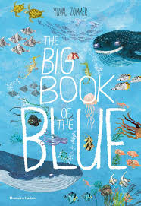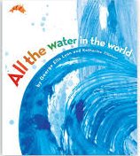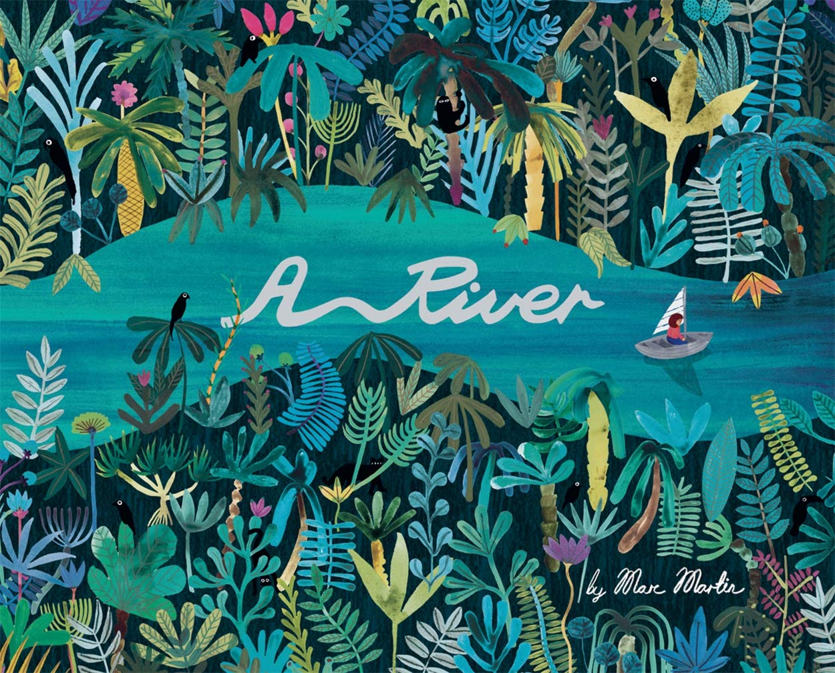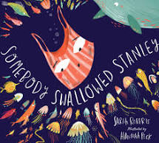

Task 1 (2 x 20 min)
Look at the back of some non-fiction books and see if you can find a glossary. What is a glossary? How is it useful?
Make a glossary for some of these words: pollution, algae, plastic, nutrients, current, river bed, murky, depth, predator, ecosystem, habitat.
It will help if you can talk about these words with some adults or older siblings so that you really understand what they mean.

Task 2 (2 x 20 min)
Take a walk with an adult to the river, the marina, a pond or a lake. Can you practice using the words that you used in your glossary?
Can you think of new words to describe the water? Think of colours, smells and how it moves. What does it remind you of? What animals can you see living on or in the water?
Write a paragraph to describe the water that you have been thinking about. Try to use some of the words in your glossary.
Task 3 (20 min)
Can you remember the difference between a statement, a command, a question and an exclamation?
Here is a link to a video to remind you, https://www.youtube.com/watch?v=n_foMADqjSc
Try to write some of your own e.g.
Command: Don’t fall in!
Exclamation: What a beautiful clear river!
Question: How deep do you think it is?
Statement: The shallow river flowed peacefully through the countryside

Task 4 (if you have a password 2 x 20 min)
Nessy https://www.nessy.com/uk/

Spelling
The ‘i’ sound spelt ey
Key, monkey, donkey, chimney, valley

PE
Task 1 (10 min each day)
Can you set up a water obstacle race where you have to carry a cup of water with you without spilling it?
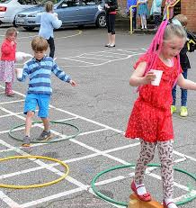

Science
Task 1 (2 x 20 min)
Can you research an underwater food chain? Remember that it starts with a plant and the arrows show the direction that energy moves in.
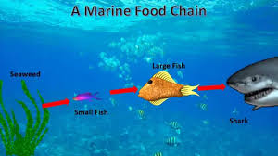

Task 2 (2 x 20 min)
Make an odd one out picture to test your family. Cut out or draw pictures of animals that live under water. Then find an animal that doesn’t live in the same habitat and stick it on your picture/or draw on your picture too. Can your family find the odd one out?

Task 3 (1 x 20 min)
Can you make a list of things that you might find in a river that are dead, alive or were never alive ?
Dead | Alive | Were never alive
leaf | fish | crisp packet

Geography
Do you know where the River Ouse is in our local area? Perhaps you walk near it or your car goes over it or you feed the ducks there sometimes. Have a look on a map can you find it? Try to see it on Google Earth.
Try this website to locate your area and find the River Ouse.
https://parallel.co.uk/os-openmap-cyo/#13/52.29548/-0.2474
This website allows you to print out and colour the River Ouse in your local area.

Art
Task 1 (1x 20 min sessions)
Try some water art
This technique is called pointillism and can be carried out using paints and cotton buds. You can use felt tip points as well.
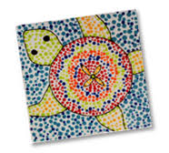
Task 2 ( 1 x 20 min sessions)
Or try some bubble art. This uses oil pastels but you could use chalks too.
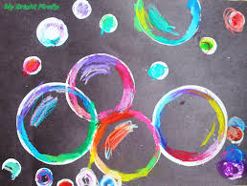
Task 3 ( 1 x 20 min sessions)
To do this you just need a piece of plastic to drop onto and a pipette or a little bottle that would make a drop. You could use coloured water and try to make a fish.
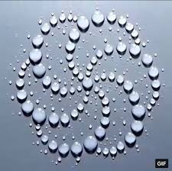

Music
Task 1 ( 1 x 20 min sessions)
Explore pitch
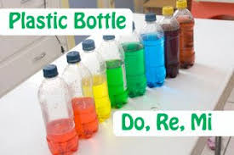
Pitch is the way that your ear and brain order sounds based on their frequency (vibrations per second). Rapid vibrations (high frequency) that reach your ear are categorized as a "higher" pitch, while slower vibrations (low frequency) are categorized as a "lower" pitch. Musicians label the pitches with the letters A through G.
When you tap a glass of water with a pencil or spoon the water molecules vibrate and create sound waves through the water. More water means slower vibrations and a deeper tone. Each of the bottles will have a different pitch when hit with the pencil. The bottle with the most water will have the lowest pitch while the bottle with the least water will have the highest.
When you blow across the top of the bottle, you set the air molecules vibrating and produce sound waves. In this case, more water results in a higher pitch, as opposed to tinkling the bottle. When the bottle has a small amount of water in it, the air molecules have lots of room and vibrate slower. Adding more water gives them less space to vibrate in, making them vibrate faster and producing a higher pitch.
Fill some bottles with different amounts of water and explore the pitch of the sound, the bottle makes if you blow over it or tap it with a spoon. Can you make up a little tune.

Computing
https://www.rodocodo.com/

