Wk beg 01.06.20
This is a suggestion of how much learning to do over the day. These slots add up to 2½ hours of learning split into small chunks with breaks. It would also be good to ensure you fit in some active time; many children are enjoying Joe Wicks live on YouTube at 9am (though you can always watch the video later in the day)/Yoga/Daily walk with immediate family.
The work listed below is more than enough for this suggested timetable so only choose the tasks that you would prefer to do.
am 20 min | Maths activity
am 20 min | English activity
10:30 approx | Snack time
am 30 min | TT Rockstars / Rodocodo - https://game.rodocodo.com/ Nessy / BBC bitesize / Topmarks / etc
am 20 min | Reading  AR quizzes can be done between 08:45 and 15:15 at this exact website  https://ukhosted43.renlearn.co.uk/2152328/default.aspx
12:30 | Lunchtime
pm 30 min | Activity of child’s choice, ideally something creative. This would be a great time to do something together, or if there are siblings for them to work together on something.
pm 30 min | An activity from general activities list
Please continue with your daily journal to capture what you are doing at home during this time. In your daily journal you write:
- How you are feeling.
- What you have done. This can be any of the work you have done from the blog and anything that you have done whilst at home.
- What you have enjoyed each day.
Reading
Please read daily for at least 15-20 minutes.
The Accelerated Reader (AR) programme is also accessible from home during this time too, so once you’ve finished your books make sure you log on and take a quiz. https://ukhosted43.renlearn.co.uk/2152328/default.aspx
Nessy - https://www.nessy.com/uk/

Maths
Abacus - The children can access this resource via the website https://www.activelearnprimary.co.uk
The password is year 3 and the school code kmm7 in the bottom box.
Topmarks – This can be accessed using the following link: https://www.topmarks.co.uk/maths-games/7-11-years/times-tables
https://www.timestables.co.uk/
Task 1
Please can you practise the following skills on a weekly basis. Choose what you think you need to focus on:
Number - count from 0 in multiples of 4, 8, 50 and 100
Times tables - recall and use multiplication and division facts for the 3, 4 and 8 multiplication tables
Measures - measure items in m/cm/mm kg/g ml/l

Money - add and subtract amounts of money to give change,

Time - tell and write the time from an analogue clock, including 12-hour and 24-hour clocks
know the number of seconds in a minute and the number of days in each month, year and leap year
REMEMBER, THE FOLLOWING TASKS ARE A SUGGESTED LIST AND WE ARE NOT EXPECTING YOU TO TRY AND COMPLETE ALL OF THEM.
Task 2
Write a series of word problems, using undersea creatures as the basis i.e. If one octopus has 3 hearts, how many hearts would 5 octopuses have? When you have done this, solve the problems to check they make sense.
Task 3
To help reinforce the learning we did on money, use Topmarks to play the ‘Coins Game.’ Remember to choose the British flag.
Task 4
TT Rockstars (https://ttrockstars.com/)
English
Task 1
Read the non-fiction article attached (Animals of the rocky shore) with an adult.
Task 2
Poster Design
Design an illustrated poster about the plant and animal life you can find on the rocky shore and explain why it is such an interesting habitat to visit.
Task 3
Read the text and answer the questions. Remember to use full answers. If you can’t print off the questions then instead of ticking or filling in the blanks, write the answer down on a sheet of paper.
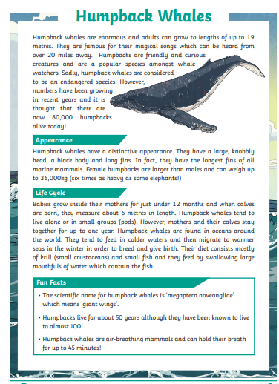
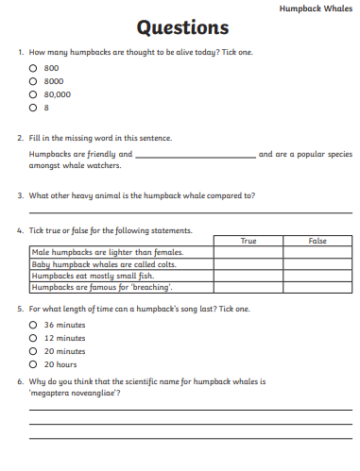

Task 4
Choose a sea creature to read about and create an information text on it. Think about what features you would need to include.
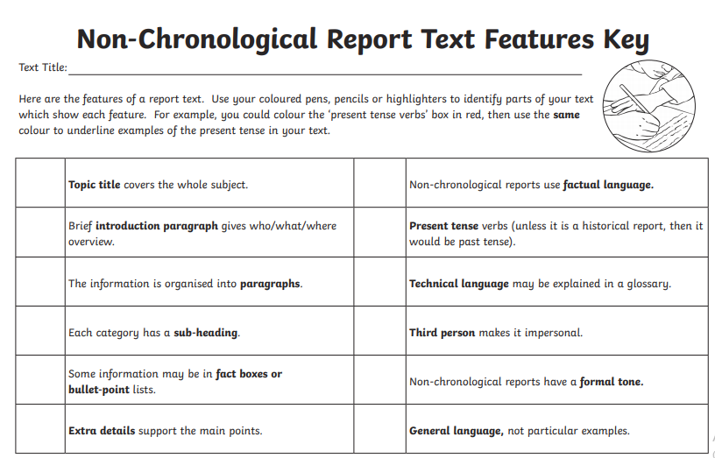
Task 5
Use one of the links below to practise SPAG - https://www.topmarks.co.uk/english-games/7-11-years/spelling-and-grammar https://www.bbc.co.uk/bitesize/topics/zhrrd2p
You will be able to choose a focus according to your year group.

Science
Task 1
Design a Sea Creature
Design your own rock pool creature. It should have features that enable it to withstand the harsh tidal conditions on the rocky shore.
Task 2
We have one heart; octopuses have 3 hearts. Can you find out about different sea creatures such as squids, sea stars and jellyfish and how many hearts they have? Why is this?
Task 3
You may find this science-based read interesting regarding a new space system launch at NASA, this weekend.

https://www.spacex.com/launches/?utm_source=morning_brew

General
Task 1
Using a non-fiction text or the internet, research Sikhism and explain the main points you have learnt in whichever way you wish i.e. tell someone, draw a picture, write a paragraph.
Task 2
Create a kindness postcard. It might be nice to send it to Hardwick Dene or someone else you think might like to receive it. See below:
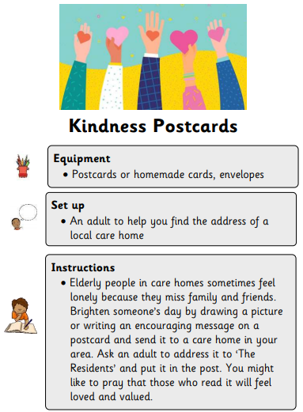
Task 3
Think back to the work we did on Vincent Scarpace. What can you remember about him? Create a collage/painting of one of his underwater creatures. Remember to think about your colour wheel and tones when choosing which colours to use.

Have a lovely week.

Mrs Anderson

