01.06.20
Good Morning Muhammad Ali,

This week’s theme for our learning is linked to the Sustainable Development Goal – Life below water. Make sure you have fun and stay safe!
Task 1 | AM 20 min | Maths activity
Task 2 | AM 20 min | English activity
10:30 Snack time
Task 3 | AM and PM 2 x 20 min | TT Rockstars/Rodocodo/SPAG
12:30 Lunchtime
Task 4 | PM 20 min | Art activity
Task 5 | PM 20 min | History/Geography
Task 6 | PM 20 min | French
2:00 Snack time
Task 7 | PM 20 min | Science
Task 8 | PM 20 min | This could be finishing an activity from earlier or an activity from the general list.
Daily journal and reading

Mathematics Task 1 (20 min)
The activities listed below are key Mathematical areas that the children need to practise every week, they do not need to do them all every day, but pick one or two per day. These will be ongoing and you can complete them in any fun ways you can.
Key Mathematical areas;
Number - count in multiples of 6, 7, 9, 25 and 1000
Times tables recall multiplication and division facts for multiplication tables up to 12 × 12
Measures - Convert between different units of measure - kilometre to metre; hour to minute]
Money - estimate costs, compare costs and calculate amounts in £ and p
Time - read, write and convert time between analogue and digital 12- and 24-hour clocks
convert from hours to minutes; minutes to seconds; years to months; weeks to days.

Make sure you are practising your timestables as much as you can. https://www.timestables.co.uk/ https://www.topmarks.co.uk/maths-games/7-11-years/times-tables
Abacus - The children can access this resource via the website https://www.activelearnprimary.co.uk
The password is year 4 and the school code kmm7 in the bottom box.

Task 1 – Problem solving addition and subtraction questions.
Task 2 – Problem solving mixed problems question sheet.
Task 3 – Using written methods to multiply questions.
Task 4 – Multiplying a 2-digit number by a 1-digit number sheet.
Task 5 – Multiplying a 3-digit number by a 1-digit number questions.
You do not need to print these, you can answer the questions on paper.
English Task 2 (20 min)
Task 1 – Research the Artist Robert Lyn Nelson. What art work is he famous for? Where was he born? What’s your favourite piece of artwork he has produced and why? What’s your least favourite piece of artwork he has produced and why? What inspired him? What style of artwork does he produce? Any other facts and information you can find.
Task 2 – Present your research findings in any way you wish – this maybe in the form of a interview report, a poster, a diary entry as Robert Lyn Nelson.
Task 3 – Watch and look at the BBC Teach Live Lesson Blue Planet powerpoint and create your own Persuasive Leaflet to save the sharks. https://www.youtube.com/watch?v=WJD5RNYkXn4 http://www.bbc.co.uk/earth/story/20140918-sharks-gather-in-their-thousands
Task 4 – Under the sea riddle activities – also try and create your own for someone in your house to solve.
Task 5 – Shark comprehension – read the text that suits you (make sure you challenge yourself) and answer the questions after. You do not need to print it, you can answer the questions on paper.
Reading
Remember to read EVERYDAY.
The Accelerated Reader (AR) programme is also accessible from home during this time too, so once you’ve finished your books make sure you log on and take a quiz. https://ukhosted43.renlearn.co.uk/2152328/default.aspx
Nessy - https://www.nessy.com/uk/
Task 3 (20 min)
Time Tables Rock Star - https://play.ttrockstars.com/auth/school/student/76329
Rodocodo - https://game.rodocodo.com/
SPAG – http://www.crickweb.co.uk/ks2literacy.html

Art/DT Task 4 (20 min)
- Create your own piece of artwork inspired by the artist Robert Lyn Nelson.
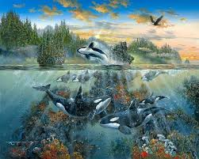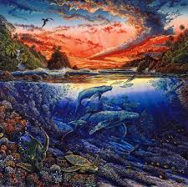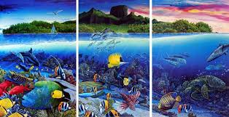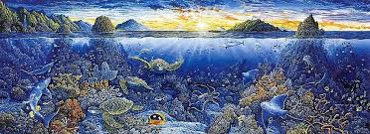

- Bubble painting - https://www.youtube.com/watch?v=z4i3Pp_ciwA 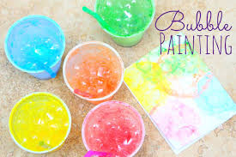
You need; Paper, paint, cups, straws and bubble solution (water and washing up liquid)
- Ocean layer jar - https://www.icanteachmychild.com/make-ocean-zones-jar/
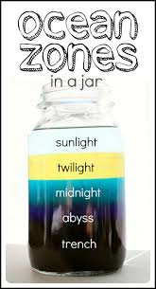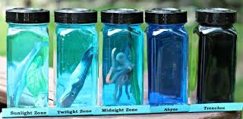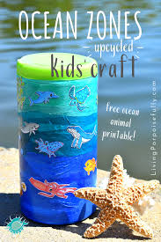

History/Geography Task 5 (20 min)
Locate on the Atlas where Robert Lyn Nelson was inspired (From your English learning).
Find and locate your favourite Ocean and gather as much information about it as you can. Create a scrapbook page about your chosen Ocean, don’t forget to add information about both the animals and plants found there, as well as its location and surrounding countries.
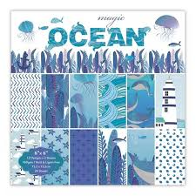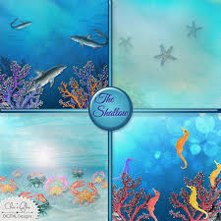
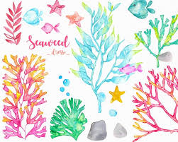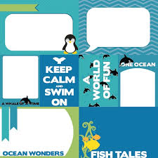

Task 6 (20 min) French - (Log in – Username - Buckden Password – Starfish)
https://www.linguascope.com/

Science Task 7 (20 min)
Ocean food chains and webs activity.

General activities
Ocean Maths Mosaic
Under the Sea record breakers worksheet
Under the Sea word search – why not make up your own too.
Under the Sea mindful colouring
Space launch on Saturday - https://www.spacex.com/launches/?utm_source=morning_brew
GenR8
Remember to keep active!
- Yoga
- PE - Join Joe Wicks for a PE lesson. He is on YouTube every weekday.
https://www.youtube.com/watch?v=lEWcBIvqjDk
- Touchtyping - https://www.bbc.co.uk/bitesize/topics/zf2f9j6/articles/z3c6tfr
- Coding - https://scratch.mit.edu/
- Get in touch with a friend or family member
- Be mindful, take your time to listen to the world around while outside.
- https://www.skulduggerypleasant.co.uk/books/
- https://www.anglianwater.co.uk/in-the-community/schools/learning-at-home/
In your journal you write:
- How you are feeling,
- What you have done (this can be any of the work you have done from the blog and anything that you have done whilst at home),
- What you have enjoyed each day.

