Dear Year 6,
I hope you had a lovely half-term break. It was good to talk to many of your parents and hear how you are getting on; I am also looking forward to seeing you this week at our Zoom meeting
Our themes for the next few weeks are based on our Global Learning, starting with Life Under Water which you learnt about in Year 5.
Hope you enjoy the activities. Take care.
Mrs Masters x

Suggested Timetable:

45 mins | PE/Walk/Cycle Ride
45 mins | Maths Activity
10.30am | Break
45 mins | English Activity
45 mins | Online Learning Games/Activities
12.30am | Lunch
30 mins | Reading
45 mins | Global Learning Activity

Reading
It is really important that you try to read every day. There is some additional guidance for your parents to support your reading at home (attached to the blog).
Remember you can read silently to yourself, listen to audiobooks or ask your parents to read to you.
AR Quizzes
I have looked at and updated your reading targets on AR. Well done to those of you who have taken quizzes
The login for you to take AR quizzes is accessible for you from home and is:
https://ukhosted43.renlearn.co.uk/2152328/default.aspx
You will need your login and password which you should know. Email the office if you can’t remember them and I will send them out to you.

Maths Activities
The areas of Maths that you need to practise every week are listed below. You do not need to do them all every day; pick one or two per day. These will be ongoing and you can complete them in any fun ways you can. Some ideas are suggested in brackets for you to try.

Number:
- read, write, order and compare numbers up to 10 000 000

(practise reading and writing large numbers; put large values in order, e.g. house prices – which is the most expensive?)

Times Tables:
- know multiplication and division facts up to 12 x 12

(use online apps and websites such as Hit the Button and Times Tables Rockstars; have a ‘table of the week’ and put post-it notes up around the house with this table on them – constantly recite and practise them and then get an adult to test you – reward yourself with a treat if you get them all right; time yourself to write out or recite your tables – can you get faster each week?)

Measures :
- convert between different units of metric measure - kilometre and metre; centimetre and metre; centimetre and millimetre; gram and kilogram; litre and millilitre
- convert between miles and kilometres
(a great excuse for lots of cooking and baking – convert the values given in recipes; plan a day trip out for when lockdown is over – how far will you travel in miles/km?)

Money:
- estimate costs, add and calculate change in £ and p
- when shopping, calculate 10%, 20%, 25% and 50% off amounts

(use an online grocery website to plan a week of family shopping – can you stick to a budget? Can you use estimation to predict what your final bill will be? How much of your budget would be left over?; Plan a family holiday – where would you like to go? Plan a budget for travel, accommodation & food. Add up the total cost of your holiday.)

Time:
- tell the time using analogue, digital, 12 and 24 hour clocks.
- read and interpret a variety of timetables including, bus, train and TV guides

(practise telling the time, all the time! – work out how long it will be until TV time/bedtime; plan a train journey from St Neots – use online timetables to work out the times of your trains, where you would need to change trains and how long you would have to wait at each station?; plan a family 12-hour telethon using the TV planner – what could you watch and when?)

Task 1:
Oceans are made up of five distinct layers.
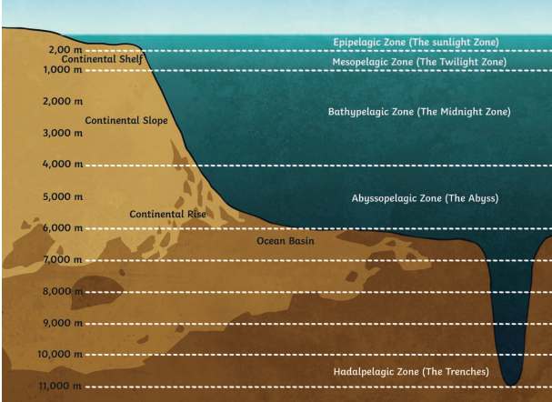
Complete the table below to show the depth (distance) of each of these layers below the surface. Remember 1 mile is 1.6km.
 | Depth (m) | Depth (km) | Depth (miles)
Epipelagic Zone
Mesopelagic Zone
Bathypelagic Zone
Abyssopelagic Zone
Hadalpelagic Zone

Task 2:
This image shows a summary of some of the items of rubbish collected from one of our oceans.
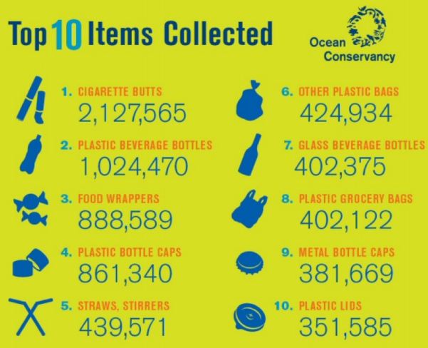
Write out these numbers in words.
Task 3:
I have attached a problem solving Maths quiz as I know some of you want to have a go at this. It covers everything in Year 6. It will help you to work out what you can remember and also whether you need to ask for more support with some areas.
See how you get on (the answers are attached too!).

English Activities
Task 1:
Continue with your daily journal to capture what you are doing during these unprecedented times.
In your daily journal, you could write:
- How you are feeling.
- What you have done at home - this might be any of the work you have done from the blog or anything else that you have done with your family.
- What you have enjoyed about each day.
You might want to include photographs and drawings to decorate your writing.

Task 2:
Have a look at these two comic books, both of which are designed to educate younger people about Global Goal 14 – Life Under Water.
https://www.yumpu.com/en/document/read/60795544/poseidon-patrol-eng
https://www.yumpu.com/en/document/view/59374530/annie-sunbeam-english
Design your own comic book to share what you know about life under water and the ways that we can work to protect it into the future.

Task 3:
Use a dictionary to write a definition of the following words:
marine, pollution, ocean, coastal, ecosystems, overfishing, aquaculture, acidification, destructive, conserve, prohibit
Then see if you can find the words in the attached word search.

Task 4:
Should people have to pay more for items made or wrapped in plastic or for drinks in plastic bottles? Write a balanced argument to explain the reasons why people might or might not support this idea. What do you think?

Task 5:
Research an endangered creature that lives under water – this might be a turtle, dolphin, seal, whale or any other creatures you are interested in. Use your research to write an information leaflet about your creature. Think about where it lives, what it eats, whether it has any predators and why it is so important to protect your endangered creature.

Online Learning Games/Activities
Times Tables
https://ttrockstars.com/
https://www.timestables.co.uk/
Power Maths
https://www.activelearnprimary.co.uk/login?c=0
All the activities for Year 6 are now unlocked and available.
Remember the password is: year6 and the school code is: kmm7

French (you can also use this to practise spellings and vocabulary in English)
https://www.linguascope.com/
Username - buckden Password – starfish

Coding
https://www.rodocodo.com/
All the activities are now unlocked and available. Remember the password is Radcliffe.
You might also want to look at:
https://scratch.mit.edu/

Global Learning Activities
Task 1
Monday 8th June 2020 is World Oceans Day.
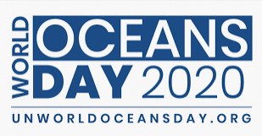
Find out what the purpose of this day is. Could you design a poster to advertise this day to your friends?

Task 2:
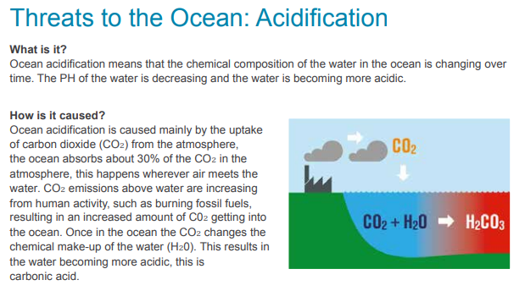
What are acids? Can you make a list of different acids? What do they do? Can you find any acids in your home? Why is acid in the oceans a problem?

Task 3:
Create a model (or drawing) to explain the different layers of the ocean. You could include the creatures that you might find living in each layer.

Task 4:
Create some Under the Sea art – these ideas might help you:
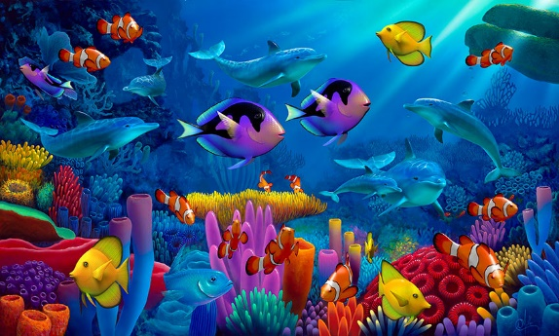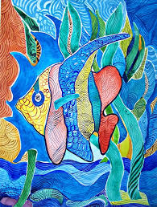

Task 5:
Listen to some music inspired by the sea:
La Mer by Claude Debussy
https://www.youtube.com/watch?v=FOCucJw7iT8
The Aquarium by Camille Saint-Saens
https://www.youtube.com/watch?v=YVpl-RNzdE4
Fingal’s Cave by Felix Mendelssohn
https://www.youtube.com/watch?v=CtJkEWCQEbE
Can you find any other examples of music inspired by the sea?

In Addition:
- GenR8 have sent some resources which may help you at home – they are attached to the blog for you to look at

- You may be interested in the launch of SpaceX this weekend (Saturday 30th May):
https://www.spacex.com/launches/

