Life Below Water
Hi everyone, we hope you and your family are well and staying safe.
Here are some ideas for you to be working on whilst you are at home this week.
Please continue with your daily journal to capture what you are doing at home during this time. In your daily journal you write:
- How you are feeling.
- What you have done. This can be any of the work you have done from the blog and anything that you have done whilst at home.
- What you have enjoyed each day.
Below is a table suggesting how much learning to do over a day with a year 5 child. These slots add up to 4 hours of learning, split into small chunks with breaks. Of course what is important is that you do what works best with your family. The work listed below is more than enough for 5 days of 4hr learning so choose the tasks that you would prefer to do.
Please also ensure that you include some daily physical activity, Joe Wicks uploads a PE lesson on YouTube every day, these are good fun and you can access these when you would like to.
We also expect that you read daily, whether this be a story, magazine, information book or poetry. You can complete AR quizzes using this link: https://ukhosted43.renlearn.co.uk/2152328/default.aspx

am 45 min | Maths activity
am 45 min | English activity
10:30 | Snack time
am 2 x 30min | TT Rockstars/Rodocodo/Nessy
12:30 | Lunchtime
pm 45 min | Something unfinished from the morning or maybe some art
pm 45 min | An activity from general activities list

Maths
Task 1 (45min a day)
Choose an area of maths from the list below, you only need to choose one area a day, you do not need to do all of them every day. Use this time at home to practise some real life math skills. By practising these skills, other areas of maths will become easier for you as well.
Numbers - read, write, order and compare numbers to at least 1 000 000.
You could read some different numbers that you find in books, newspapers. Write the numbers using numerals and words.
Measures - convert between different units of metric measure - kilometre and metre; centimetre and metre; centimetre and millimetre; gram and kilogram; litre and millilitre
Could you measure your garden, Bedroom, kitchen? What if you wanted to plant a new flower bed or build a den in your bedroom, how much space would it take up? How long would it be? If you go out for a daily walk, how fr do you walk in metres? Kilometres?
Could you help in the kitchen to bake or cook dinner? Measure your ingredients carefully.
Times tables - Know multiplication and division facts up to 12 x 12
Money - estimate costs, add and calculate change in £ and p.
Can you calculate the cost of the weekly shop? What about change if you didn’t have the exact amount?
Time - tell the time using analogue, digital, 12 and 24 hour clocks.
Read the clock at different times of the day. What time do you wake up, have lunch, dinner, bedtime? Can you give those times using analogue, digital, 12 and 24 hour clocks.
Read and interpret a variety of time tables including, bus, train and tv guides. What time do your favourite programs start? How long do they last? Could you take a train from St Neots to London? How long is the journey? What time are the trains? etc

Task 2 (2 x 30 min per week)
TT rockstars https://ttrockstars.com/

Task 3 (1 hour)
Maths problem.
Well, here's a pretty scene, the underwater creatures and the tall lighthouse joined by a seagull and a cloud in the sky.
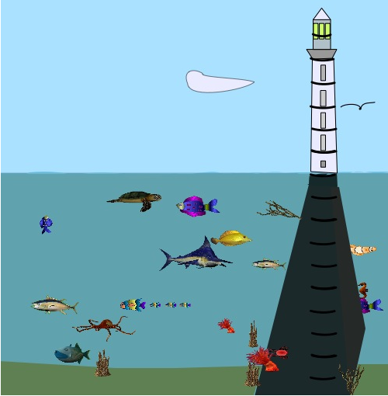
There are black markings all the way up the lighthouse and on the support for the lighthouse going down to the sea bed. These markings are 1 metre apart. I have left the numbering for you to do.
The sea level is of course "0" and then positive numbers going up and negative numbers going down to the sea bed.
If we think about the mouths of the creatures then we can see how much deeper they are from each other, or what distance they are apart.
For example the (mouth of) the fierce looking blue and white fish near the middle is 1 metre deeper than the (mouth of) the golden yellow fish.
- What number should be where the light shines from the lighthouse?
- What number should be where the (head of the) seagull is?
- What number should be where the (mouth of the) red crab, near the bottom, is?
- How far is it down from the (head of the) seagull to the (mouth of the) yellow fish?
- How far is it from the turtle, near the surface of the water, to the crab?
- There's a little brown sea-horse to the right of the lighthouse support. How far from the surface is it?
- How high above the sea level is the seagull flying?
- How far is the seagull from the sea-horse?
- How high is the pointed end of the cloud?
It would be interesting to know how you arrived at your answers.
Did you write anything down to help you?

How about thinking up some questions of your own?

English Task 4 (5x 30 min)
Read every day

Task 5 (1 hour)
- Read the information about the Plastic Pollution below.
Plastic Pollution
What’s the problem with plastic?
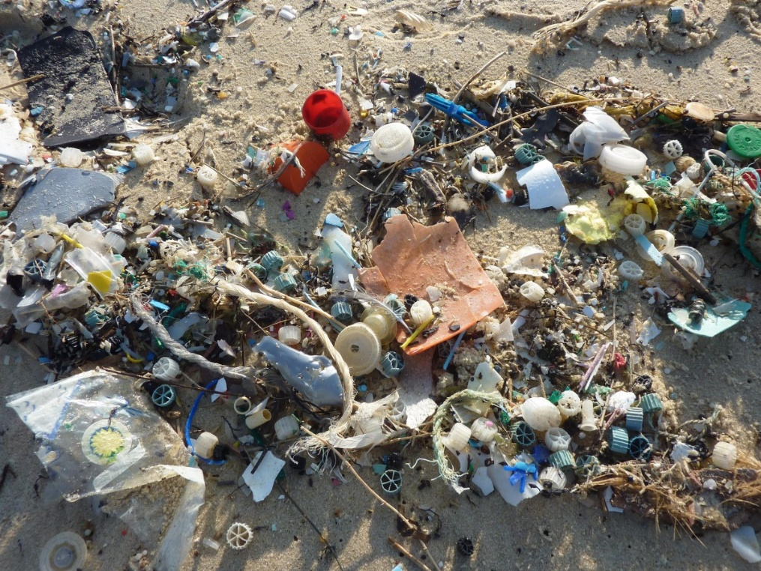
It is an unfortunate fact that plastic can’t be digested easily by the Earth. Our reliance on disposable plastic packaging for a great many things we buy has led to serious environmental problems. For example, experts predict that, by 2050, there will be more plastic in the oceans than fish. With 8 million pieces of plastic entering the oceans every day, we are creating a problem for future generations as well as a problem today.
The increasing amount of plastic in the oceans is creating real problems for the creatures who live in the sea. Wildlife such as dolphins, seals and seabirds often eat plastic, mistaking it for food. Studies carried out on dead sea creatures has revealed plastic bags caught up in the intestines and stomachs of sea creatures, which would have caused them pain when alive and may have caused or contributed to their deaths.
The plastic problem isn’t just limited to sea life: it’s a problem for people too. Latest statistics show that 1 in 3 of all fish consumed by humans contains plastic. Added to this, marine life play a key role in producing the oxygen that we breathe, so we should all be very concerned about maintaining healthy oceans.
Is plastic pollution only found in the oceans?
The sad fact is that this would be devastating enough, but it is also only part of the problem. As well as affecting oceans, plastic causes harm to land. The majority of single-use plastics are not recycled, and 79% of all plastics end up as waste in landfill sites. Chlorinated plastic leaks harmful chemicals into the soil, which can then get into water systems and cause harm to the species which drink the water. The breakdown of biodegradable plastics also releases methane, a greenhouse gas which is a major contributor to global warming.
In 2017, a study of tap water around the world found that 83% of tap water contained pollutants from plastic.
What is being done about the harm caused by plastics?
There has been an effort to reduce and control the amount of plastic being used. For example, many supermarkets are now charging their customers for plastic bags; many coffee shops and restaurants are banning plastic straws; many campaigns have been launched to replace plastic with reusable or biodegradable materials. Recycling has become a common practice, although out of the 8.3 billion tons of plastic that have been produced since the 1950s, only 9% has been recycled.
As well as this, there is a lot of important research into developing biodegradable plastic, such as plastic made from seaweed, corn or sugarcane. Seaweed is especially promising as an alternative to traditional plastics, as seaweed absorbs carbon dioxide and helps to regulate the acidity levels in the ocean.
Now answer these questions:
1. Explain what pollution is in a sentence.
2. Name TWO reasons why plastic pollution is a problem
3. Describe two examples of the harm done by humans.
4. Highlight all the adjectives which have been used in the article.
5. Write out TWO sentences from this article which show the writer’s opinion.
6. Describe the next steps in tackling pollution, in your own words.
7. Write a sentence which summarises your own opinion on plastic pollution.

Task 6 ( 1 hour)
Write a Newspaper Article about Plastic Pollution found in water near you. This could be Grafham Water, The River, Paxton Pits or anywhere else you would like to write about.
Remember to include certain features expected to see in a Newspaper article:
- Catchy headline
- Columns
- Introduction that doesn’t give the whole article away at once
- Quotes – use the correct punctuation
- Indirect speech
- Picture with a caption

Science
Task 7 (45 mins)
Watch this video taken from Blue Planet. In it, you will see a range of items that don’t naturally occur in the oceans.
https://www.bbc.co.uk/teach/class-clips-video/science-ks2-trashing-the-deep/zjk3mfr
- Write down all the items that you notice that don’t naturally belong in the oceans.
- Identify what they are made from (plastic, metal etc).
- Explain how they damage our environment.
- Create a poster showing people how to dispose of these materials responsibly.

Task 8 (1hour)
Acidification, Dead Zones, Overfishing and Waste in the ocean are all threats to our oceans. Find out about each of these and sort them into a hierarchy from the most to the least serious (in your opinion).
Now write us a letter or email explaining which is the most serious, explaining and justifying your views. You will need to use books or the internet to research and this will enable you to add more detail to your writing. Remember to organise your writing into paragraphs and think carefully about what vocabulary is appropriate to use.

Task 9 (1 hour)
Choose one of the ‘threats to the ocean’ (Acidification, Dead Zones, Overfishing, Waste in the ocean) and create an information page or Powerpoint presentation using the following questions as sub-headings:
- What is it?
- How is it caused?
- What is the effect on the ocean?
You could also include pictures/photos to engage your audience.

Task 10 (1 hour)
Jason DeCaires Taylor underwater sculptures have been created to encourage new growth of coral reefs. Below are some of the sculptures that he has created.
Using playdough, salt dough, clay (if you have it). Create a sculpture that you would place into the ocean to encourage plant life to grow on it.
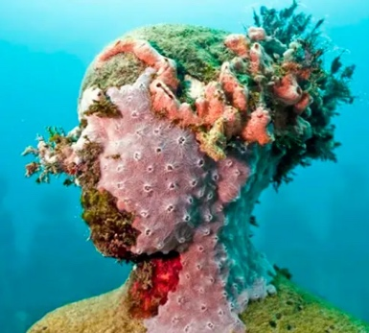
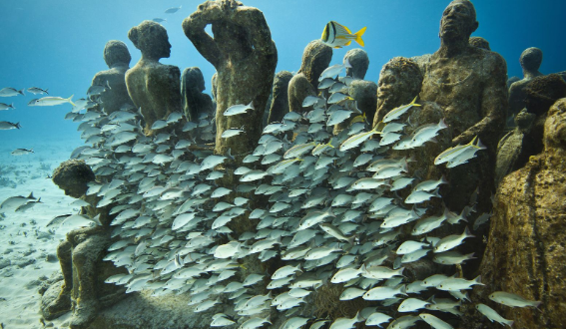
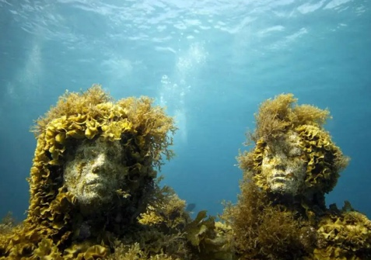

Task 11 (1 hour)
We know that plastic causes pollution in the oceans and is a danger to the animals living there. Ordinary people all over the world who have a love of nature and science have been coming up with incredible alternative materials to plastics.
The picture below shows edible cutlery. These have been created in India and are baked savoury, sweet or plain edible spoons. Can you find out about another product that has been created without the use of plastic, or, alternatively you could design your own?
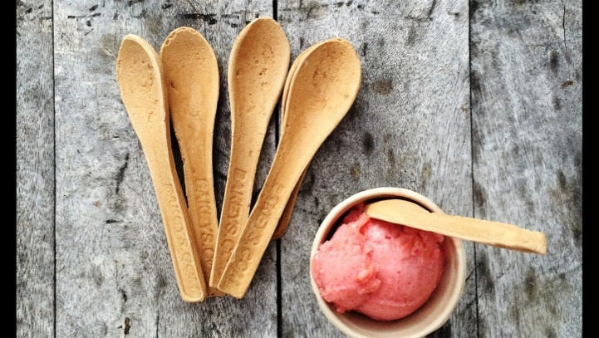

You may find this science-based read interesting regarding a new space system launch at NASA, this weekend.

https://www.spacex.com/launches/?utm_source=morning_brew

