17.05.20
Good morning all,
Our learning topic this week is food.
This is a suggestion of how much learning to do over the day. These slots add up to 2½ hours of learning split into small chunks with breaks. It would also be good to ensure you fit in some active time; many children are enjoying Joe Wicks live on YouTube at 9am (though you can always watch the video later in the day).
The work listed below is more than enough for this suggested timetable so only choose the tasks that you would prefer to do.
am 20 min | Maths activity
am 20 min | English activity
10:30 approx | Snack time
am 30 min | TT Rockstars / Rodocodo / Nessy / BBC bitesize / Topmarks / etc
am 20 min | Reading  AR quizzes can be done between 08:45 and 15:15 at this exact website  https://ukhosted43.renlearn.co.uk/2152328/default.aspx
12:30 | Lunchtime
pm 30 min | Activity of child’s choice, ideally something creative. This would be a great time to do something together, or if there are siblings for them to work together on something.
pm 30 min | An activity from general activities list

Reading
Please read daily for at least 15-20 minutes.

Maths
Please can you practise the following skills on a daily basis. Choose only one or two to practise each day:
Number - count from 0 in multiples of 4, 8, 50 and 100
Times tables - recall and use multiplication and division facts for the 3, 4 and 8 multiplication tables
Measures - measure items in m/cm/mm kg/g ml/l

Money - add and subtract amounts of money to give change,

Time - tell and write the time from an analogue clock, including 12-hour and 24-hour clocks
know the number of seconds in a minute and the number of days in each month, year and leap year
REMEMBER, THE FOLLOWING TASKS ARE A SUGGESTED LIST AND WE ARE NOT EXPECTING YOU TO TRY AND COMPLETE ALL OF THEM.

Maths
Task 1
Create a lovely fruit/ vegetable kebab, using as many different mathematical shapes as you can. Can you name the shape in 2D and 3D form?
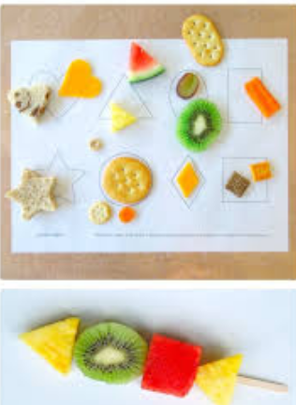

Task 2
See Task 2 English. Using the data you have collected, draw a table to show how many fruits grow in the 4 different seasons. Don’t forget a title and to label the x and y axis.
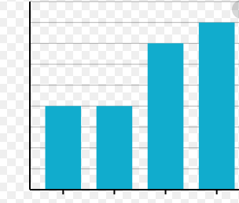
Put your seasons on the x axis and the number of different fruits grown on the y axis.

Task 3
If you have the ingredients, bake something (probably with some help). Make sure you measure the ingredients very carefully! Maybe you could email me a picture of what you made (and let me know if it’s OK to put it on the blog).

Task 4
Look at the use by or best before dates on some of the food in your house. Can you find anything with a date exactly one week away? What about something with a date more than two weeks away? (You’ll need to remember how many days there are in a week.) Can you find anything with a date more than three months away?

Task 5
Set up a food shop in your house, How much will you charge for different foods? How much could I buy if I came in with £10? What change would I get? Maybe other people in your house could come and buy things?

English
Task 1
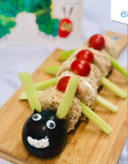
Can you create a set of instructions for making a Hungry Caterpillar sandwich?

Task 2
Fruits grow naturally according to the seasons. Can you research as many foods as you can and sort them into the seasons they grow in?

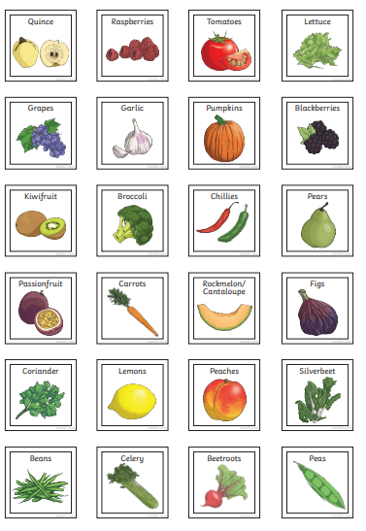

Task 3
Find out about The Potato Famine in Ireland

Task 4 and 5
Create an information text about The Potato Famine.
Include:
When it happened
What blight was
Why it impacted the people so badly
What happened to the people of Ireland during and after the famine

General
Task 1
Using what you have learnt about a balanced diet, design a menu that you can eat either for breakfast, lunch or dinner.

Task 2
Design a healthy eating plate

Task 3
Go onto Linguascope and learn the breakfast foods in French .
Linguascope:
Username – buckden
Password – starfish
French – Beginner – L’alimentation – Le petit déjeuner

Task 4
Design a leaflet or poster to encourage people to eat more healthily.
Make sure you explain why they should eat healthily and give some examples of what they could eat or drink.

