18th May
Dear Whitlock class,
Hello everyone! Thank you for your photos and work and VE day celebrations. I have loved seeing them. Hope you all had a lovely weekend. This week the blog is all about food! I hope you enjoy some of these activities.
I hope you are enjoying writing your daily journals to capture what you are doing at home during this time. Remember to write in your journal:
- How you are feeling
- What you have done. This can be any of the work you have done from the blog and anything that you have done whilst at home.
- What you have enjoyed each day.
I can’t wait to see your journals which will be shared upon our return to school with your classmates!
If you would like to take some photos of your work to show, me you can send them to the school office! I have loved seeing the videos/photos/work that you have been sending in.
Take care and stay safe
Hopefully I will see you all soon
Mrs Tarpey
x
This is a suggestion of how much learning to do over a day with a year 2 child. These slots add up to 2 hours of learning, split into small chunks with breaks. Of course what is important is that you do what works best with your family. The work listed below is more than enough for 5 days of 2hr learning so please choose the tasks that you would prefer to do with your child. Also don’t forget to do some exercise and read every day!
am 20 min | Maths activity
am 20 min | English activity
10:30 | Snack time
am 2 x 20 min | TT Rockstars/Nessy
12:30 | Lunchtime
pm 20 min | Something unfinished from the morning or maybe some art
pm 20 min | An activity from general activities list

Where does food come from?

Maths
Task 1 (1 x 20 min a day)
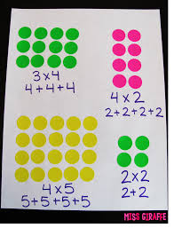
Do you remember what an array is? Look below to remind yourself. Can you use arrays made out of seeds, pasta, sweets, to represent your 3 x tables?
What array would you draw to calculate how many rows of 3 chairs you would need for 24 people to sit down?

Task 2 (1 x 20 min a day)
Make a playdough pizza and see if you can cut it up into halves, quarters and thirds.

Use something to help you work these out. Use anything pasta, stones etc. Remember, to work out a quarter you can draw a square and divide it into 4 equal quarters. Then divide/share your 16 sweets into the equal quarters…how many do you have in one quarter?
- There were 16 sweets in a box. ¼ were blue. How many were blue?
- Pat has 24 crisps. He gives half to his brother. How many did he give away?
- Sam had 28 chips. He gave Jake ¼. How many chips did he give Jake?
- Emma bakes 28 cookies. She eats ¼ of them. How many does she have left?
- There are 15 cup cakes on the table. The dog ate ⅓ of them. How many did the dog eat? How many were left?
- What is ¾ of 12, 24, and 44?

Task 3 (20 min a day)
The following activities are ongoing tasks and should be practised every week at times that would suit you best. You do not need to do them all every day, pick one or two per day.
Number - count in steps of 2, 3, and 5 from 0, and in tens from any number, forwards and backwards
Know number bonds to 20
Times tables - recall and use multiplication and division facts for the 2, 5 and 10 multiplication tables (Try making mini times tables booklets)
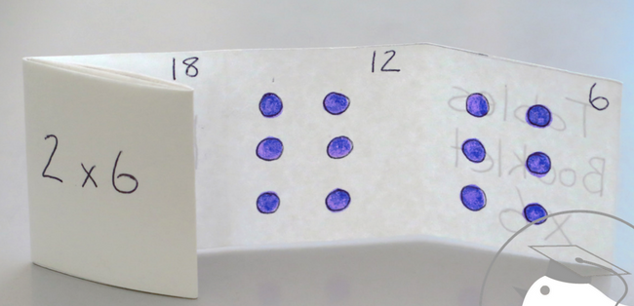
Time - tell and write the time to five minutes, including quarter past/to the hour (on an analogue clock)
Know the number of minutes in an hour and the number of hours in a day.
Money - Recognise different monetary coins, find different combinations of coins that equal the same amounts of money
Measure - measure items in cm/m, kg/g, l/ml

Task 4 (2 x 20 min per week)
TT Rockstars https://ttrockstars.com/

Task 5 (2 x 20 min per week)
Abacus https://www.activelearnprimary.co.uk/login?c=0

English
Remember to read every day
Perhaps you have a food themed book.
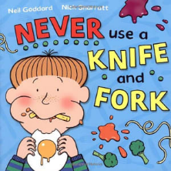
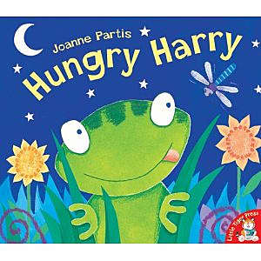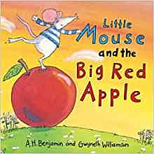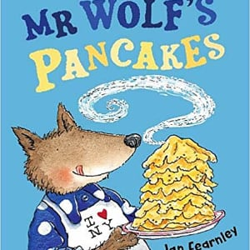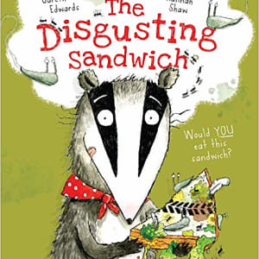
Task 1 (2 x 20 min)
You will need an adult to help you with this. Help to make some biscuits, a cake, a fruit salad (see science and art ideas below as may link) or your lunch. Can you write some instructions to help somebody else make what you made. If you made a jam sandwich, then perhaps the next day you can follow your own instructions to see if they work well!

Task 2 (2 x 20 min)
Read this poem
I Like to Eat!
I like hotdogs
I like beans,
I like eating in my jeans.
I like French fries
I like ham
I like eating in my jams.
I like cookies
I like pie
I like eating in my tie.
I like bagels
I like chocs
I like eating in my socks.
I like pancakes
I like molasses
I like eating in my glasses.
I like veggies
I like fruit
I like eating in my boots.
Can you find the matching rhyming words?

Task 3 (20 min)
Can you write a poem about your favourite foods? You might prefer to write a poem about disgusting foods instead!

Task 4 (if you have a password 2 x 20 min)
Nessy https://www.nessy.com/uk/

Spelling
Recap spelling numbers up to 100 in words.
Make sure you can spell all 7 days of the week.
If you can spell the days then can you spell the 12 months?

PE
Task 1 (10 min each day)
Can you draw an obstacle course in chalk? If you don’t have chalk use what you have e.g.
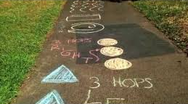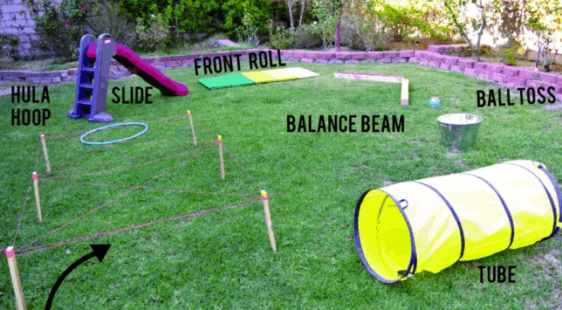

Science
Task 1 (2 x 20 min)
Use a bucket of water and whatever fruit you have to investigate which fruits sink and which fruits float. Keep a record of which fruits float and which sink. What do you notice about the fruits that float? Are they different to the ones that sink? With the help of an adult perhaps you can look inside the fruit to see if there are any clues to why some float and some sink?
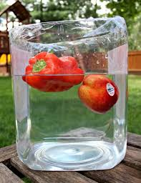
Task 2 (2 x 20 min)
Grow some food. Think about what you know about seeds and how things grow. You can grow things at home without going to buy seeds. Try these ideas below to grow more food from the food you already have.
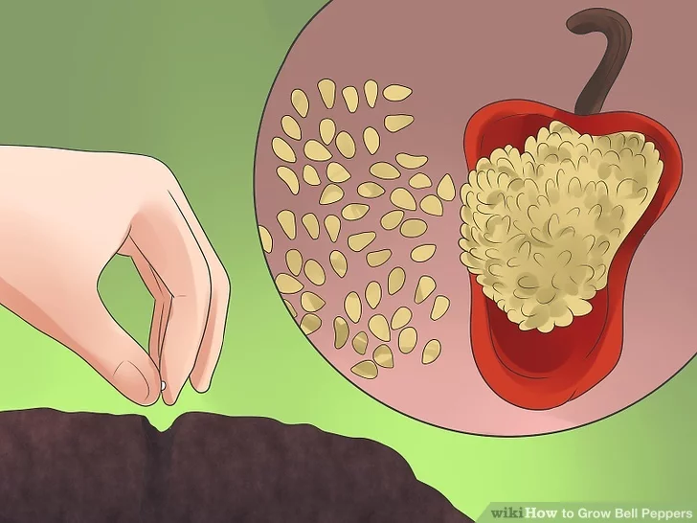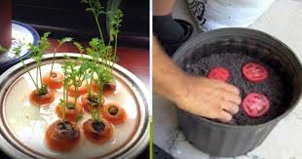
Task 3 (1 x 20 min)
Can you sort some foods into the main food groups? Can you find some meat and fish (protein), bread, cereals, potatoes (carbohydrates), milk butter (dairy), apples, carrots (fruit and vegetables), oil, sweets (fats and sugars)?
Geography
Have a look through your fridge or food cupboard with an adult and find some food that tells you where it comes from. Use Google Earth or an Atlas to try to find out where the country is that the food came from. This is a great opportunity to remind yourself of the 7 continents. Which continent did your food item come from. Do you think it came from a long way away? Do you have any local food in your cupboard. Why do you think some of your food travels a long way?

Art
Task 1 (1x 20 min sessions)
Try some food art
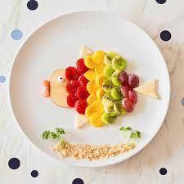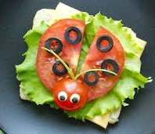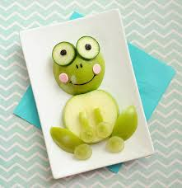
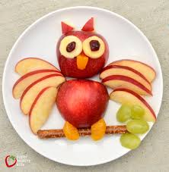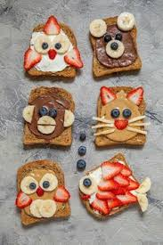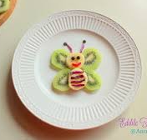
Task 2 ( 3 x 20 min sessions)
Try some art with seeds these are made with pumpkin seeds and sunflower seeds. Did you know that rice and lentils are seeds too!
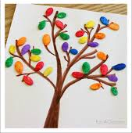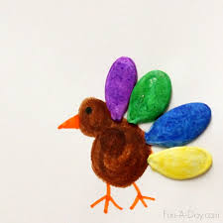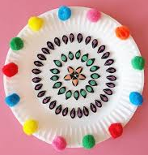

Music
https://www.bbc.co.uk/teach/school-radio/music-ks1-music-food-fest-2-kitchen-sink/z77snrd
This is a website that helps you learn a song about the sounds of kitchen sink. Why not have a go at learning it.
If you would prefer how about making up your own song about the kitchen. You could use some pots and pans as drums to keep the beat.
Listen to the song from Oliver, ‘Food glorious food’

Computing
https://www.rodocodo.com/

