Maths tasks 18th May 2020
Task 1 – adding by making 10 (10 frames) 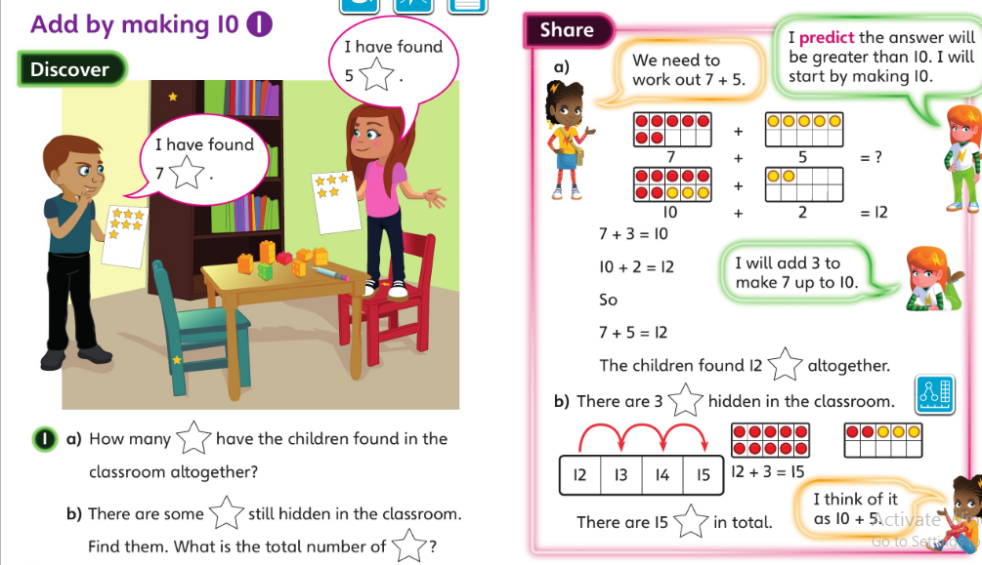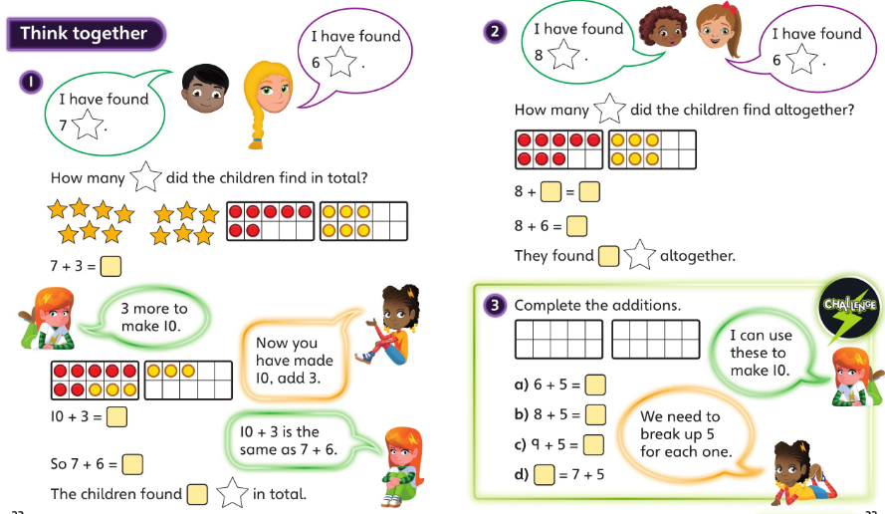
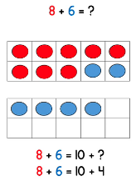
When adding 2 numbers together an efficient method is to make 10 then add on.
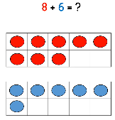
Use 2 10 frames and place each number on a 10 frame.

Then move some counter from the lower number to fill in one of the 10 frames. (see right).
Then it is much easier to add a number onto 10.
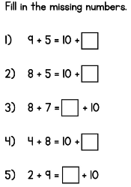
Try this method with lots of single digit numbers that will add up to more than 10. You can create your own.

Task 2 - adding by making 10 (part whole model)
Another way of adding by making 10 is to use a part whole model to help.
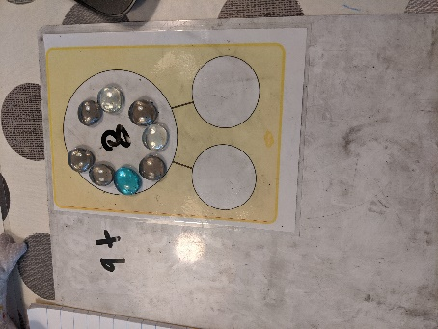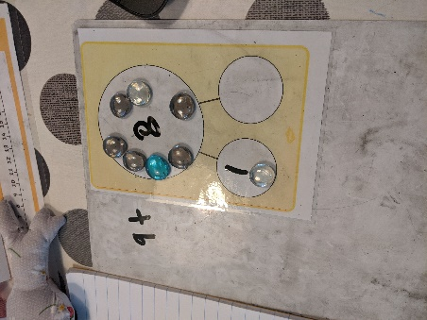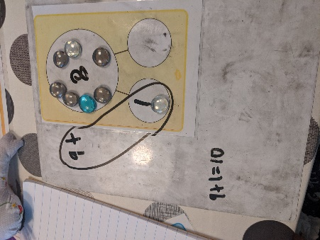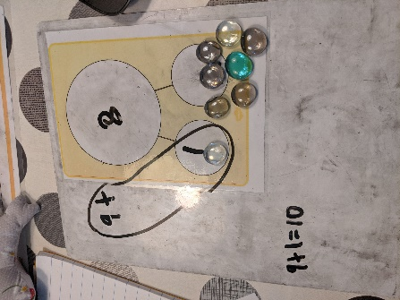
Place counters for the lower number you are adding in the whole. Then using your number bonds to 10 make 10 with the first number and move that amount of counters into one part. You can see above we have circled the numbers that make 10. Then you can see how many counters you have left to go in the other part, in this case 7. Then all you need to do is add 10 and 7.
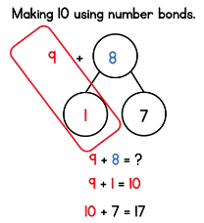
A good video to go through this in steps is White rose https://whiterosemaths.com/homelearning/year-1/ week 4 lesson 1.
This is also a good time to recap adding a single digit number to 10.
We have done this method at school but it is one that not all children have embedded yet.
Task 3- adding by making 10 (numberline)
The next step is to transfer this method into using a number line.

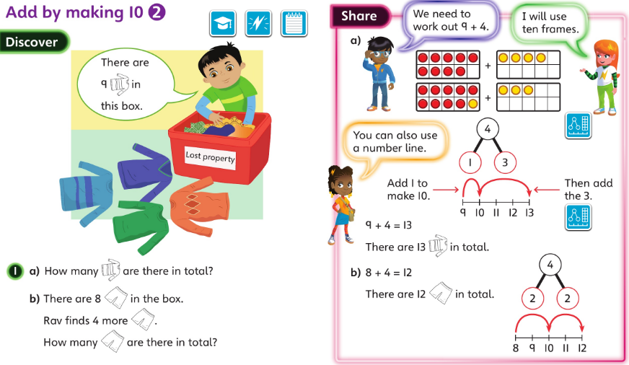
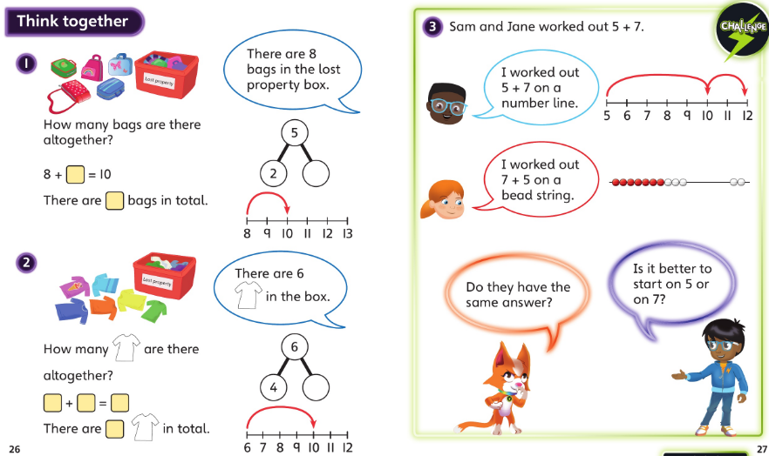
Children might want to use the part whole model along side the numberline especially when they first start using this method or are not completely secure in their number bonds to 10 (if they are not secure in number bonds to 10 this is an important thing to work on).
Try these calculations but working it out on a number line. Circle the first number and then jump to 10. How much was that? Partition the second number and then jump on (maybe in 1s) the amount of the other part to find the answer.

6 + 7 = 9 + 6 = 5 + 8 =
= 7 + 4 8 + 7 = = 9 + 3

Task 4 and 5 – addition problems see next page



