Year 1 English tasks week beginning 11th May 2020
Theme: Food
Task 1
Think of your favourite food. Draw it, or look at the packaging. Then write adjectives around it to describe it:

Gooey mouth-watering

Rich crumbly soft

Delicious sweet melty

Yummy sticky

- Read some poems about food – there are lots of examples on this website but you may need to read these with an adult as some are quite long. https://www.poetry4kids.com/topic/food/page/2/
- Have a go at writing your own poem about your favourite food using the adjectives you came up with.

Task 2/3/4 Imperative verbs & recipes
Remember when we wrote instructions and we looked at ‘bossy verbs’ (imperative verbs) A verb is a 'doing word'. An imperative verb is one that tells someone to do something, so that the sentence it is in becomes an order or command. For example in this sentence:
Fold your clothes up.
the imperative verb is 'fold'.
- Have a go at writing some instructions below. You do not have to print this out it could just be written down on paper.
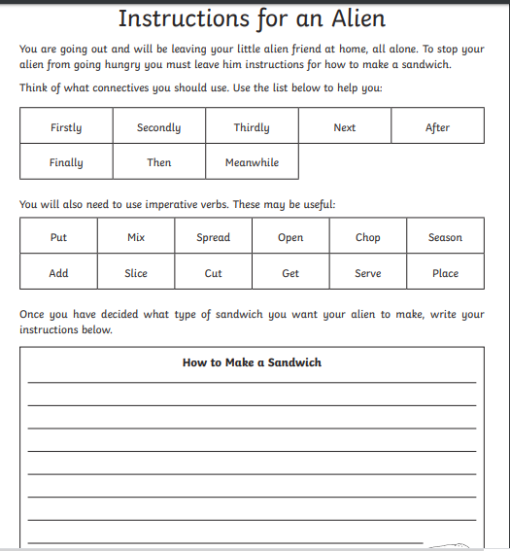

- Now try this one.
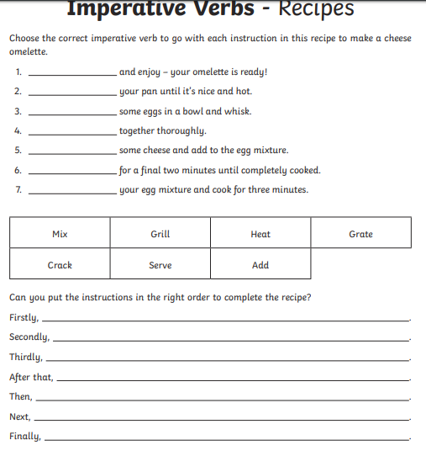
- Once you have put them in the correct order can you have a go (with an adult’s help) at making an omelette?

- Think of some food you have made/helped to make while you have been at home. Use time connectives and imperative (bossy verbs) to write a set of instructions (recipe) to make it. Maybe send it to a friend or family member and see if they can follow it!

Task 5
- Design your own restaurant. This could be in your house or smaller in a shoe box or cereal box! Think about what kind of restaurant it will be: Italian (pizza, pasta) Mexican, Indian, British, bit of everything? All your favourites?
- Write a menu for your restaurant. Under each meal can you write a mini description?


