FOOD
Hi everyone, we hope you and your family are well and staying safe.
Here are some ideas for you to be working on whilst you are at home this week.
Please continue with your daily journal to capture what you are doing at home during this time. In your daily journal you write:
- How you are feeling.
- What you have done. This can be any of the work you have done from the blog and anything that you have done whilst at home.
- What you have enjoyed each day.
Below is a table suggesting how much learning to do over a day with a year 5 child. These slots add up to 4 hours of learning, split into small chunks with breaks. Of course what is important is that you do what works best with your family. The work listed below is more than enough for 5 days of 4hr learning so choose the tasks that you would prefer to do.
Please also ensure that you include some daily physical activity, Joe Wicks uploads a PE lesson on YouTube every day, these are good fun and you can access these when you would like to.
We also expect that you read daily, whether this be a story, magazine, information book or poetry. You can complete AR quizzes using this link: https://ukhosted43.renlearn.co.uk/2152328/default.aspx

am 45 min | Maths activity
am 45 min | English activity
10:30 | Snack time
am 2 x 30min | TT Rockstars/Rodocodo/Nessy
12:30 | Lunchtime
pm 45 min | Something unfinished from the morning or maybe some art
pm 45 min | An activity from general activities list

Maths
Task 1 (45min a day)
Choose an area of maths from the list below, you only need to choose one area a day, you do not need to do all of them every day. Use this time at home to practise some real life math skills. By practising these skills, other areas of maths will become easier for you as well.
Numbers - read, write, order and compare numbers to at least 1 000 000.
You could read some different numbers that you find in books, newspapers. Write the numbers using numerals and words.
Measures - convert between different units of metric measure - kilometre and metre; centimetre and metre; centimetre and millimetre; gram and kilogram; litre and millilitre
Could you measure your garden, Bedroom, kitchen? What if you wanted to plant a new flower bed or build a den in your bedroom, how much space would it take up? How long would it be? If you go out for a daily walk, how fr do you walk in metres? Kilometres?
Could you help in the kitchen to bake or cook dinner? Measure your ingredients carefully.
Times tables - Know multiplication and division facts up to 12 x 12
Money - estimate costs, add and calculate change in £ and p.
Can you calculate the cost of the weekly shop? What about change if you didn’t have the exact amount?
Time - tell the time using analogue, digital, 12 and 24 hour clocks.
Read the clock at different times of the day. What time do you wake up, have lunch, dinner, bedtime? Can you give those times using analogue, digital, 12 and 24 hour clocks.
Read and interpret a variety of time tables including, bus, train and tv guides. What time do your favourite programs start? How long do they last? Could you take a train from St Neots to London? How long is the journey? What time are the trains? etc

Task 2 (2 x 30 min per week)
TT rockstars https://ttrockstars.com/

Task 3 (1 hour)
Maths problem.
1)
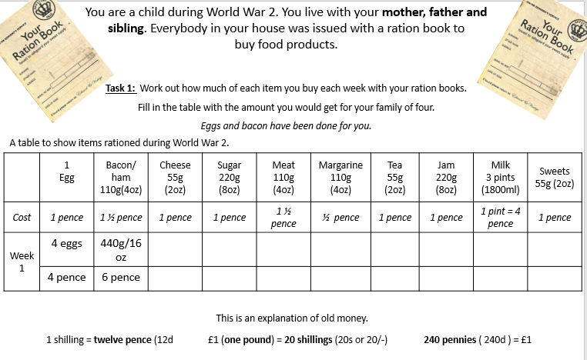
Note: the amount given (weight) of the food in the first row is how much 1 person is allowed. Think about how many people there are that you have to cater for. The example in the first 2 boxes (eggs and bacon) should help you with this.
2) Where possible, can you convert the old money into the money that we use today?
English Task 4 (5x 30 min)
Read every day

Task 5 (1 hour)
- Read the information about the Fairtrade below.
Fairtrade – What’s it all about?

Fairtrade is all about making things fairer for the people in developing countries who grow and harvest the food we eat. It is a global movement which is represented in the UK by the Fairtrade Foundation, whose logo you’ll likely have seen on many supermarket products. When you spot it, it means that the ingredients in the product have been sourced in a way that does not damage the environment, and that all the workers who helped produce the product have been paid fairly and enjoy decent working conditions. As well as paying fair prices, companies that use the Fairtrade mark also contribute towards making life better for the people they are trading with, by giving money for things like schools, water pumps and health clinics – without them having to work their fingers to the bone just to afford bare essentials.

Fairtrade is a response to traditional trading arrangements which can be very unfair. Often, shops and businesses in first world countries such as the UK can take advantage of workers in developing countries who have very little money to put into their community or business, but badly need to sell their product. This means that farmers and other labourers have no say in their own futures, and are often taken advantage of. Long working days, back-breaking labour and poor pay are just a few of the ways workers can be exploited.
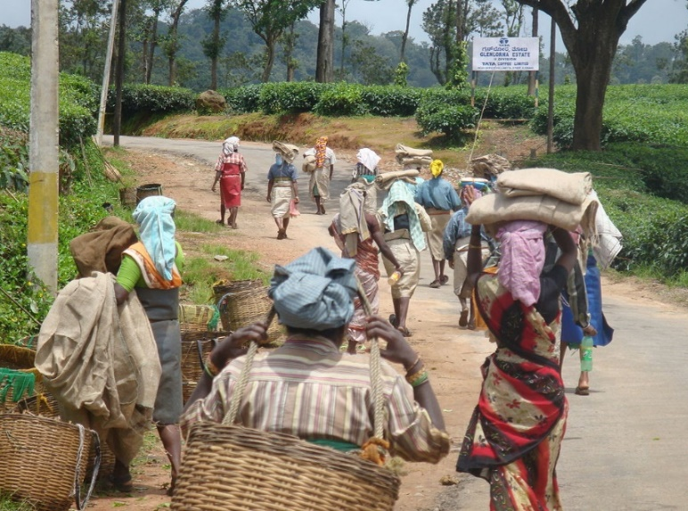
The idea of Fairtrade has been around for a long time. The first ‘Fairtrade’ shop opened in 1958 in the USA, and Oxfam UK started to sell crafts made by Chinese refugees at around the same time. Similar stores began opening around the world, and the big businesses and supermarkets caught on to the idea during the 1990s.

One product you might often see marked as ‘Fairtrade’ is coffee. It is one of the UK’s most popular drinks, and 125 million people around the world depend on its production for their livelihood. It is a sad state of affairs that most of the time, farmers are paid very little for their coffee, despite it being sold for a great deal more afterwards.

With Fairtrade, producers are guaranteed a minimum price for their coffee, which will cover their costs as well as let them invest back into their businesses, improving the quality of their product and the production process. For many workers in developing countries, it means the difference between living in poverty and looking forward to a sustainable future.

Now answer these questions:
1.Name TWO facts about Fairtrade from the first three paragraphs.

2. State TWO reasons Fairtrade is a fairer deal for workers.

3. Highlight all the connective phrases that are used in this article.

4. Write out the sentence which proves that the writer thinks that Fairtrade is a good idea.

5. Describe the problems caused for workers by unscrupulous employers.

6. Highlight and label THREE stylistic techniques that the writer of this
article has used in order to interest the reader.

7. Define the terms ‘consumers’ and ‘developing countries.’ Use each term in a sentence of your own.

Task 6 ( 1 hour)
Write a story with the title: My Lunch is Alive!
Be as creative as you can with it.
- Remember to include speech in your story that helps to move the story on as well as helping the audience know what the characters are like.
- Remember to use modal verbs
- Remember to use punctuation for parenthesis () - ,
- Remember to use a range of punctuation

Science
Task 7 (45 mins)
Watch this short clip: Food needed by the human body
https://www.bbc.co.uk/bitesize/clips/ztr3cdm

- Have a look at some of the food packets in your house and look at the energy information to identify those that have the highest energy. You could create a graph to compare them.
- If you can, research how the energy that is consumed is used during a typical day.

Task 8 (1 hour)
Take a piece of fruit out of your fruit bowl that you think looks most interesting. Cut it in half.
Draw a picture that includes the outside and the inside of the fruit. Look really carefully at the detail.
Add colour by using either, chalk, pastel, colouring pencil or paint. Here are some ideas:



