18.05.20
Good Morning Muhammad Ali,

This week’s theme for our learning is ‘Food’. Make sure you have fun!

Task 1 | AM 20 min | Maths activity
Task 2 | AM 20 min | English activity
10:30 Snack time
Task 3 | AM and PM 2 x 20 min | TT Rockstars/Rodocodo/SPAG
12:30 Lunchtime
Task 4 | PM 20 min | Art activity
Task 5 | PM 20 min | Global learning activity
Task 6 | PM 20 min | French
2:00 Snack time
Task 7 | PM 20 min | Science
Task 8 | PM 20 min | This could be finishing an activity from earlier or an activity from the general list.
Daily journal and reading

Mathematics Task 1 (20 min)
The activities listed below are key Mathematical areas that the children need to practise every week, they do not need to do them all every day, but pick one or two per day. These will be ongoing and you can complete them in any fun ways you can.
Key Mathematical areas;
Number - count in multiples of 6, 7, 9, 25 and 1000
Times tables recall multiplication and division facts for multiplication tables up to 12 × 12
Measures - Convert between different units of measure - kilometre to metre; hour to minute]
Money - estimate costs, compare costs and calculate amounts in £ and p
Time - read, write and convert time between analogue and digital 12- and 24-hour clocks
convert from hours to minutes; minutes to seconds; years to months; weeks to days.

Abacus - The children can access this resource via the website https://www.activelearnprimary.co.uk
The password is year 4 and the school code kmm7 in the bottom box.

Activity 1 – Make sure you are practising your timestables as much as you can. https://www.timestables.co.uk/ https://www.topmarks.co.uk/maths-games/7-11-years/times-tables

Activity 2 – Can you make your own pizza or a plate of food and use your fraction knowledge and divide your toppings or food types into fractions. For example – I would like 9 toppings please, 1/3 Mushroom, 1/3 Ham and 1/3 Pineapple. Make as many different fraction examples as you can. You could record this written or by drawing.
https://www.twinkl.co.uk/resource/tg-ga-177-pizza-fractions-2-extra-toppings-game
Activity 3 – 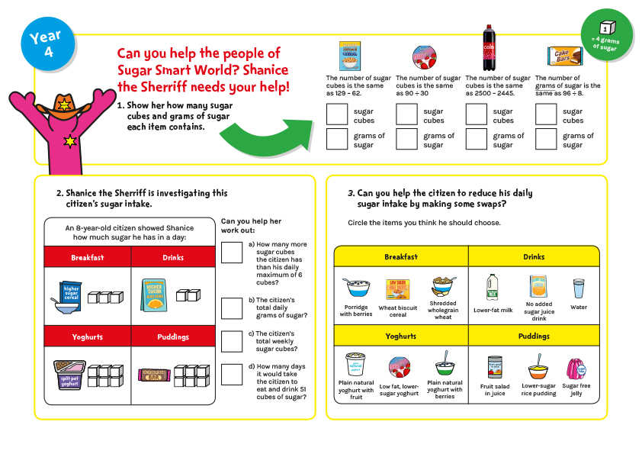

Activity 4 –
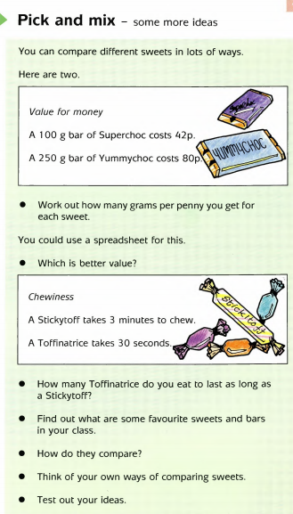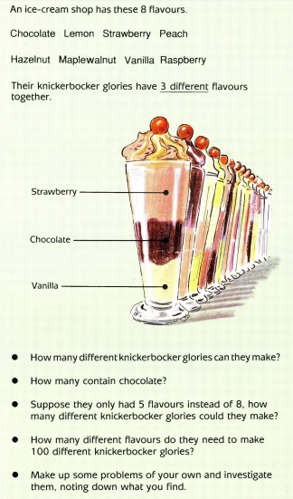

Activity 5 –
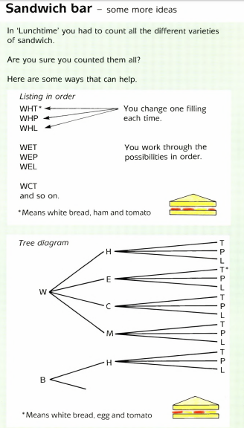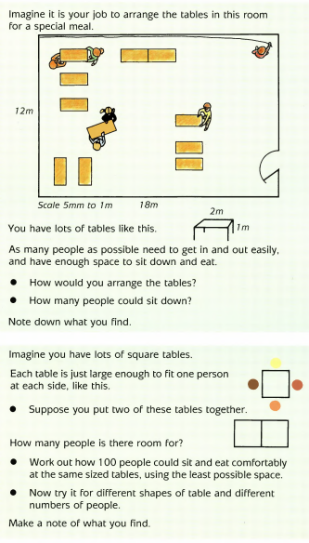

English Task 2 (20 min)
Activity 1 - Please see ‘Middle ages’ comprehension sheets below.
Activity 2 - Read the castle fact sheets attached below and write your own castle fact sheet.
Activity 3 – Answer the questions under the facts on the ‘fairer trader’ discussion cards.

Activity 4 – Read the ‘Foods and their uses’ sheet attached. Now sort what you know into a table.
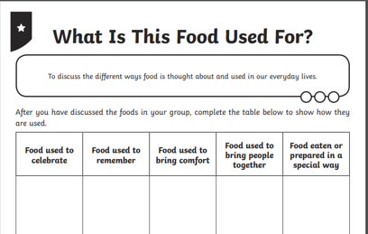
Activity 5 – Use the ‘Kosher’ food hints sheet attached and prepare a presentation for the people at home to tell them what you have learnt.
Reading
Remember to read EVERYDAY.
The Accelerated Reader (AR) programme is also accessible from home during this time too, so once you’ve finished your books make sure you log on and take a quiz. https://ukhosted43.renlearn.co.uk/2152328/default.aspx
Nessy - https://www.nessy.com/uk/
Task 3 (20 min)
Time Tables Rock Star - https://play.ttrockstars.com/auth/school/student/76329
Rodocodo - https://game.rodocodo.com/
SPAG - https://www.topmarks.co.uk/english-games/7-11-years/spelling-and-grammar https://www.bbc.co.uk/bitesize/topics/zhrrd2p
Art/DT Task 4 (20 min)
Create a family portrait, make sure you think about the features of your face and where they are on your face with correct proportions.
How to draw a face - https://www.youtube.com/watch?v=yyfPULeQhPo
How to draw an eye - https://www.youtube.com/watch?v=wpZzbAeVxAE
How to draw a nose - https://www.youtube.com/watch?v=8VNmEnj8UiQ

Global learning Task 5 (20 min)
Research what food they ate in the middle ages and design a dinner party. See if you can create this dinner party at home and cook your ideal Middle Aged menu.
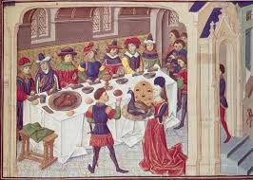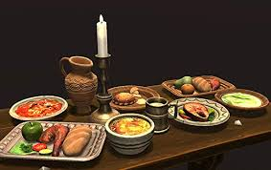
Draw and label the Flags of all of the European countries. Challenge yourself to find them in the Atlas too.
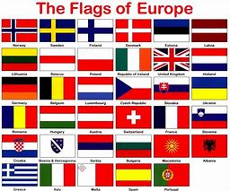

Task 6 (20 min) French - (Log in – Username - Buckden Password – Starfish)
https://www.linguascope.com/
Design a French food menu. Don’t forget to add images and find out about traditional French foods. Have a look to see if you have an traditional French foods at home, see if you can taste them.
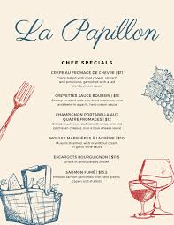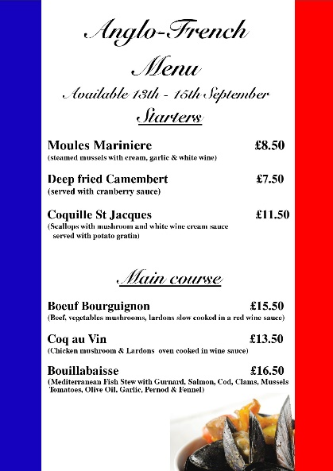
Science Task 7 (20 min)
Recap what we have learnt about the digestive system. Design a poster or a 3D model of the digestive system. Don’t forget to label each part and explain its function.
Use things from around your home and create your own digestive system using objects to represent each stage.
https://www.youtube.com/watch?v=Qsa2auNfc34
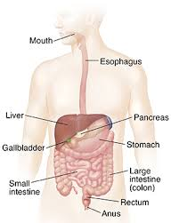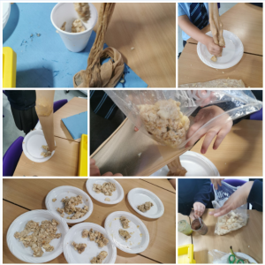
Create an animal food chain, remember to label to producers and consumers. Extend your learning and think about predators and prey too.
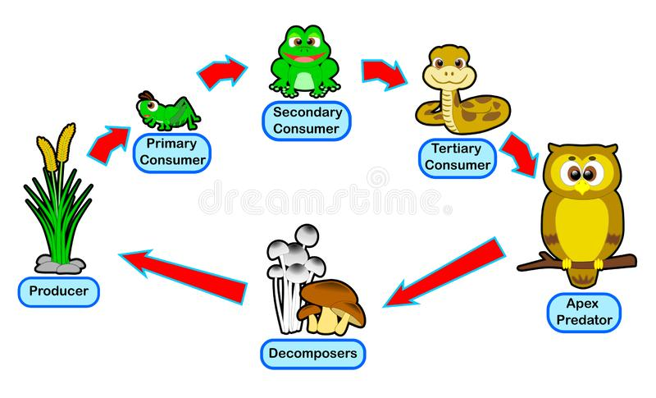

General activities
Remember to keep active!
- Yoga
- PE - Join Joe Wicks for a PE lesson. He is on YouTube every weekday.
https://www.youtube.com/watch?v=lEWcBIvqjDk
- Touchtyping - https://www.bbc.co.uk/bitesize/topics/zf2f9j6/articles/z3c6tfr
- Coding - https://scratch.mit.edu/
- Get in touch with a friend or family member
- Be mindful, teach someone at home how to do a brain break.
- https://www.skulduggerypleasant.co.uk/books/
- https://www.anglianwater.co.uk/in-the-community/schools/learning-at-home/
- https://shaunthesheep.com/games/sustainable-shaun
Get creative with food;
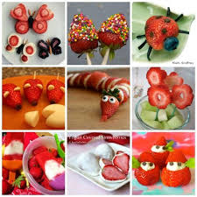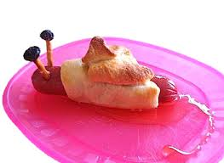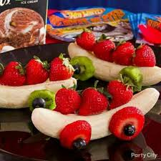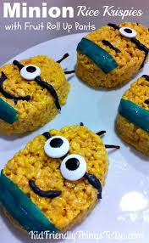
Make a tin can bowling alley;
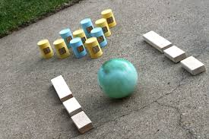
In your journal you write:
- How you are feeling,
- What you have done (this can be any of the work you have done from the blog and anything that you have done whilst at home),
- What you have enjoyed each day.

