Maths tasks 11th May
Task 1- Number bonds
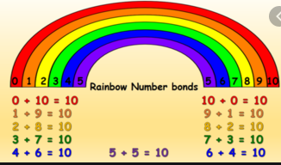
Knowing and being able to manipulate number bonds is incredibly important so spend the day playing with number bonds to 10 and to 20. (and follow up these activities whenever you get a chance.
Try making your own number bond rainbow and write the addition facts underneath.

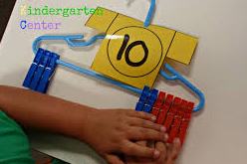

Use a coat hanger with 10 pegs on. Slide the pegs along to find out all the number bonds you can. Write the calculations down as you find them.
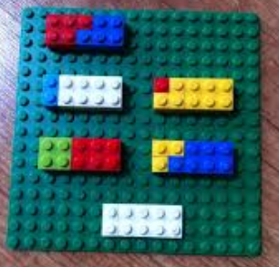
Use lego to make number bonds to 10 or 20
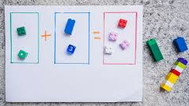
Create number bond calculations using a grid like this. You could write down ones you found in your book.
There are also lots of worksheets you can access on Twinkl.
https://www.topmarks.co.uk/maths-games/hit-the-button
https://www.bbc.co.uk/bitesize/articles/zh8m6v4

Task 2- Fact families
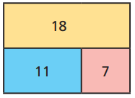
Fact families are a group of math facts using the same numbers. Bar models and part whole models are great for learning how these work.
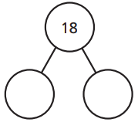
Bar model Part whole model

These models show the following fact family
11+7=18 7+11=18 18-7=11 18-11=7
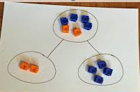
Try making your own bar model or part whole model (or both) and create fact families. You could do this in your books, or be creative and draw some colourful ones, use chalk pens on the window or chalk outside on the floor.
You can also use object within your models to help you.
https://www.topmarks.co.uk/number-facts/number-fact-families
https://www.bbc.co.uk/bitesize/articles/zkd98xs

Task 3 – adding together to find a part
Use the part whole model to add together 2 numbers.
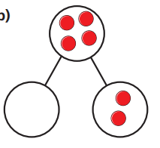
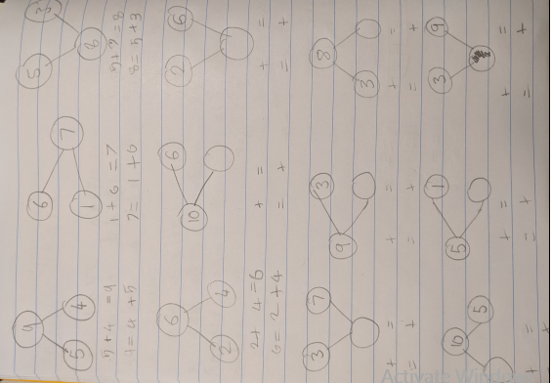
To do this we had a part whole model and some glass beads so we could physically put the beads inn the correct part (or whole). Then I drew some part whole models in Jemimas book and filled them out with 1 missing number, sometimes a part sometimes the whole. Jemima used the glass beads on the part whole model to work out what the missing number was and then write the calculation underneath. She wrote it in two ways 2 + 2 = 4 and 4 = 2 + 2. This is important because it often confuses them when it starts with the whole.
https://www.ictgames.com/mobilePage/partPartWhole/index.html
https://www.bbc.co.uk/bitesize/articles/zvk7mfr

Task 4 - Add more and count on within 20
An important skill we have been teaching the children is adding on when adding numbers, not starting at 1 each time. This is a good time to make a number line.
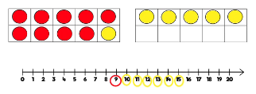
9 + 6
Start at the 9 and then add on 6.
Also talk about starting at the greatest number.

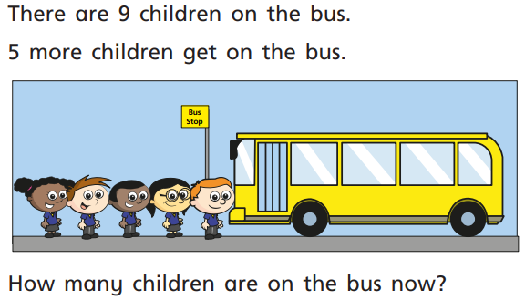

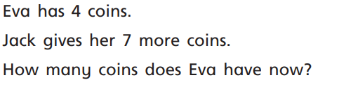
https://www.topmarks.co.uk/addition/robot-addition
Task 5 –
https://www.bbc.co.uk/bitesize/articles/zbpbrj6 BBC bitesize lesson with link to activities.
See activity cards on blog.

