Year 1 English tasks week beginning 11th May 2020
Theme: Space
https://www.bbc.co.uk/bitesize/topics/zwccwmn/articles/zqbxb82
https://www.bbc.co.uk/bitesize/topics/zdrrd2p/articles/ztsqj6f
Have a watch of is these videos about planets before doing the space themed tasks this week.
Task 1:
Think back to when we read the book Beegu, By Alexis Deacon. Beegu is an alien who visited the planet Earth!
- Design a new planet for Beegu to visit next.
How is it the same or different to Earth? Maybe the land is purple and the water is red? Perhaps it is very hot, or extremely cold? Draw a picture of your planet with what it looks like from space (as a round sphere shape). Remember to give your planet a name!
- When you’re done: Use some comparison words that end with the suffixes ‘est’ ‘er’
Example: My planet is bigger than earth but is not the biggest planet in the solar system. My planet has the greenest water, with fish that are much smaller than on Earth.
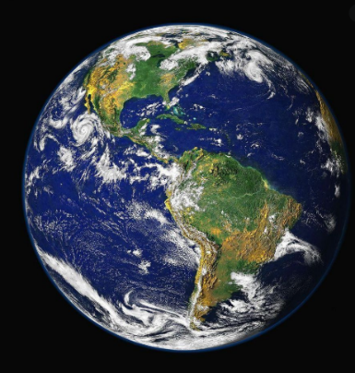
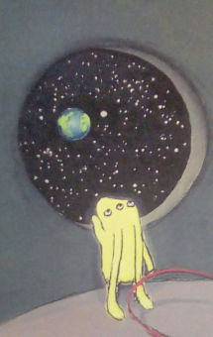

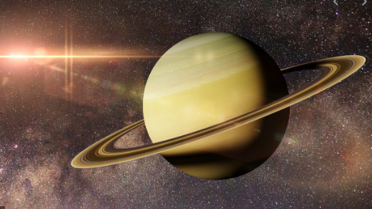

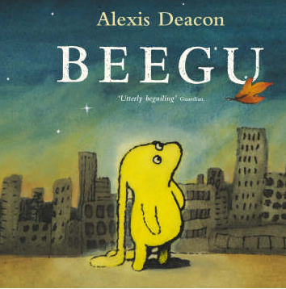

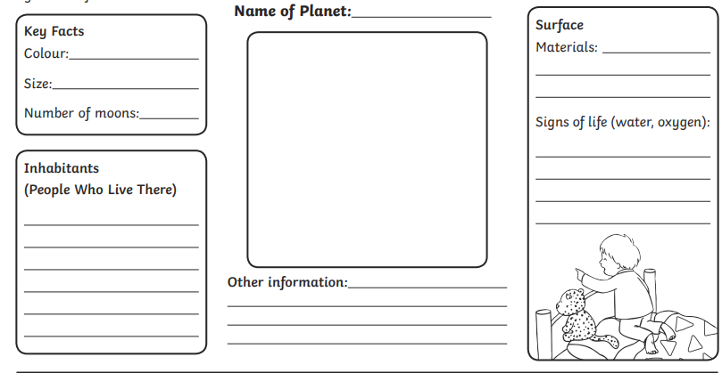
Task 2:
Now you have designed a new planet for Beegu to visit, time to think about describing it!
- Draw the landscape of your planet. (This means what it would look like if you were standing on the ground of that place.
What sorts of things will Beegu see when visiting? Does it look like a desert, with not many trees/plants? Or does it look similar to a rainforest with strange animals around? Is it so cold it looks frozen, but the ice is a different colour to on Earth?
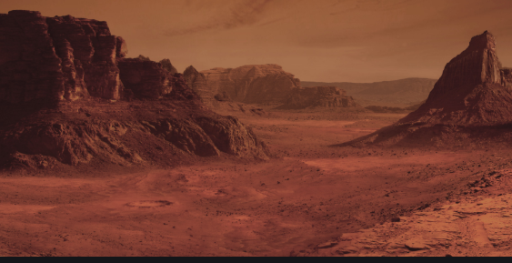
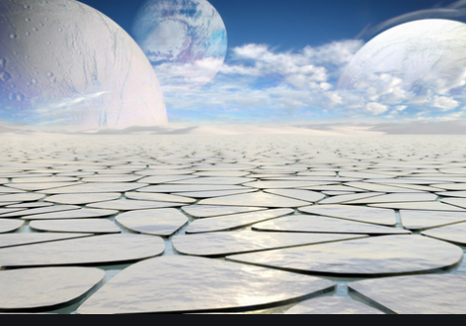
- Think about the different parts of your planet and write a short ‘fact file’ about it. 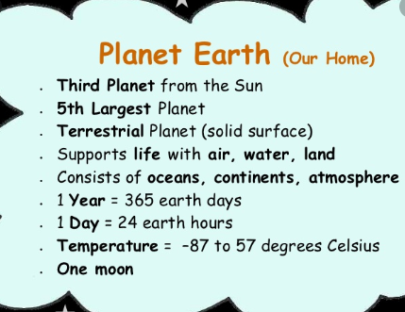

Task 3/4
Now you have a brand new planet, you need to persuade Beegu, her family and friends to visit it! This means you want to talk about how interesting, different, exciting and great this place is and most importantly WHY she should visit?
- Write a short letter to Beegu explaining why she needs to visit this planet. To help you plan maybe write down a list of all the interesting things your planet has and use this by picking a few to write about in the letter.
Example:
To Beegu,
I am writing to tell you about this amazing new planet called Sugarton. It is so brilliant, you and your family just HAVE to visit. The sky is purple and the wind smells like popcorn! Instead of water there are rivers and lakes of liquid chocolate which tastes delicious. Instead of trees having leaves they are covered in Candyfloss, which floats around in the sweet smelling wind. You can even catch it and eat it!
You should really go and visit this planet because everything is so yummy to eat. Also the people who live there are very friendly!
From Mrs Sandham

Task 4 Make an Alien for your planet by playing this game:
Each player starts with a piece of paper and a drawing tool and sits so that his or her drawing is somewhat hidden from the person in the next seat. The element of surprise at the end is half the fun!
2. Each person draws a head and neck. This can look like anything as it’s YOUR alien! Fold the top of the paper down to hide your drawing, letting only the bottom of the neck show. Hand the drawing to the other person.
3. Next each person draws the body and arms, using the neck lines as the beginning point. Again, fold the paper down to hide your drawing, letting just the bottom of the waist line show. Hand the drawing to the next person.
4. Draw from the waist to the knees. Fold the paper down, and pass to the left.
5. Draw from the knees to the feet. Fold the paper and pass again. (Note :: Sometimes we just draw from the waist all the way down to the feet, especially with younger kids.)

Open up your paper to reveal your alien!

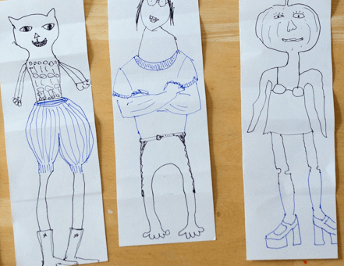
- Give your Alien a name and write a sentence about what happens when Beegu meets them!
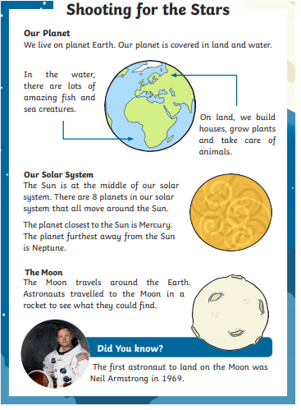
Task 5 Read this information about the planets and answer some questions.



