11/05/20
Hello Simone Biles,
Our theme for this week is Space. I’ve already received a few pieces of work and piccies of your practical activities. It’s been lovely to see your hard work. Don’t forget to write your thoughts and reflections in your journals so that we can share the things that have kept us entertained these last few weeks. I hope you had an opportunity to have a picnic or do something special for VE Day on Friday. We had a picnic, and our neighbours came outside too (though we all stayed apart from each other of course). It was a lovely day, and Mrs Mayes’ scones were delicious!
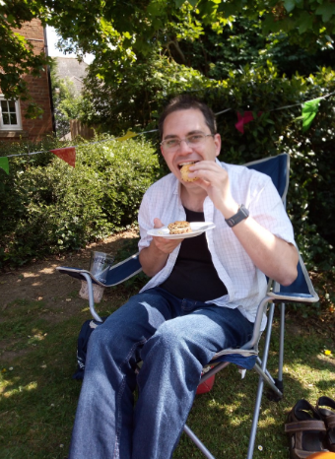
Stay safe everyone,
Mr B
Back to our learning. This is a suggestion of how much learning to do over the day. These slots add up to 2½ hours of learning split into small chunks with breaks. It would also be good to ensure you fit in some active time; many children are enjoying Joe Wicks live on YouTube at 9am (though you can always watch the video later in the day).
The work listed below is more than enough for this suggested timetable so only choose the tasks that you would prefer to do.
am 20 min | Maths activity
am 20 min | English activity
10:30 approx | Snack time
am 30 min | TT Rockstars / Rodocodo / Nessy / BBC bitesize / Topmarks / etc
am 20 min | Reading  AR quizzes can be done between 08:45 and 15:15 at this exact website  https://ukhosted43.renlearn.co.uk/2152328/default.aspx
12:30 | Lunchtime
pm 30 min | Activity of child’s choice, ideally something creative. This would be a great time to do something together, or if there are siblings for them to work together on something.
pm 30 min | An activity from general activities list

Maths
Please can you practise the following skills on a daily basis. Choose only one or two to practise each day:
Number - count from 0 in multiples of 4, 8, 50 and 100
Times tables - recall and use multiplication and division facts for the 3, 4 and 8 multiplication tables
Measures - measure items in m/cm/mm kg/g ml/l

Money - add and subtract amounts of money to give change,

Time - tell and write the time from an analogue clock, including 12-hour and 24-hour clocks
know the number of seconds in a minute and the number of days in each month, year and leap year

REMEMBER, THE FOLLOWING TASKS ARE A SUGGESTED LIST AND WE ARE NOT EXPECTING YOU TO TRY AND COMPLETE ALL OF THEM.

Task 1
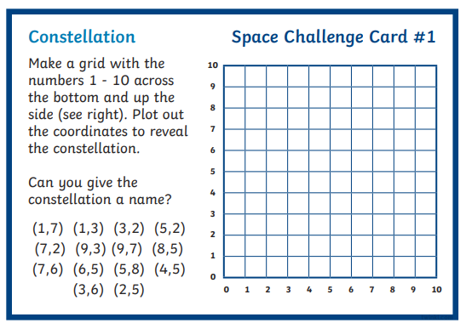

Task 2
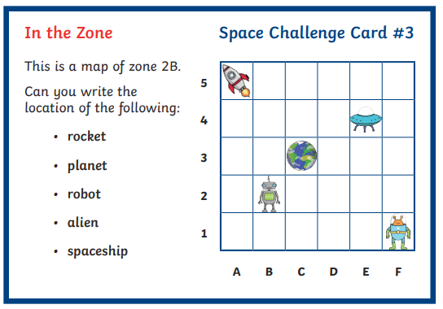

Task 3
Play a game of ‘Alien Battleships’.
Create a grid each similar to the one below. Decide on the number of spaces you are going to fill. Add your aliens and space objects in wherever you want. Then take it in turn to call out a set of coordinates to try and locate all of your partner’s aliens. The winner is the first person to locate them all.
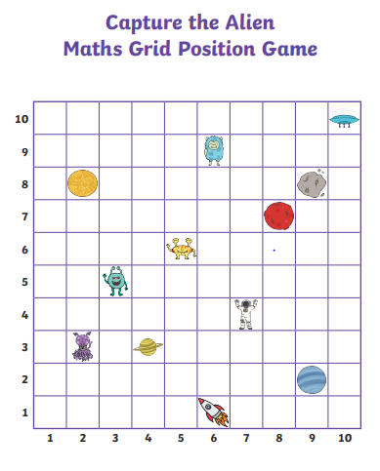
Task 4
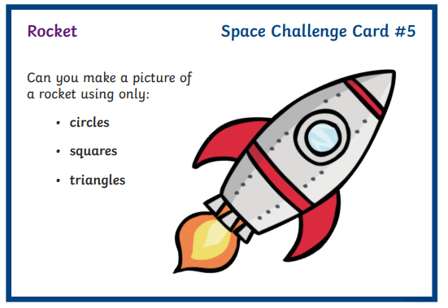

English
Task 1
Research the planets in our solar system. How many are there? Can you name them? Now choose one and write a detailed report on it (Do this over 2 days. You could create a mind map on Day 1 and then write your report on Day 2).

Task 2
See above

Task 3
One of the skills we have been learning about in Year 3 is the importance of editing our work. Your third task is to go back and read your report again. Check it makes sense. Have you remembered to use capital letters and full stops? Have you used headings and sub-headings? Pictures? Can you improve your word choices? Is your handwriting neat enough to read? Go back and make any corrections that will improve your writing.

Task 4
From the research and detailed report you wrote, can you pick out adjectives/words that paint a picture of what your planet is like? Write them down.

Task 5
Using the words from yesterday, can you write a poem about your chosen planet?

General ideas:
Task 1
This project can be done over the course of the week.
Making a papier maché planet/solar system
You will need:
• Lots of Newspaper
• white glue
• Water
• Bowl (for the watery glue)
• 1 balloon per planet to be made
• Paints and paintbrushes once they are dry

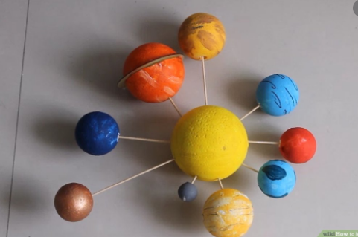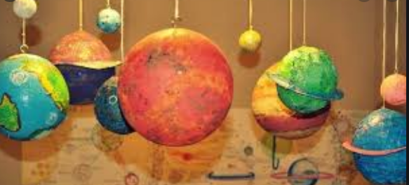

Instructions:
1. Cover your work surface with newspaper or a protective cover and yourself with an old shirt or an apron – this is going to get messy!
2. In a bowl, mix glue with water so it is the consistency of runny yoghurt.
3. Cut the newspaper into strips roughly around 5cm x 10cm as a guide – they don’t need to be accurate.
4. Blow up a balloon to the size that you want your planet and tie the end.
5. Now cover your balloon in a first layer of papier-mache by dipping a piece of paper into the watery glue mix, wiping off the excess mixture and then laying onto your balloon. Make sure that the pieces of paper overlap and you only put the first two layers on.
6. Leave to dry
7. Repeat steps 5 and 6 until you are happy with your planet structure and leave to dry. The more layers you put on, the sturdier your planet will be.
8. If you are making Saturn or Uranus, you will want to add a ring to your structure. Do this by cutting out a large circle of card the size of the outside of the rings (you can tape smaller pieces together). Now cut a hole in the middle, so that your papier-mache balloon slots inside. Use masking tape to attach the ring to the planet and then cover the ring in two layers of papier-mache. (Don’t do too many layers or it will be too heavy.)
9. When fully dry, use the scissors to cut the tail of the balloon off so it deflates and you can remove it from the middle, leaving your perfect, papier-mache planet.
10. Paint your planet. You may want to start with a base layer and you may need to do research if you want an accurate representation of a particular planet.

Task 2
Go out and look at the night sky with an adult. Can you find any of the constellations in the sky? Can you locate any planets? For those of you who have access to a telescope, what can you see?

Task 3
Identify one or two different constellations and draw or create a picture of it.
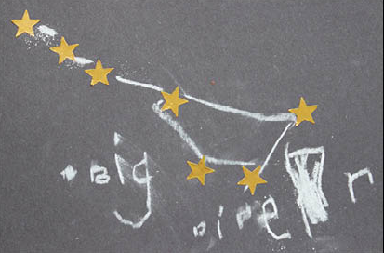

This is The Big dipper or The Plough of the constellation Ursa Major.

Task 4
Find out about these first things:
- The first satellite humans sent to space
- The first animal in space
- The first person to go into space
- The first mission to go to the moon

