11th May
Dear Whitlock class,
Hello everyone! It was lovely to catch up with everyone on the phone this week and to hear all about what you have been doing. This week the blog is all about Space! I hope you enjoy some of these activities.
I hope you are enjoying writing your daily journals to capture what you are doing at home during this time. Remember to write in your journal:
- How you are feeling
- What you have done. This can be any of the work you have done from the blog and anything that you have done whilst at home.
- What you have enjoyed each day.
I can’t wait to see your journals which will be shared upon our return to school with your classmates!
If you would like to take some photos of your work to show, me you can send them to the school office! I have loved seeing the videos/photos/work that you have been sending in.
Take care and stay safe
Hopefully I will see you all soon
Mrs Tarpey
x
This is a suggestion of how much learning to do over a day with a year 2 child. These slots add up to 2 hours of learning, split into small chunks with breaks. Of course what is important is that you do what works best with your family. The work listed below is more than enough for 5 days of 2hr learning so please choose the tasks that you would prefer to do with your child. Also don’t forget to do some exercise and read every day!
am 20 min | Maths activity
am 20 min | English activity
10:30 | Snack time
am 2 x 20 min | TT Rockstars/Nessy
12:30 | Lunchtime
pm 20 min | Something unfinished from the morning or maybe some art
pm 20 min | An activity from general activities list

Is space important?

Maths
Task 1
Recap on what a vertex, edge and face is on a 3D shape.
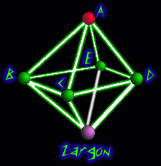
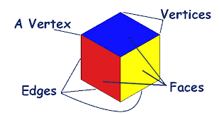
In the planet system of Octa the planets are arranged in the shape of an octahedron. The major space routes follow the edges of this shape. How many different routes could be taken to get from Planet A to Planet Zargon, without visiting any planet more than once. To make this easier to visualise you could make this model out of straws and blutack/playdough/sticks/marshmallows and spaghetti. I think you will need to write down all of your ideas to keep a list of your thoughts.

Task 2 (1 x 20 min a day)
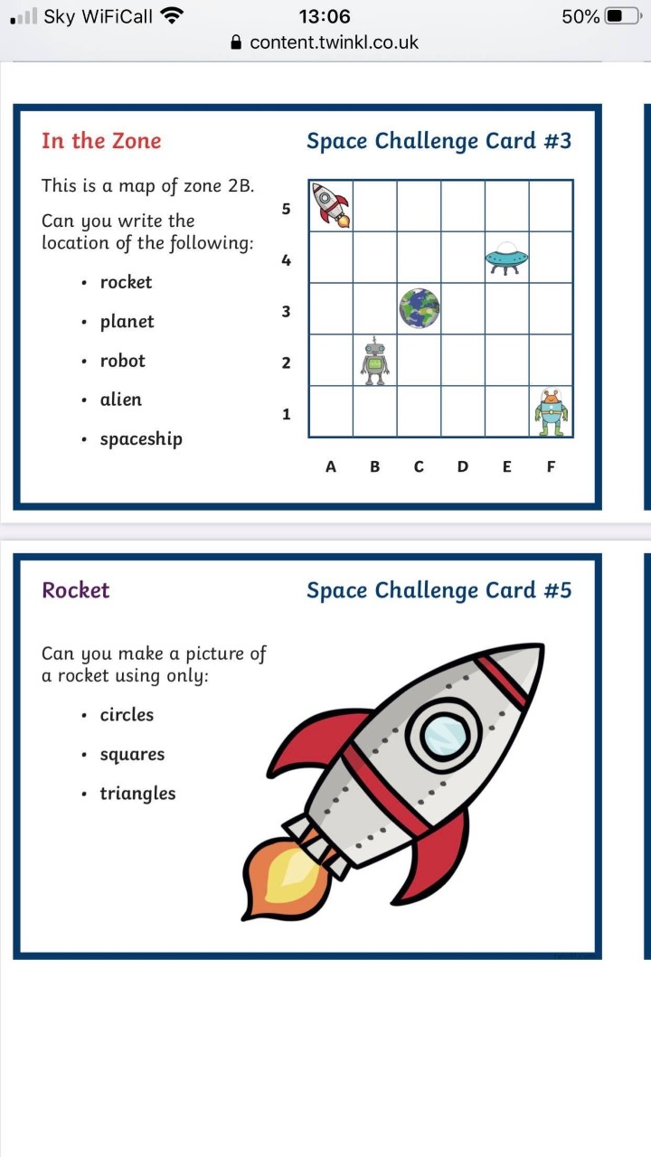

Task 3 (20 min a day)
The following activities are ongoing tasks and should be practised every week at times that would suit you best. You do not need to do them all every day, pick one or two per day.
Number - count in steps of 2, 3, and 5 from 0, and in tens from any number, forwards and backwards
Know number bonds to 20
Times tables - recall and use multiplication and division facts for the 2, 5 and 10 multiplication tables
Time - tell and write the time to five minutes, including quarter past/to the hour (on an analogue clock)
Know the number of minutes in an hour and the number of hours in a day.
Money - Recognise different monetary coins, find different combinations of coins that equal the same amounts of money
Measure - measure items in cm/m, kg/g, l/ml

Task 4 (2 x 20 min per week)
TT Rockstars https://ttrockstars.com/

Task 5 (2 x 20 min per week)
Abacus https://www.activelearnprimary.co.uk/login?c=0

English
Remember to read every day
Perhaps you have a space themed book.
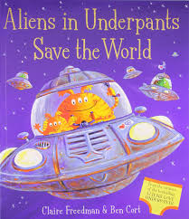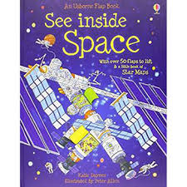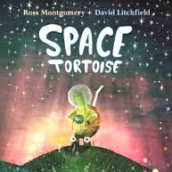
Task 1 (20 min)
Draw a picture of all of the planets in our solar system and include the Sun. Make a model if you prefer. Can you label them all correctly? Can you make up a sentence to remember the order they are in? For example,
Mercury | My | Many | My | Mother
Venus | Very | Very | Vicious | Veronica
Earth | Educated | Elderly | Earthworm | Enjoyed
Mars | Mother | Men | Might | My
Jupiter | Just | Just | Just | Jam
Saturn | Served | Snooze | Swallow | Sandwich
Uranus | Us | Under | Us | Under
Neptune | Nachos / Noodles | Newspapers | Now | Neptune

Task 2 (2 x 20 min)
Do some research on the planets in our solar system. Things that you might consider would be: How big is it? Does it have a moon or moons? Does it have rings? Does it have a colour? Is the planet made of rock or gas?
You could collect your facts and put them into a fact sheet.
I have attached a fact sheet if you would like to use it.

Task 3 (20 min)
Who was Neil Armstrong? Interview an adult, read a book or find a good website with the help of an adult to find out why Neil Armstrong is famous. https://www.natgeokids.com/uk/discover/science/space/neil-armstrong-facts/
I have attached a fact sheet/cartoon below to help.
Write a paragraph to explain who Neil Armstrong was and what he did in his life?

Task 4 (if you have a password 2 x 20 min)
Nessy https://www.nessy.com/uk/

Spelling
- Recap spelling numbers to twenty in words.

Can you now spell numbers up to 100 in words?
What can you remember from last week?

PE
Task 1 (10 min each day)
Find some balls to be the planets in our solar system. Can you make up an obstacle course where you have to do a different activity with each ball or planet. For example, when you get to Mars you have to throw the ball in the air and catch 10 times and when you reach Saturn you need to run and orbit the Sun 5 times.

Science
Task 1 (2 x 20 min)
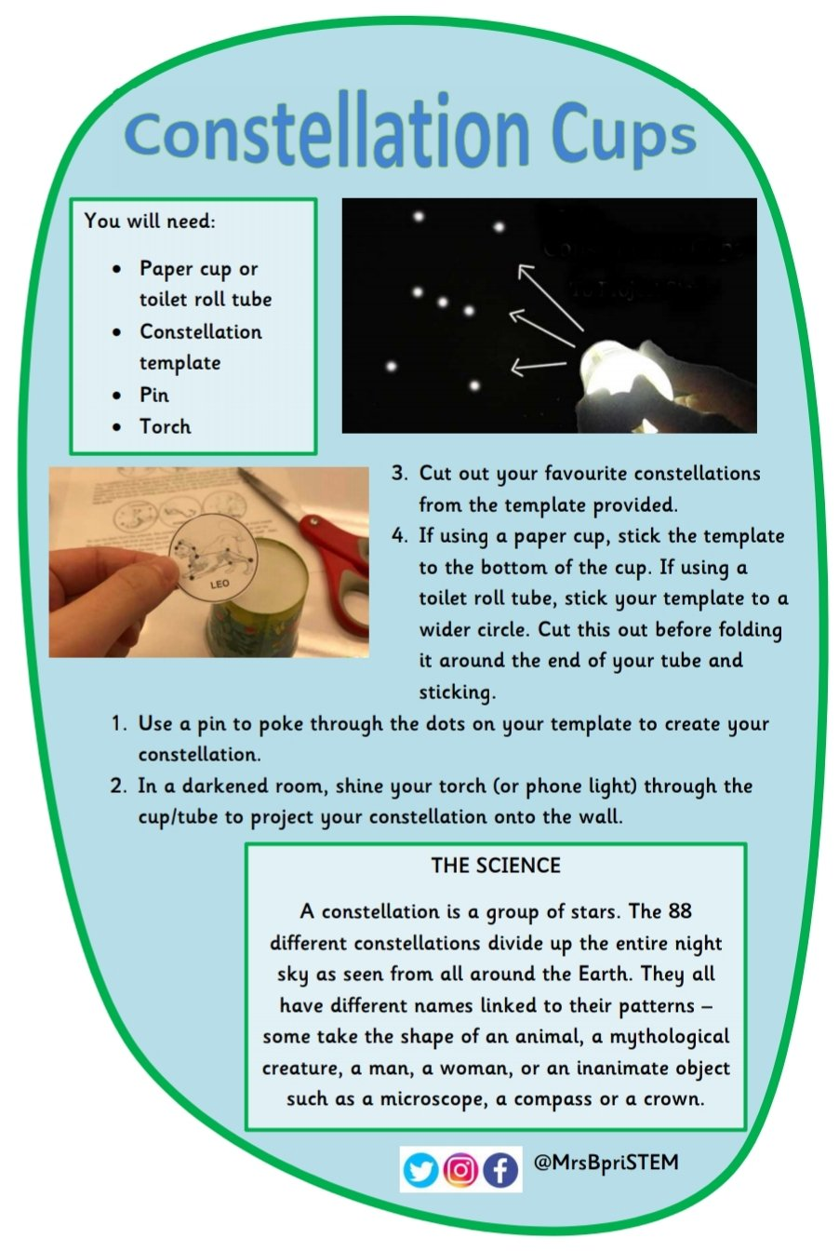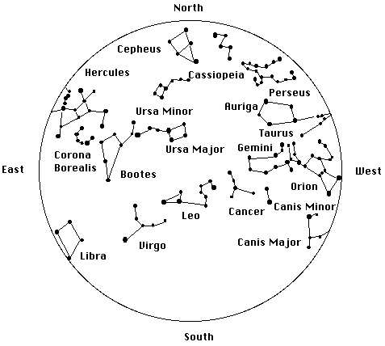
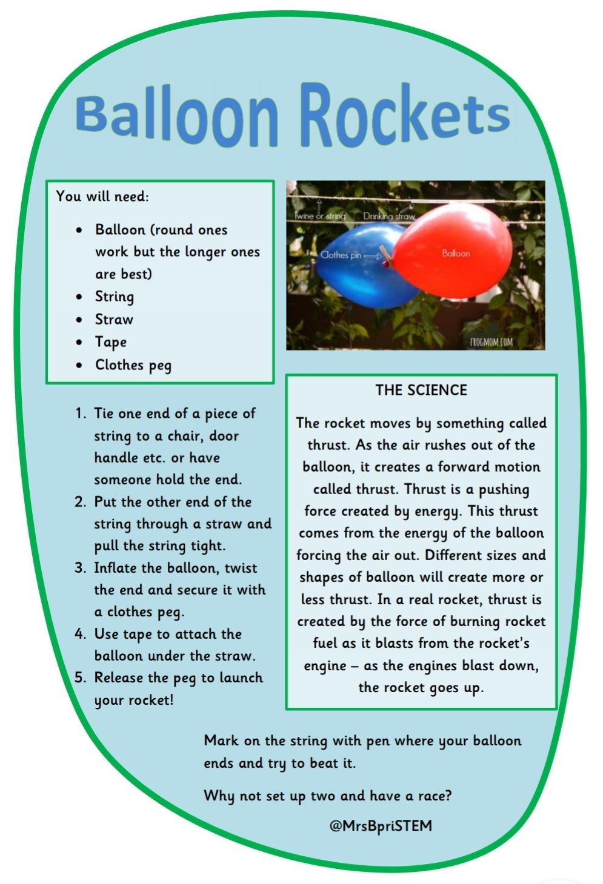
Art
Task 1 (many 20 min sessions)
Using what you know about planets can you now design your own planet? You will have lots of decisions to make. You can choose how would like to present your work. You could draw your planet and colour it with whatever materials you have (coloured pencils, pastels, paints, chalks, collage using scrap paper/magazines. If you are feeling ambitious you could make a papier mache model around a balloon. https://www.instructables.com/id/Papier-Mache-Planets/
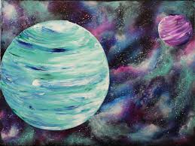

Task 2 ( 3 x 20 min sessions)
Design and make your own alien or space rocket
Make a junk model, draw a picture, make out of salt dough or play dough.
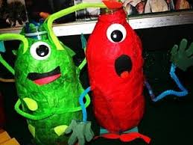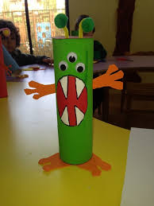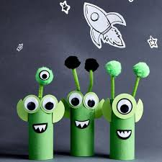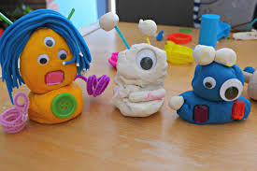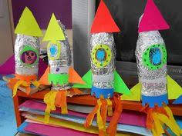

Task 3 (1 x 20 min session)
Constellation art
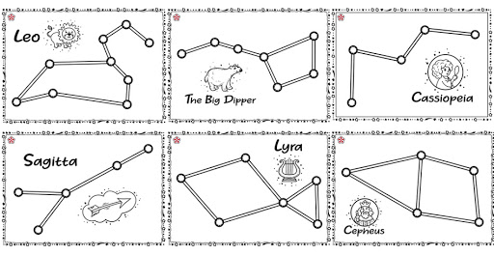
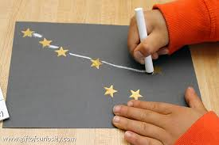
General ideas
https://www.rodocodo.com/

Try some space themed cooking



