Dear Year 6,
I hope you have all enjoyed a sunny Bank Holiday weekend. I wonder how many of you listened (and danced?) to the Lambeth Walk on VE Day!
This week would have been your SATs week - it definitely feels very strange not being in school with you, probably more so this week than any other. However, you can feel proud that you have already shown me how determined you are to do your very best and I am sure you are doing your best at home too. I spoke to many of your parents last week and it was lovely to hear that you are all keeping busy, whilst staying safe and well.
The theme of our learning this week is: Space
Have fun and take care of each other.
Mrs Masters x

Suggested Timetable:

45 mins | PE/Walk/Cycle Ride
45 mins | Maths Activity
10.30am | Break
45 mins | English Activity
45 mins | Online Learning Games/Activities
12.30am | Lunch
30 mins | Reading
45 mins | General Activity

Reading
It is really important that you try to read every day. Regular reading is one of the most important skills that will help you in your transition to secondary school.
Remember you can read silently to yourself, listen to audiobooks or ask your parents to read to you.
AR Quizzes
I have looked at and updated your reading targets on AR. Well done to those of you who have taken quizzes
The login for you to take AR quizzes is accessible for you from home and is:
https://ukhosted43.renlearn.co.uk/2152328/default.aspx
You will need your login and password which you should know. Email the office if you can’t remember them and I will send them out to you.
Maths Activities
The areas of Maths that you need to practise every week are listed below. You do not need to do them all every day; pick one or two per day. These will be ongoing and you can complete them in any fun ways you can. Some ideas are suggested in brackets for you to try.

Number:
- read, write, order and compare numbers up to 10 000 000

(practise reading and writing large numbers; put large values in order, e.g. house prices – which is the most expensive?)

Times Tables:
- know multiplication and division facts up to 12 x 12

(use online apps and websites such as Hit the Button and Times Tables Rockstars; have a ‘table of the week’ and put post-it notes up around the house with this table on them – constantly recite and practise them and then get an adult to test you – reward yourself with a treat if you get them all right; time yourself to write out or recite your tables – can you get faster each week?)

Measures :
- convert between different units of metric measure - kilometre and metre; centimetre and metre; centimetre and millimetre; gram and kilogram; litre and millilitre
- convert between miles and kilometres
(a great excuse for lots of cooking and baking – convert the values given in recipes; plan a day trip out for when lockdown is over – how far will you travel in miles/km?)

Money:
- estimate costs, add and calculate change in £ and p
- when shopping, calculate 10%, 20%, 25% and 50% off amounts

(use an online grocery website to plan a week of family shopping – can you stick to a budget? Can you use estimation to predict what your final bill will be? How much of your budget would be left over?; Plan a family holiday – where would you like to go? Plan a budget for travel, accommodation & food. Add up the total cost of your holiday.)

Time:
- tell the time using analogue, digital, 12 and 24 hour clocks.
- read and interpret a variety of timetables including, bus, train and TV guides

(practise telling the time, all the time! – work out how long it will be until TV time/bedtime; plan a train journey from St Neots – use online timetables to work out the times of your trains, where you would need to change trains and how long you would have to wait at each station?; plan a family 12-hour telethon using the TV planner – what could you watch and when?)

Task 1:
A ‘Calculating with Time’ activity is attached to the blog. This looks at how long it takes each planet in our Solar System to rotate once on its axis. The answers are included so you can check your work.

Task 2:
A ‘Writing Whole Numbers’ activity is attached to the blog. This gives you a chance to practise writing large numbers. Again, the answers are included so you can check your work.

English Activities
Task 1:
Continue with your daily journal to capture what you are doing during these unprecedented times.
In your daily journal, you could write:
- How you are feeling.
- What you have done at home - this might be any of the work you have done from the blog or anything else that you have done with your family.
- What you have enjoyed about each day.
You might want to include photographs and drawings to decorate your writing.

Task 2:
Some scientists are very interested in whether there might be life on other planets or in other parts of the Universe. What do you think? Write a summary of your ideas. Why do you think there is/isn’t life elsewhere in the Universe? What evidence do you have to support your ideas?

Task 3:
Tim Peake was the first British astronaut to visit the International Space Station in 2015. Write an application letter to become the second British astronaut to visit the ISS. What do you think the job requirements would be? What skills would you need? How would you convince someone that you are a good candidate for the job?

Task 4:
Write a quiz about space. Write out your questions or create a Powerpoint with each question on a different slide. Maybe you could have a quiz night at home and see how much your family knows about space.
You might want to extend this task and write quiz rounds about other topics that interest you.

Task 5:
There is a SPAG puzzle attached to the blog. This is similar to the ones we have done before - you have to carry out SPAG challenges in order to eliminate the suspects. Can you solve the mystery? (the answers are at the end of the document).

Online Learning Games/Activities

Times Tables
https://ttrockstars.com/
https://www.timestables.co.uk/

Power Maths
https://www.activelearnprimary.co.uk/login?c=0
All the activities for Year 6 are now unlocked and available.
Remember the password is: year6 and the school code is: kmm7

French (you can also use this to practise spellings and vocabulary in English)
https://www.linguascope.com/
Username - buckden Password – starfish

ICT
Have a go at learning a bit of touch-typing!
https://www.bbc.co.uk/bitesize/topics/zf2f9j6/articles/z3c6tfr

Coding
https://www.rodocodo.com/
All the activities are now unlocked and available. Remember the password is Radcliffe.
You might also want to look at:
https://scratch.mit.edu/

General Activities
Science:
Rockets:
There is no better Science task than making your own rockets – especially if we have good weather so that you can test them outside.
There is a suggested method attached to the blog but there are also lots of websites you can look at to help you to make your own rockets. There are lots of different types of rockets that you can try.
Think about how you can improve your rocket design – you might want to draw/write about your design plans and then describe any improvements you make after each test run.
https://www.science-sparks.com/making-a-bottle-rocket/
https://ioi.london/latest/new-video-make-your-own-paper-rocket-launcher/?gclid=EAIaIQobChMIt5Ge1vCm6QIVDevtCh0O-QlgEAAYASAAEgJfnPD_BwE

History:
Space Exploration
Attached to the blog, there are information cards that describe the key moments in space exploration.
- Put these events into chronological order
- Draw out a timeline to show when these events took place.
You then might like to research any of the events and find out more details about what happened. You could write fact cards or create posters to summarise the events.
Can you find out what other developments in space exploration have occurred since 2015?

Art:
Task 1:
Vincent Van Gogh created a number of paintings based on the night sky:
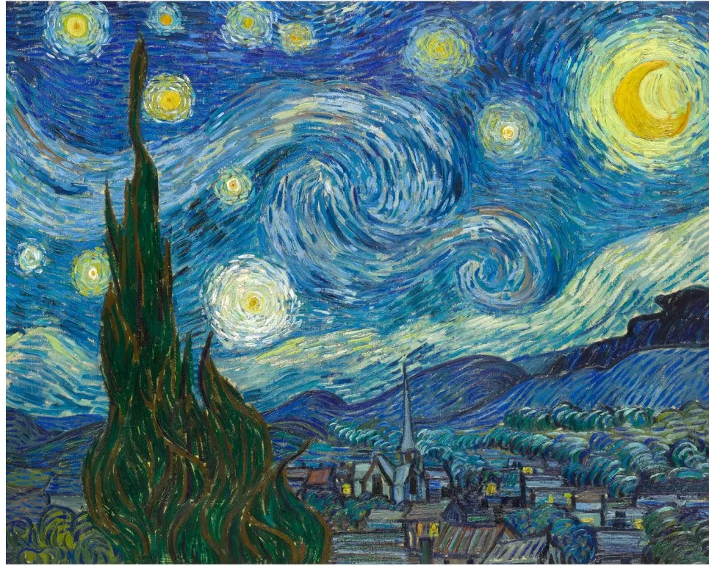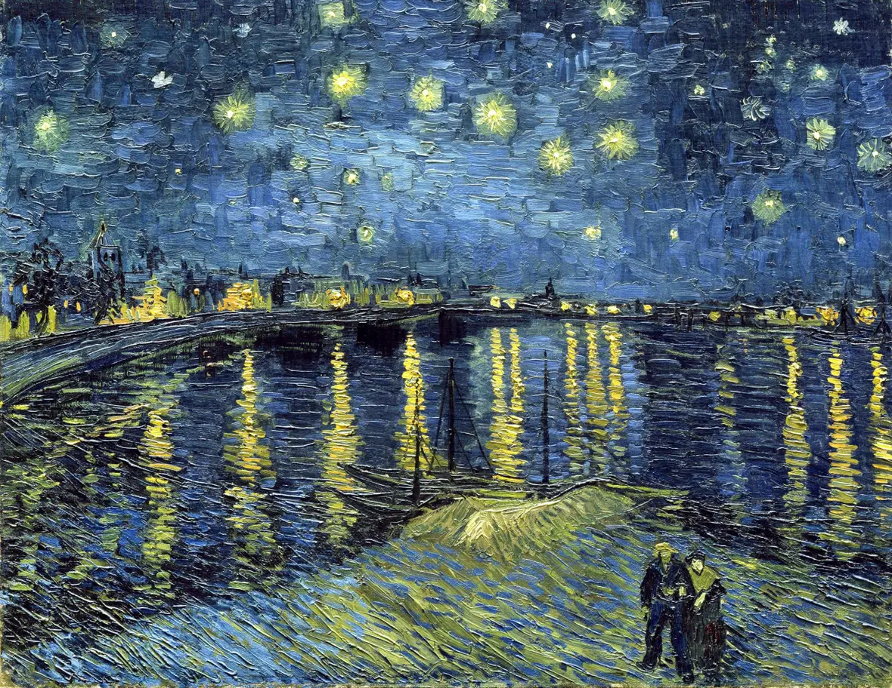
Use these examples to see if you can create a piece of art work in a similar style, based on the night sky.

Task 2:
Create your own space landscape. This might be a painting or a collage, or even a model. Think about the colours and textures you will use to help represent your ideas.
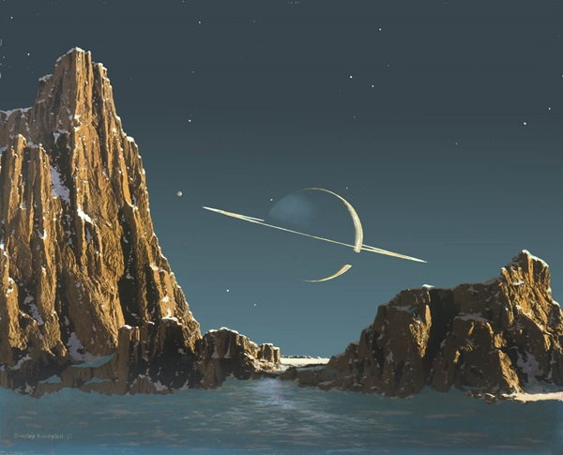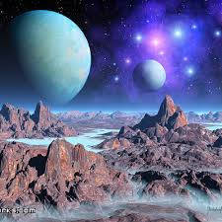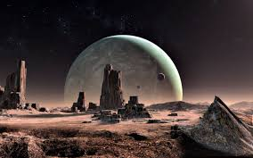

Music:
Task 1:
Lots of musical compositions have been influenced by space. Some of these include:
- The Planets Suite by Gustav Holst
https://www.youtube.com/watch?v=Isic2Z2e2xs

- Also Sprach Zarathustra by Richard Strauss
https://www.youtube.com/watch?v=dfe8tCcHnKY

- Star Wars soundtrack by John Williams
https://www.youtube.com/watch?v=sDMPTZ7y1lE

Try and listen to some of this music (or to any other compositions that are influenced by space). What do you like or dislike about this music? What instruments can you hear?

Task 2:
Some of you might want to have a go at writing your own space themed music – you can use instruments you have at home. Or maybe make your own instruments from things you can find at home?
Or you might want to try and write a space themed song?
David Bowie wrote this one:
https://www.youtube.com/watch?v=iYYRH4apXDo

