11.05.20
Good Morning Usain Bolt,

I hope you had a wonderful Bank Holiday weekend, I really enjoyed my V E Day celebrations with Ellie-Louise. We had a lovely afternoon tea and enjoyed making decorations, dancing and playing games.
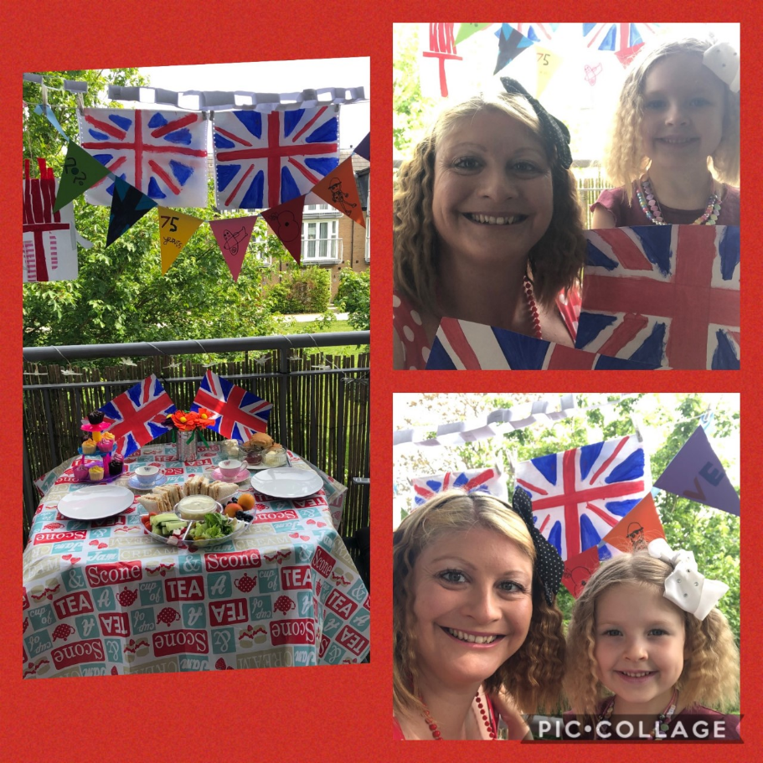

This week’s theme for our learning is Space. Make sure you have fun!

Please find attached a printable version below, if needed.

Task 1 | AM 20 min | Maths activity
Task 2 | AM 20 min | English activity
10:30 Snack time
Task 3 | AM and PM 2 x 20 min | TT Rockstars/Rodocodo/SPAG
12:30 Lunchtime
Task 4 | PM 20 min | Art activity
Task 5 | PM 20 min | Global learning activity
Task 6 | PM 20 min | French
2:00 Snack time
Task 7 | PM 20 min | Science
Task 8 | PM 20 min | This could be finishing an activity from earlier or an activity from the general list.
Daily journal and reading

Mathematics Task 1 (20 min)
The activities listed below are key Mathematical areas that the children need to practise every week, they do not need to do them all every day, but pick one or two per day. These will be ongoing and you can complete them in any fun ways you can.
Key Mathematical areas;
Number - count in multiples of 6, 7, 9, 25 and 1000
Times tables recall multiplication and division facts for multiplication tables up to 12 × 12
Measures - Convert between different units of measure - kilometre to metre; hour to minute]
Money - estimate costs, compare costs and calculate amounts in £ and p
Time - read, write and convert time between analogue and digital 12- and 24-hour clocks
convert from hours to minutes; minutes to seconds; years to months; weeks to days.

Make sure you are practising your timestables as much as you can, make up a keep fit video whilst reciting your tables.
Money – any practise with money using pounds and pence, talk about giving change. Make your families weekly shopping list with food prices (you could use an old receipt as a reference) and work out the amount spent and the amount of change you would receive from the weekly budget.
Abacus - The children can access this resource via the website https://www.activelearnprimary.co.uk
The password is year 4 and the school code kmm7 in the bottom box.
Measure the distance your space buggy (see Science) travels and convert your measurements.
Challenge - Can you find out the distance between the Earth and the Sun and convert this distance as many times as you can.
Please find some Mathematical Space sheets attached (these do not have to be printed, they can be written out).

English Task 2 (20 min)
Make up your own mnemonic to remember all of the planets in our solar system.
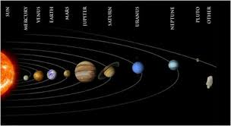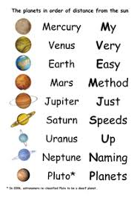
Watch an international space station clip and find out about life on the space station (what do you eat, who are you with, where are you, what does your day look like, what is your job?). Write a diary entry of your time in space.
https://www.nasa.gov/multimedia/nasatv/iss_ustream.html
https://www.nasa.gov/audience/foreducators/stem-on-station/dayinthelife
While you are in space you can contact home via email, write a letter home telling them what you have been doing and how you are feeling.
Please see attached some English Comprehension Activities about the Sun and Mars (these do not have to be printed, the questions can be written out).
Reading
Remember to read EVERYDAY.
The Accelerated Reader (AR) programme is also accessible from home during this time too, so once you’ve finished your books make sure you log on and take a quiz. https://ukhosted43.renlearn.co.uk/2152328/default.aspx
Nessy - https://www.nessy.com/uk/
Task 3 (20 min)
Time Tables Rock Star - https://play.ttrockstars.com/auth/school/student/76329
Rodocodo - https://game.rodocodo.com/
SPAG – https://www.topmarks.co.uk/english-games/7-11-years/spelling-and-grammar https://www.bbc.co.uk/bitesize/topics/zhrrd2p

Art/DT Task 4 (20 min)
Make your own planet mobile.
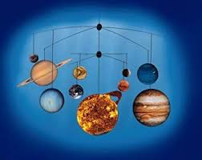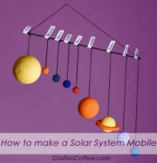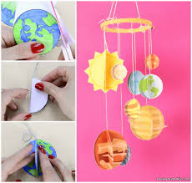
Make salt dough planets.
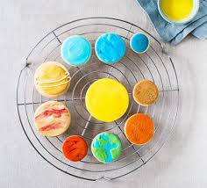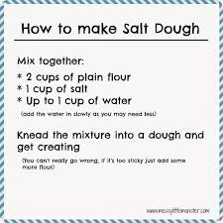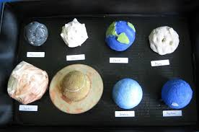
Global learning Task 5 (20 min)
Look at star constellations – if you can, ask your grown-ups if they can download a free star gazing app. Can you name them all? Now create your own star constellation and measure the distance between each of your stars. Don’t forget to make sure they make a picture.
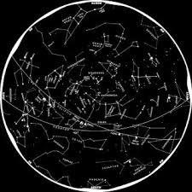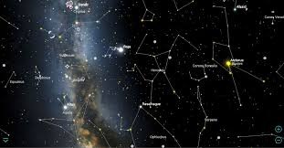
Find out about a planet that interests you, what do we know about it? Does it have water, life on it, what is its atmosphere like, what is the surface like? Now, compare this planet to Earth. Are there any similarities? Could we live on your planet? If not, why not?

Task 6 (20 min) French - (Log in – Username - Buckden Password – Starfish)
https://www.linguascope.com/
Science Task 7 (20 min)
Make a Space buggy to explore your new planet. Find out what surfaces your space buggy prefers. Why doesn’t it move as well on certain surfaces? What changes the speed of your space buggy?
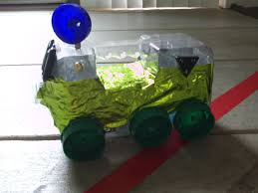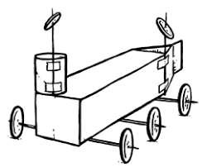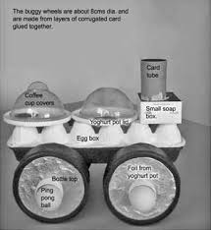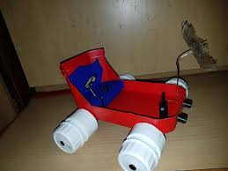
General activities
Remember to keep active!
- Yoga
- PE - Join Joe Wicks for a PE lesson. He is on YouTube every weekday.
https://www.youtube.com/watch?v=lEWcBIvqjDk
- Touchtyping - https://www.bbc.co.uk/bitesize/topics/zf2f9j6/articles/z3c6tfr
- Coding - https://scratch.mit.edu/
- Get in touch with a friend or family member
- Be mindful, find some items in your kitchen cupboards and guess the contents through just smelling them.
- https://www.skulduggerypleasant.co.uk/books/
- https://www.anglianwater.co.uk/in-the-community/schools/learning-at-home/

Make your own telescope
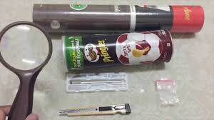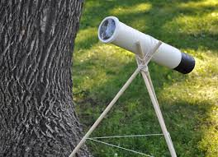
In your journal you write:
- How you are feeling,
- What you have done (this can be any of the work you have done from the blog and anything that you have done whilst at home),
- What you have enjoyed each day.

