Maths tasks week beginning 4th May 2020
Task 1 – finding half
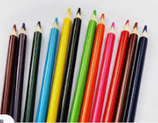
Last week we found half of a shape, this week we will start looking at half of amounts.
Grab a handful of pencils (or lego or buttons, whatever you have, just make sure it is an even number) and ask “How many pencils are there? Can you find half of the pencils?”
Encourage the children to answer in a sentence
e.g. “Half of 12 is 6.”
(You could get them to record this in their books)

Do this with lots of different objects and amounts. When counting encourage the children to use more efficient methods with larger numbers such as counting in 2s and 5s.
Also remember those arrays? When counting the objects at the beginning encourage them to arrange them in columns and rows.
Challenge: give your child/children 5 pencils and say “This is half my pencils, how may do I have?”

Task 2 – find a quarter
https://www.bbc.co.uk/bitesize/topics/z3rbg82/articles/zq2yfrd
Similar activities to when we found one half. You can use shapes and get children to draw lines to show quarters, colour in half, cut them in half. Remember to be quarters all 4 parts must be EQUAL.
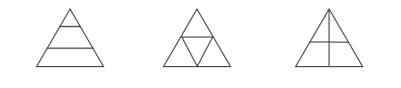
You could challenge the children with pictures like this. Do any of them show quarters??

Can you split these squares into quarters in 4 different ways.

Task 3- Finding a quarter of an amount.
Look back at task 1 where we found halves. The same activity can be done here but finding quarters. Encourage children to arrange objects in arrays so that they can often ‘see’ how to find halves and quarters. We can show them how to find a quarter we can halve an amount and then halve each of the half’s. E.g.
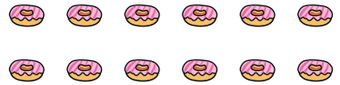
Halves

Quarters
Or
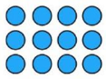
I used this red line to halve it
Then these yellow lines to halve each half to make quarters

Task 4- challenge cards
Please find attached to the blog some challenge cards for finding halves.

