Year 1 English tasks week beginning 4th May 2020
Theme: Everyday heroes and Captain Tom
Task 1:
Think of your favourite super hero. Can you draw a picture of them? Can you label them and their special powers?
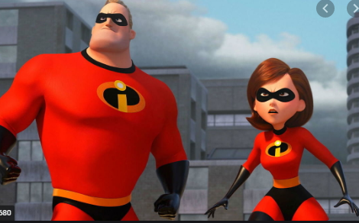
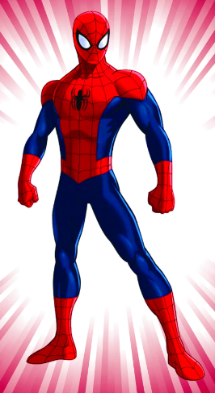


- Design your own superhero! If you could have any super power what would it be? Flying, super strength, mind reading, invisibility, super speed? Imagine your super hero has your chosen powers. Can you make your superhero out of play dough/modelling clay/salt dough? If you don’t have these can you draw them? Why not dress up and role play as your super hero?
- Come up with a list of adjectives to describe your chosen super hero.

Task 2:
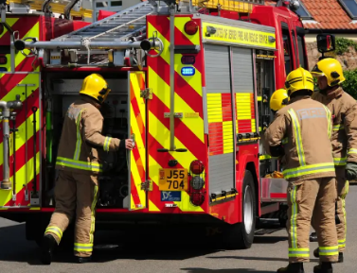
Can you think of any real life super heroes? Someone who does a very important job? You may have heard the term ‘Key Worker’ or clapped recently for the NHS. Can you find some old magazines and cut out pictures of any of these real life heroes?
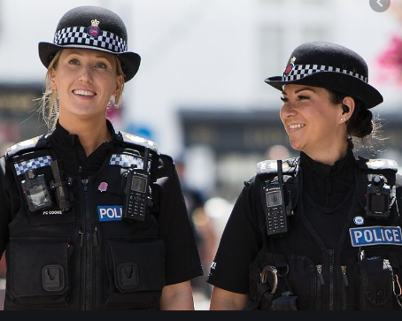
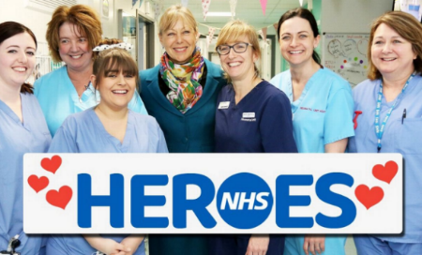

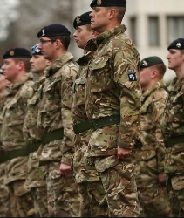

Write a sentence to answer:
- Why do you think they are heroes?
- What qualities do they have? (brave, kind, caring)
- Is there anyone you know who does a job like this?
- Can anyone be a hero? Explain why you think that.
Task 3: Captain Tom Moore. Read the information below about Captain Tom. Have a go at answering the questions once you have read about him. Watch this video of him completing his 100th lap. https://www.youtube.com/watch?v=3RiaVBWq40A

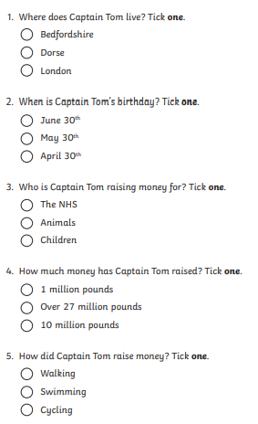
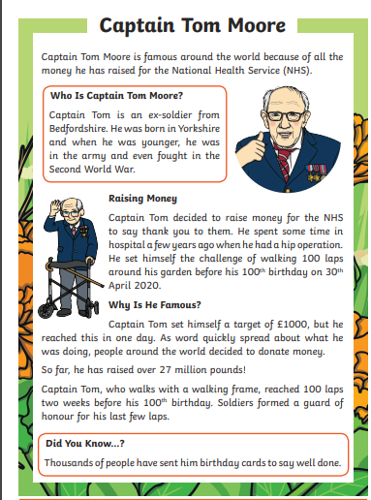

Task 4
VE day.
Captain Tom Moore, who you read about yesterday fought in World War 2 when he was younger. On May 8th it is VE day. Read this information about VE day.
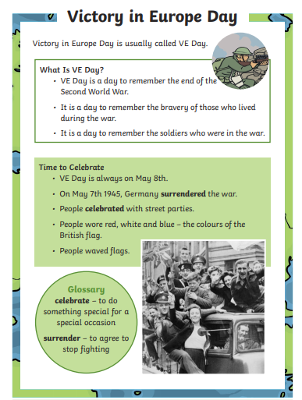

You might like to celebrate the 75th anniversary of VE day on 8th May. Choose an activity based on VE day:
- Can you make some bunting like they would have to celebrate VE day? Can you Design some other decorations in red, white and blue, or colour in the Union Jack flag.
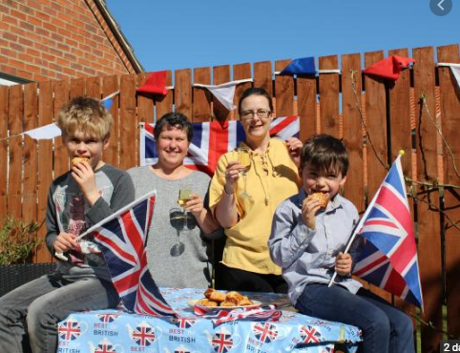
- Have a picnic in your house or in your garden with your family. Can you put up some red, white and blue decorations for VE day? If you do this we would love to see some photos of you and how you celebrated!

- Can you design and make a medal that you would give to Captain Tom or the other people who worked during World War 2?
*Parents* have a look at the uploaded document about VE day from Bletchley Park for a family activity pack with some for the grown-ups!

