04.05.20
Good Morning Muhammad Ali,

This week’s theme for our learning is ‘Everyday heroes and Captain Tom’. Make sure you have fun!

Please find attached a printable version below, if needed.

Task 1 | AM 20 min | Maths activity
Task 2 | AM 20 min | English activity
10:30 Snack time
Task 3 | AM and PM 2 x 20 min | TT Rockstars/Rodocodo/SPAG
12:30 Lunchtime
Task 4 | PM 20 min | Art activity
Task 5 | PM 20 min | Global learning activity
Task 6 | PM 20 min | Mind UP!
2:00 Snack time
Task 7 | PM 20 min | Science
Task 8 | PM 20 min | This could be finishing an activity from earlier or an activity from the general list.
Daily journal and reading

Mathematics Task 1 (20 min)
The activities listed below are key Mathematical areas that the children need to practise every week, they do not need to do them all every day, but pick one or two per day. These will be ongoing and you can complete them in any fun ways you can.
Key Mathematical areas;
Number - count in multiples of 6, 7, 9, 25 and 1000
Times tables recall multiplication and division facts for multiplication tables up to 12 × 12
Measures - Convert between different units of measure - kilometre to metre; hour to minute]
Money - estimate costs, compare costs and calculate amounts in £ and p
Time - read, write and convert time between analogue and digital 12- and 24-hour clocks
convert from hours to minutes; minutes to seconds; years to months; weeks to days.

- Make sure you are practising your timestables as much as you can, can you create your own Timestables song/rap.
- Practise telling the time and converting time between analogue and digital 12- and 24- hour clocks.
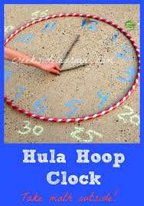
- Make a clock and write the time using both digital and analogue, create a daily routine chart and write the times using 12 and 24 hours.
- Abacus - The children can access this resource via the website https://www.activelearnprimary.co.uk
The password is year 4 and the school code kmm7 in the bottom box.
See Superhero Mathematics task sheets attached below.
English Task 2 (20 min)
See if you can learn and perform the NHS heroes’ charity song.
https://www.youtube.com/watch?v=pjrAfy2v63c
Write your own lyrics and see if you can add a backing track (maybe use the instrumental version of your favourite song.
- Find out about Captain Tom Moore, write a ‘This is your life book’ about his life and service to our country. You could consider such questions as; How would the Country describe him?...Where he has lived?... Who are the important people in his life?... What are his Most Memorable Experiences? ... What has been the best day of his life?

You could then ask a someone at home to become Captain Tom Moore and you can interview him.

https://www.bbc.co.uk/newsround/52414255
https://www.cornwalllive.com/news/cornwall-news/captain-tom-moore-stationed-cornwall-4086007
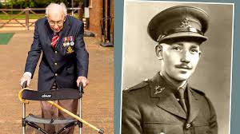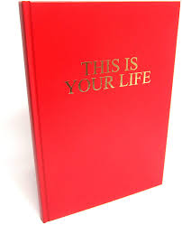

List all the everyday heroes you can think of and add what their ‘super power’ is. Create a poem about them. First, plan your poem, think about what type of poem you would like to do. Write your poem in neat and add some pictures related to your text.
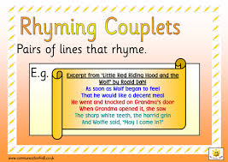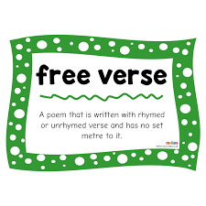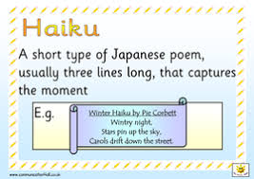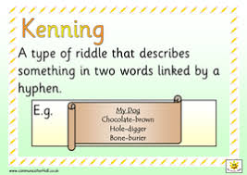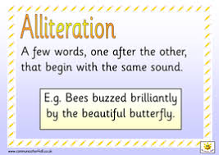
Write a newspaper article of Winston Churchill’s arrival at Bletchley Park. Don’t forget to add who he was, quotes from your interviews with a code breaker, the staff there and what preparations had to take place for his visit. Don’t forget you could draw a picture of and describe the Bletchley Manor.
https://bletchleypark.org.uk/blog/celebrate-ve-day-at-home-with-bletchley-park
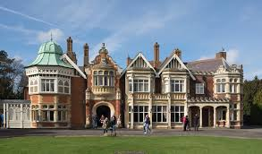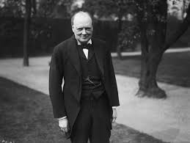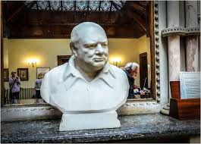
Reading
Remember to read EVERYDAY.
The Accelerated Reader (AR) programme is also accessible from home during this time too, so once you’ve finished your books make sure you log on and take a quiz. https://ukhosted43.renlearn.co.uk/2152328/default.aspx

Task 3 (20 min)
Time Tables Rock Star - https://play.ttrockstars.com/auth/school/student/76329
Rodocodo - https://game.rodocodo.com/
SPAG – http://www.crickweb.co.uk/ks2literacy.html
Art/DT Task 4 (20 min)
Create an Everyday Heroes poster to display in your window.
Make red, white and blue bunting for your stay at home street party, Friday 8th May 2020.
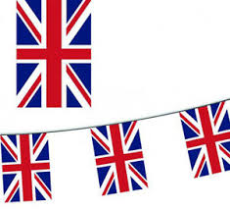
Global learning Task 5 (20 min)
Research The Bayeux Tapestry. Find out where it is kept, how is was made, why it was made, what events are shown. Create your ‘tapestry’ about your time at home so far. You could paint it, draw it, sew it etc.
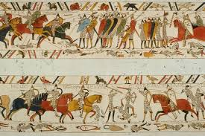
Find out about VE Day
https://www.bbc.co.uk/teach/class-clips-video/history-ks2-ve-day/z7xtmfr
https://www.bbc.co.uk/newsround/48201749

Task 6 (20 min)
Mind Up
https://mindup.org.uk/families/
Science Task 7 (20 min)
Create a rubber band cannon.
https://www.rigb.org/families/experimental/rubber-band-cannons
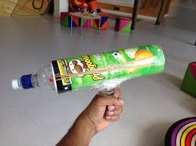
Make your own superhero vehicle, out of recycled materials to suit your chosen hero job. Try and make your vehicle move, think about how it will be powered.
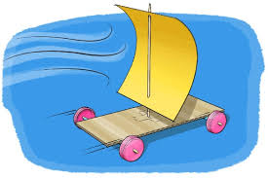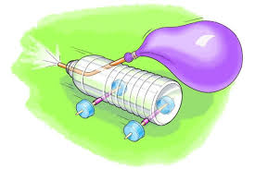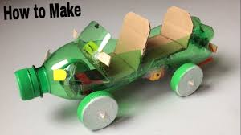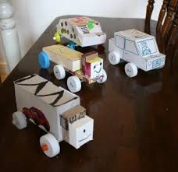

General activities
Remember to keep active!
- Yoga
- PE - Join Joe Wicks for a PE lesson. He is on YouTube every weekday.
https://www.youtube.com/watch?v=lEWcBIvqjDk
- Get in touch with a friend or family member
- Be mindful, listen to the sounds you can here when walking.
- Spellings - Any spellings using the prefixes; in-, im-, il-, i-r-, sub-, inter-, super-, anti-, auto-.
- Any spellings using the suffixes; –ation and –ous
- https://www.skulduggerypleasant.co.uk/books/
- https://www.anglianwater.co.uk/in-the-community/schools/learning-at-home/
- Adults, for extra ideas please see VE Day activity pack attached.
Make your own musical instrument to accompany your song.
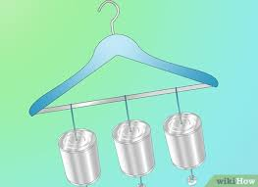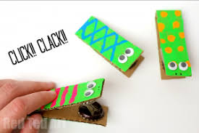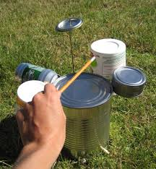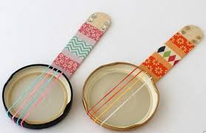

In your journal you write:
- How you are feeling,
- What you have done (this can be any of the work you have done from the blog and anything that you have done whilst at home),
- What you have enjoyed each day.

