Dear Year 6,
I hope you have all had another good week and are managing to keep busy
Many of you who are off to Hinchingbrooke in September will have seen the work that was sent from Mr Milner. These tasks will give you opportunities to research, make notes, write summaries and present your ideas in your own words – all important skills for secondary school. It will also give you a head start with some of your Year 7 topics.
As well as this, I will continue to suggest work on the blog – please remember these are all only suggestions and you need to do what works best for you and your family.
The theme of our learning this week is: Everyday Heroes & Captain Tom.
Have fun and take care of each other.
Mrs Masters x

Suggested Timetable:

45 mins | PE/Walk/Cycle Ride
45 mins | Maths Activity
10.30am | Break
45 mins | English Activity
45 mins | Online Learning Games/Activities
12.30am | Lunch
30 mins | Reading
45 mins | General Activity

Reading
It is really important that you try to read every day. Regular reading is one of the most important skills that will help you in your transition to secondary school.
Remember you can read silently to yourself, listen to audiobooks or ask your parents to read to you.
AR Quizzes
I have looked at and updated your reading targets on AR. Well done to those of you who have taken quizzes
The login for you to take AR quizzes is accessible for you from home and is:
https://ukhosted43.renlearn.co.uk/2152328/default.aspx
You will need your login and password which you should know. Email the office if you can’t remember them and I will send them out to you.
Maths Activities
The areas of Maths that you need to practise every week are listed below. You do not need to do them all every day; pick one or two per day. These will be ongoing and you can complete them in any fun ways you can. Some ideas are suggested in brackets for you to try.

Number:
- read, write, order and compare numbers up to 10 000 000

(practise reading and writing large numbers; put large values in order, e.g. house prices – which is the most expensive?)

Times Tables:
- know multiplication and division facts up to 12 x 12

(use online apps and websites such as Hit the Button and Times Tables Rockstars; have a ‘table of the week’ and put post-it notes up around the house with this table on them – constantly recite and practise them and then get an adult to test you – reward yourself with a treat if you get them all right; time yourself to write out or recite your tables – can you get faster each week?)

Measures :
- convert between different units of metric measure - kilometre and metre; centimetre and metre; centimetre and millimetre; gram and kilogram; litre and millilitre
- convert between miles and kilometres
(a great excuse for lots of cooking and baking – convert the values given in recipes; plan a day trip out for when lockdown is over – how far will you travel in miles/km?)

Money:
- estimate costs, add and calculate change in £ and p
- when shopping, calculate 10%, 20%, 25% and 50% off amounts

(use an online grocery website to plan a week of family shopping – can you stick to a budget? Can you use estimation to predict what your final bill will be? How much of your budget would be left over?; Plan a family holiday – where would you like to go? Plan a budget for travel, accommodation & food. Add up the total cost of your holiday.)

Time:
- tell the time using analogue, digital, 12 and 24 hour clocks.
- read and interpret a variety of timetables including, bus, train and TV guides

(practise telling the time, all the time! – work out how long it will be until TV time/bedtime; plan a train journey from St Neots – use online timetables to work out the times of your trains, where you would need to change trains and how long you would have to wait at each station?; plan a family 12-hour telethon using the TV planner – what could you watch and when?)

Task 1:
You have probably all seen the recent news story about Captain Tom Moore. He has raised over 32 million pounds for the NHS by walking 100 laps of his garden.
- Each lap of his garden was 25m. Calculate how far Captain Tom has walked in metres and then convert this into kilometres.
- Challenge: Can you find out how you could convert this distance into miles?

- Think of a way you could measure a lap of your own garden.
- Can you work out how many laps of your own garden you would have to walk to equal the distance that Captain Tom walked?
(if you don’t have a garden or outdoor space, you could measure a lap of your bedroom or another room in your house)

Task 2:
We are celebrating VE Day on Friday 8th May. Attached to the blog is a Wartime Recipe Booklet so you can have a go at making some of the food that they might have eaten during World War 2. There is plenty of opportunity for accurate reading of scales and careful measuring when you are cooking!

Task 3:
Lots of you enjoyed the Arithmetic quiz that I suggested two weeks ago so I have attached another one for you to have a go at. Can you improve your previous score?

English Activities
Task 1:
Continue with your daily journal to capture what you are doing during these unprecedented times.
In your daily journal, you could write:
- How you are feeling.
- What you have done at home - this might be any of the work you have done from the blog or anything else that you have done with your family.
- What you have enjoyed about each day.
You might want to include photographs and drawings to decorate your writing.

Task 2:
As we learnt at Bletchley Park, communication during the war was often done using codes.
Make up your own code and then write a secret message to someone. You can use any symbols or colours to create your code. Display your code on a poster so that someone can use it to crack your coded messages.
Remind yourself what Morse Code is. You could use this to write messages too!

Task 3:
Find out more about Captain Tom Moore and all he has done to raise such a phenomenal amount of money for the NHS. Write a newspaper article documenting his fantastic achievements and why he is such an inspiration to us all at this time.

Task 4:
Lots of people are going above and beyond at this time to help keep us all safe. These include our NHS workers and the emergency services. There are lots of other people who are also continuing to go to work to make sure we have enough food, that our bins are emptied and that we receive post from our friends.
Write a letter to one of these Everyday Heroes – what would you like to say to them? How would you like to thank them for what they are doing?

Task 5:
Write an acrostic poem to celebrate an Everyday Hero. For example, you might choose a Nurse – and you would need to write five lines (one starting with N, U, R, S and E).

Online Learning Games/Activities

Times Tables
https://ttrockstars.com/
https://www.timestables.co.uk/

Power Maths
https://www.activelearnprimary.co.uk/login?c=0
All the activities for Year 6 are now unlocked and available.
Remember the password is: year6 and the school code is: kmm7

French (you can also use this to practise spellings and vocabulary in English)
https://www.linguascope.com/
Username - Buckden Password – Starfish

ICT
Have a go at learning a bit of touch-typing!
https://www.bbc.co.uk/bitesize/topics/zf2f9j6/articles/z3c6tfr

Coding
https://www.rodocodo.com/
All the activities are now unlocked and available. Remember the password is Radcliffe.
You might also want to look at:
https://scratch.mit.edu/

General Activities

History:
Task 1:
Bletchley Park has produced a Family VE Day Celebrations Booklet – this is attached to the blog and includes how you can make decorations, bakes some scrummy treats and dress up. You might like to try some of these ideas. Take some photos of your celebrations. I would love to see them!
https://bletchleypark.org.uk/whats-on/stay-home-ve-day-75-celebrations

Mind-Up:
Mind-Up have released these resources to support you and your parents at this time. There are lots of activities which link to the Mind-Up work and the Brain Breaks that we do in class.
https://mindup.org.uk/families/

Art:
Task 1:
Design an Everyday Heroes poster to celebrate all the people who are working in our community. Here is an example to help you:
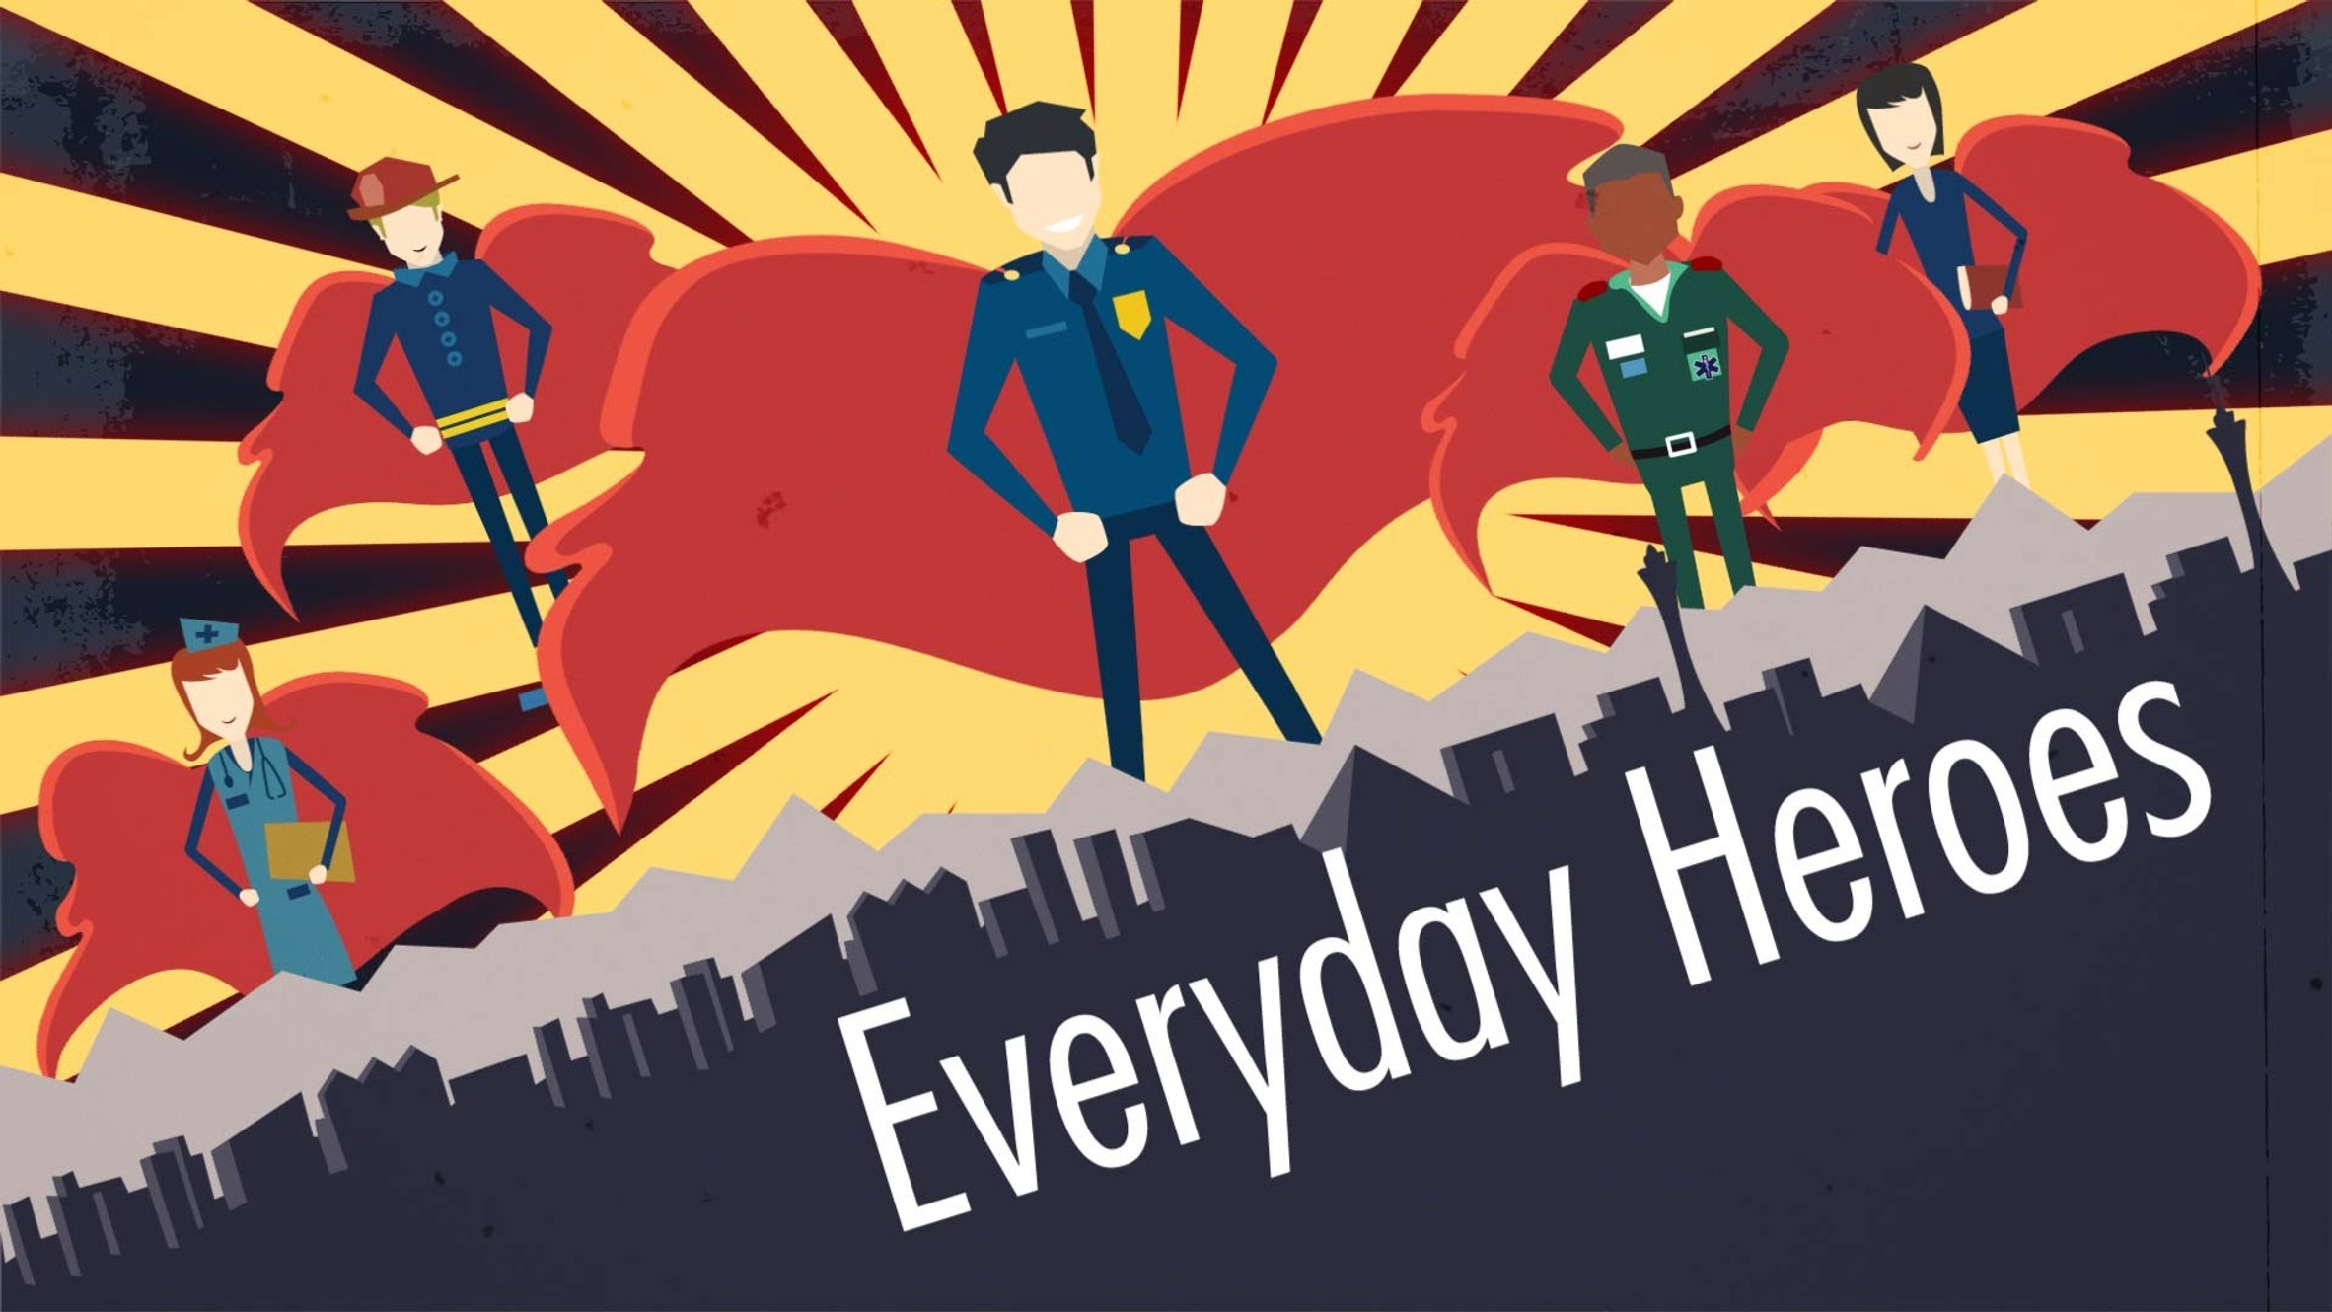

Task 2:
Create a piece of red, white and blue art based on the Union Jack. You might want to use your art as part of your VE Day celebrations.
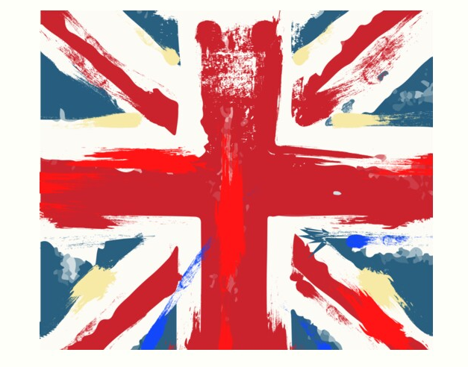

Task 3:
Design a VE Day Medal – there is a guidance sheet attached to the blog to help you.

PE:
Task 1:
Follow this link for the music ‘The Lambeth Walk. It was a popular song and dance during World War 2.
https://www.youtube.com/watch?v=wkS0lIysivQ
See if you can remember our dance moves to the music - can you make up a dance for the rest of the song?

Task 2:
Create your own sports circuits in your garden or as part of your daily exercise. Think about the different activities you could do – jumping, stretches, runs - do each one for a minute and then move on. Can you set yourself weekly challenges to improve your speed? Or to improve the number of each activity you can complete in a minute?

