Hi everyone, we hope you and your family are well and staying safe.
Here are some ideas for you to be working on whilst you are at home this week.
Please continue with your daily journal to capture what you are doing at home during this time. In your daily journal you write:
- How you are feeling.
- What you have done. This can be any of the work you have done from the blog and anything that you have done whilst at home.
- What you have enjoyed each day.
Below is a table suggesting how much learning to do over a day with a year 5 child. These slots add up to 4 hours of learning, split into small chunks with breaks. Of course what is important is that you do what works best with your family. The work listed below is more than enough for 5 days of 4hr learning so choose the tasks that you would prefer to do.
Please also ensure that you include some daily physical activity, Joe Wicks uploads a PE lesson on YouTube every day, these are good fun and you can access these when you would like to.
We also expect that you read daily, whether this be a story, magazine, information book or poetry. You can complete AR quizzes using this link: https://ukhosted43.renlearn.co.uk/2152328/default.aspx

am 45 min | Maths activity
am 45 min | English activity
10:30 | Snack time
am 2 x 30min | TT Rockstars/Nessy
12:30 | Lunchtime
pm 45 min | Something unfinished from the morning or maybe some art
pm 45 min | An activity from general activities list

Maths
Task 1 (45min a day)
Choose an area of maths from the list below, you only need to choose one area a day, you do not need to do all of them every day. Use this time at home to practise some real life math skills. By practising these skills, other areas of maths will become easier for you as well.
Numbers - read, write, order and compare numbers to at least 1 000 000.
You could read some different numbers that you find in books, newspapers. Write the numbers using numerals and words.
Measures - convert between different units of metric measure - kilometre and metre; centimetre and metre; centimetre and millimetre; gram and kilogram; litre and millilitre
Could you measure your garden, Bedroom, kitchen? What if you wanted to plant a new flower bed or build a den in your bedroom, how much space would it take up? How long would it be? If you go out for a daily walk, how far do you walk in metres? Kilometres?
Could you help in the kitchen to bake or cook dinner? Measure your ingredients carefully.
Times tables - Know multiplication and division facts up to 12 x 12
Money - estimate costs, add and calculate change in £ and p.
Can you calculate the cost of the weekly shop? What about change if you didn’t have the exact amount?
Time - tell the time using analogue, digital, 12 and 24 hour clocks.
Read the clock at different times of the day. What time do you wake up, have lunch, dinner, bedtime? Can you give those times using analogue, digital, 12 and 24 hour clocks.
Read and interpret a variety of time tables including, bus, train and tv guides. What time do your favourite programs start? How long do they last? Could you take a train from St Neots to London? How long is the journey? What time are the trains? etc

Captain Tom Moore and our everyday heroes
English / History/ Geography / Science / Art/ DT
Task 1 (5x 30 min)
Read every day

Task 2 (45mins)
You may have heard or read in the news all about Captain Thomas Moore, who turned 100 on April 30th. He raised £28 million for our NHS by walking 100 laps of his garden. Although Captain Tom is now a national hero, we all have someone in our community that we consider to be a hero. His actions have made a positive difference to the world around us.
Write a letter thanking someone for the positive difference they have made to our world. This might be one that you want to send to somebody or one to thank all of our everyday heroes.

Task 3 (45mins)
VE Day – Victory in England. This year, VE day is on the Friday 8th May. Below are 2 extracts of peoples experiences of the celebrations. Your task is to:
- highlight in one colour the words and phrases that indicate happiness,
- highlight in another colour the words and phrases that indicate relief
- highlight in a different colour the words and phrases that indicate sadness.
Extract 1
VE day came after I had been working in Bath for just over a year. With some friends from the office, including the boss and his wife, we all rushed down to the centre of Bath and found a nice pub where we had a celebratory meal and lots of drinks.
Later in the evening we joined the crowds dancing around Bath Abbey until the small hours. Someone suggested going to London to celebrate there, so we caught the early morning train with a two hour journey to Paddington and somehow — tube, taxi, walking, I cannot remember — we made our way to St Paul's — the symbol of Britain surviving the Blitz. Hundreds of people were walking around.

Knowing that I wanted to work in Fleet Street after the war, we then went straight there, looking at all the great newspaper buildings and ending up at the famous journalists' pub The Cheshire Cheese. Carried along by euphoria, we walked all the way to Park Lane, talking to strangers all the way. A distant relative with a flat near the Dorchester Hotel took us in for a cup of tea and a wash. We arrived back in Bath in the early hours of the morning.

We had to be back in the office by 8.30am. 'Back to work,' said the boss, 'our war isn't over yet.’

Extract 2

We were getting more and more and more excited. The war in Europe was nearly over. The 3rd September 1939 had been the day before I was due to start school - now I was almost leaving junior school, and certainly old enough to read the papers, listen to the news broadcasts and know what was going on.
So much had happened in those six years. The victory celebrations in Trowbridge had already been planned. Posters were going up in shop windows amid red white and blue rosettes. Only the date of VE Day had been left out. As we left school on Monday 7 May the teachers told us that if there was an announcement during the evening that Germany had surrendered there would be a holiday for the next two days. The announcement came - and no way were we going to school!

A procession had been arranged for the late evening, led of course by the Trowbridge British Legion Boys Band. Behind the band came Sammy Paradise and his horse and cart - and there, strung up in Guy Fawkes fashion, were effigies of Hitler and Mussolini en route to a large bonfire that had been built in the lower part of the Park. You can guess the rest. Back home coloured lights had been placed in the trees at the top of Union Street. There all the folk, joined by us children, danced the night away. (This area is now a mini-roundabout but I still think of this when I am driving through the rush hour traffic.)

Street parties had been hastily arranged. Ours was a few days later in the schoolroom of Zion Chapel, which had been used as a storage depot. I don't think it had been officially released by the Government but was reoccupied by the street elders just for the occasion! We marched down from the top of the road with mugs and plates - rather like the soldiers had done a few years earlier. In fact we had to march up the side passage of our own house feeling very important.

There were of course also Church celebrations. At our Sunday School we had been practising a special hymn for several weeks. We also practised for a special service - attended by all the Sunday Schools - which was held the following Sunday in the park on the lawn, where sports events had been held.

How might you celebrate VE Day this year?
Task 4 (1 hour)
Research about when and how the NHS was established and what difference this made to our country.
You can present the information that you collect in different ways, you could choose to:
- Create a presentation that you can present to people in your household.
- Create a poster presenting all the information you have learnt.
- Create an information page showing the information you have collected.
Task 5 (45mins)
Watch this video from Kew Gardens about Fungi, it will give you your activity to do from this:
https://www.youtube.com/watch?v=vWo1VYQeoWM
You might want to do some more information about Fungi before completing your task.
Task 6 (45 mins)
Throughout history, medicine has changed a lot.
The Tudors had some very strange ways of curing people, they created many potions to help people recover from their ailments, read the information below. Then create some silly remedies for minor ailments people might have, such as a nose bleed, saw toe, cut to the knee or stinging nettle rash….
Tudor doctors had some herbs that worked but many of their cures were just sad and silly superstitions. Here are a few of the wacky (but true) Tudor cures:
- Got a headache? Then rub your forehead with a rope that was used to hang a criminal.
- Suffer from rheumatism? Then wear the skin of a donkey. In pain with gout? Boil a red-haired dog in oil, add worms and the marrow from pig bones. Rub the mixture in.
- A painful liver? Drink a pint of ale every morning for a week - with nine head-lice drowned in it.
- Are you bald? Use a shampoo made from the juice of crushed beetles. When the head is clean then rub in grease made from the fat of a dead fox.
- Are you a martyr to asthma? Swallow young frogs or live spiders, cover them in butter to help them slide down easier.
- Other crazy cures included powdered human skull, bone-marrow mixed with sweat, a stone that has killed a she-bear and fresh cream mixed with the blood of a black cat's tail.
Tasty treats! You'd soon be out of your sick bed if you were offered those poisonous potions.
Task 7 (45 mins)
Emergency services are needed for natural disasters that occur around the world.
What natural disasters can you think of? Choose one to research e.g. Tsunami in Thailand, what emergency services would have been needed to help?
The effects of natural disasters last longer than just the day that they occurred. What other help would you suggest could help the people of those that have lived through the disaster. For example, people might be left homeless, or are without food,

Task 8 (2 x 30 min per week)
TT rockstars https://ttrockstars.com/

Task 9 (1-2 hours)
Now time to get really creative, can you make an emergency vehicle using recycling materials?
Maybe you could also make a model of the building and some of the people that work in that building. Here are some ideas.
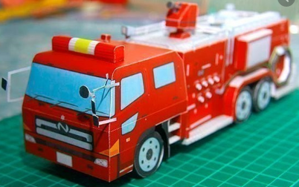
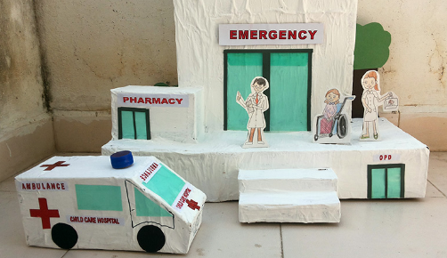
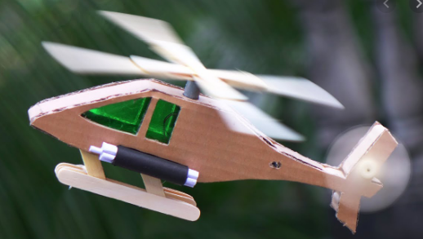

Answers for Fungi challenge:


