Year 1 English tasks week beginning 27th April 2020
Task 1:
Look at these pictures of weather. Can you come up with and write a list of interesting adjectives/adverbs to describe the weather types? You could use some of these to get you started:
howling, freezing, chilly, icy, warm, sunny, bright, soggy
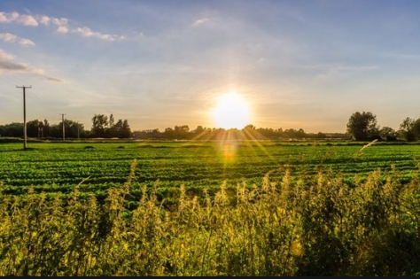
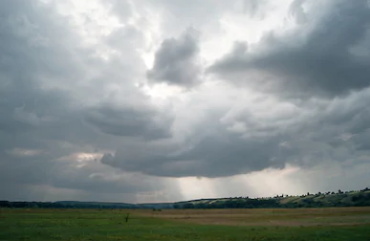
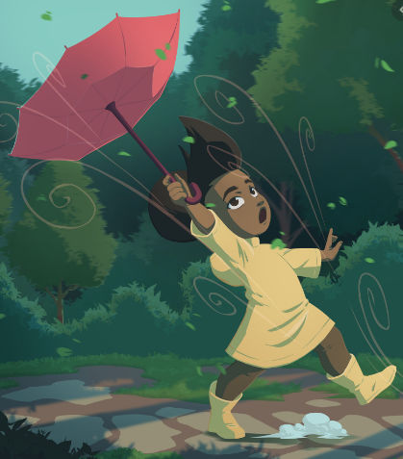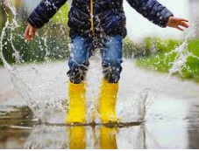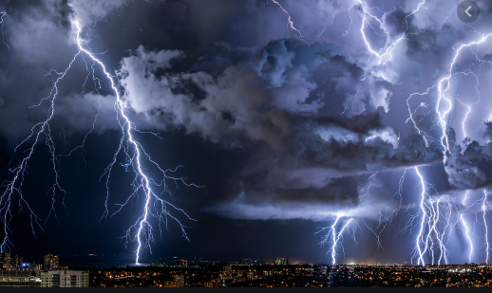
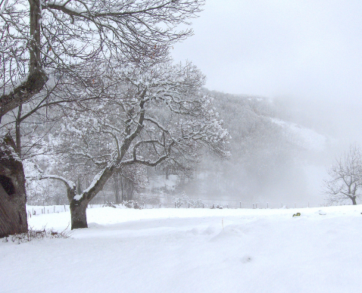

Can you explain a type of weather to your adults or brothers/sisters and get them to guess which weather it is? Try not to say the words!

Task 2:
Pick one of the weather types from the pictures or choose your favourite weather. Imagine you have to describe that kind of weather to an alien who has never experienced the weather on Earth before. Start by listing some ideas to answer these questions: it looks like ... It sounds like ... It makes you think of ... It makes you feel ....

Task 3:
Have a go at writing your own weather poem using some of the words you have thought of from task 1 and 2. There are different structures of poems you could try:
- The first line of the poem is the one-word subject of the poem. (for example, wind) The second line consists of two adjectives describing the subject. (cool, gusty) The third line contains three verbs telling what the subject does. (blows, sweeps, howls) The fourth line expresses, in two words, the writer's feelings about the subject. (wonderful wind).
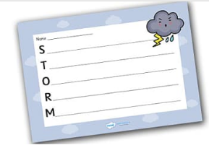
- Write an acrostic poem about your weather type.

- Write your word down vertically.
- Think of words or phrases that describe that word/subject.
- Place your words or phrases on the lines that begin with the same letters.
- Fill in the rest of the lines to create a poem.
Example:
S oaking through from the torrential rain.
T errifying thunder shakes the ground.
O verhead dark clouds loom.
R ivers of water pour down from the clouds.
M ighty storm full of danger.

Task 4
Watch the weather forecast on the television to help you prepare your weather report tomorrow. Write a list of useful words that you hear e.g. overcast, pollen count, breeze, northernly, light winds etc.
Task 5
Can you prepare a weather report using the notes you made about the weather? You might need to draw a weather map and stick it on the wall (you can point to that as you deliver the report). Can you find England and Buckden on the map. Remember to tell everybody what the weather will be like today and tomorrow. Practise your weather report and perform it to your family.

