Maths
Task 1 & 2– make doubles
Use objects from around the house to ask what double that amount is. Allow your child to find the same amount of that object again to work out the answer.
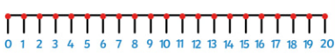
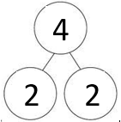
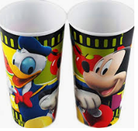
I have 2 cups. What is double 2? Can you find double 3,4,5,6,7,8,9,10?
You can use part whole models or number lines to help you.

2 + 2 = 4

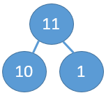
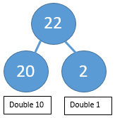
Challenge - finding double of teen numbers.
Use the part whole model to double the 10
then double the ones and add together

You could also practise doubles by making ladybird biscuits and doubling the spots. Or painting ladybirds and painting spots on. Doubling the spots on one side to the other. The children could then write underneath the lady bird the calculation or ‘double 2 is 4’.
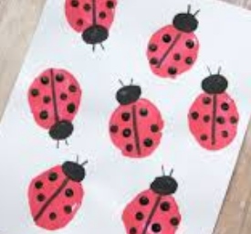
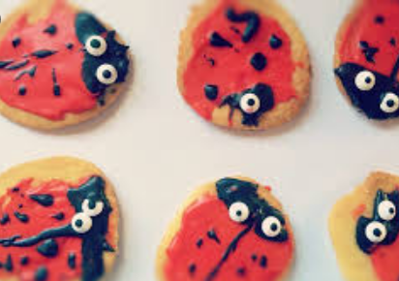
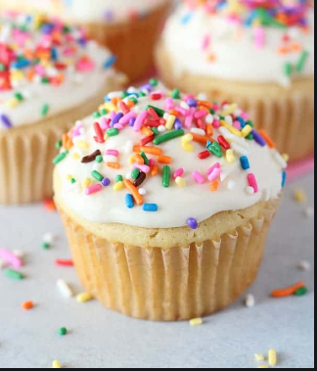
Ingredients
Butter 2oz
Caster sugar 2oz
Self-rising flour 2oz
1 egg

How about making cakes but getting the children to double the amount of each ingredient.

Task 3 – make equal groups
Do you remember last week when we made equal groups? This week I’d like you to wow your parents or brothers and sisters by finding things around your house or garden to make into equal groups. When you have made equal groups can you tell someone how many groups you have of how many objects, “I have 3 equal groups of 5”.

Task 4 – make equal groups (sharing)
There is a document on this week’s blog called food division problems. These are problems that the children can solve practically by using objects or drawing pictures. To make them more relevant you could substitute the items in the question for items you have in the house or use the word problems and inspiration to make your own with real life objects and people in the house. If the children are enjoying this, they might also like to make their own problems for you to solve. They could work the answer out first and put it in an envelope (or somewhere safe) and share your answers. It is also good to ‘make a mistake’ and then get the children to talk you through how you should have solved it!
Task 5 - finding a half
This task is all about learning what half actually is. It is not just splitting something into 2 parts, each part has to be equal.
- Get the children to physically cut food items in half, apples, sandwiches etc
- Children can cut pictures of items in half (printed or drawn or from magazines).
- Half shapes but cutting them, drawing a line or folding. Folding can be a great visual way of seeing if the two parts are equal.
- Challenge the children to see how many ways some of the shapes can be cut in half.

