27th April
Dear Whitlock class,
Hello everyone! It was great to talk with your adults this week and to hear all about the things you are doing. Here are some more ideas for you to be working on whilst you are at home this week. This week’s suggestions are all linked to the weather.
I hope you are enjoying writing your daily journals to capture what you are doing at home during this time. Remember to write in your journal:
- How you are feeling
- What you have done. This can be any of the work you have done from the blog and anything that you have done whilst at home.
- What you have enjoyed each day.
I can’t wait to see your journals which will be shared upon our return to school with your classmates!
If you would like to take some photos of your work to show, me you can send them to the school office!
Take care and stay safe
Hopefully I will see you all soon
Mrs Tarpey
x
This is a suggestion of how much learning to do over a day with a year 2 child. These slots add up to 2 hours of learning, split into small chunks with breaks. Of course what is important is that you do what works best with your family. The work listed below is more than enough for 5 days of 2hr learning so please choose the tasks that you would prefer to do with your child. Also don’t forget to do some exercise and read every day!
am 20 min | Maths activity
am 20 min | English activity
10:30 | Snack time
am 2 x 20 min | TT Rockstars/Rodocodo/Nessy
12:30 | Lunchtime
pm 20 min | Something unfinished from the morning or maybe some art
pm 20 min | An activity from general activities list

Is it always sunny in the summer?

Maths
Task 1
You could learn how to make a sundial outside.
How to make a Sundial - all you need is a small stick and a few stones.
• choose an unshaded area to set up your sundial. Put the stick or pencil in the ground, or in a large piece of modelling clay, if your space is on a concrete or wooden surface
• observe the stick’s shadow carefully over the course of the day. Add a stone to your sundial for each hour, from sunrise to sunset. Mark the exact spot where the shadow falls each hour
• to make it easier to tell the time, label each stone with the corresponding hour in which it was placed
• using your sundial to tell time may take practice. Start by looking at the sundial on the hour, which is when the shadow should fall precisely on a stone. With practice, it will become easier to determine the time, even when the shadow falls between two rocks.

Task 2
You could make a kite using your measuring skills. I have attached some instructions below.

Task 3 (20 min a day)
The following activities are ongoing tasks and should be practised every week at times that would suit you best. You do not need to do them all every day, put to pick one or two per day.
Number - count in steps of 2, 3, and 5 from 0, and in tens from any number, forwards and backwards
Know number bonds to 20
Times tables - recall and use multiplication and division facts for the 2, 5 and 10 multiplication tables
Time - tell and write the time to five minutes, including quarter past/to the hour (on an analogue clock)
Know the number of minutes in an hour and the number of hours in a day.
Money - Recognise different monetary coins, find different combinations of coins that equal the same amounts of money
Measure - measure items in cm/m, kg/g, l/ml

Task 4 (2 x 20 min per week)
TT Rockstars https://ttrockstars.com/

Task 5 (2 x 20 min per week)
Abacus https://www.activelearnprimary.co.uk/login?c=0

English
Remember to read every day
Task 1 (20 min)
Each day spend a few minutes describing the weather. Is the rain hitting against the window today or is the wind blowing the washing on the line? Is the sun bouncing off the trampoline? Make notes for each day, remembering to make a note of the temperature, the direction of the wind or how much rain has fallen. (You will need these notes to make a weather report at the end of the week).

Task 2 (20 min)
Watch the weather forecast on the television to help you prepare your weather report tomorrow. Write a list of useful words that you hear e.g. overcast, pollen count, breeze, northernly, light winds etc.

Task 3 (20 min)
Can you prepare a weather report using the notes you made about the weather? You might need to draw a weather map and stick it on the wall (you can point to that as you deliver the report). Can you find England and Buckden on the map. Remember to tell everybody what the weather will be like today and tomorrow. Practise your weather report and perform it to your family.

Task 4 (20 min)
Can you write a list of all the things that you would put into a picnic?

Task 5 (if you have a password 2 x 20 min)
Nessy https://www.nessy.com/uk/

Spelling
- Can you find words (nouns) in your reading book that end in ‘al’? e.g. metal, pedal, animal, hospital, capital.
- Can you spell all the days of the week

Science
Task 1 (20 min)

https://www.wikihow.com/Make-a-Tornado-in-a-Bottle
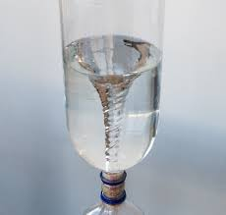
Instructions:
- Fill the plastic bottle with water until it reaches around three quarters full.
- Add a few drops of dish washing liquid.
- Sprinkle in a few pinches of glitter (this will make your tornado easier to see).
- Put the cap on tightly.
- Turn the bottle upside down and hold it by the neck. Quickly spin the bottle in a circular motion for a few seconds, stop and look inside to see if you can see a mini tornado forming in the water. You might need to try it a few times before you get it working properly.
What's happening?
Spinning the bottle in a circular motion creates a water vortex that looks like a mini tornado. The water is rapidly spinning around the center of the vortex due to centripetal force (an inward force directing an object or fluid such as water towards the center of its circular path). Vortexes found in nature include tornadoes, hurricanes and waterspouts (a tornado that forms over water).

Task 2 (20 min)
April Rain drops! Draw a series of different sized raindrops, then place inside a plastic wallet. How many drops of water can you fit in each raindrop? Look at the shape of the drop, what do you notice?
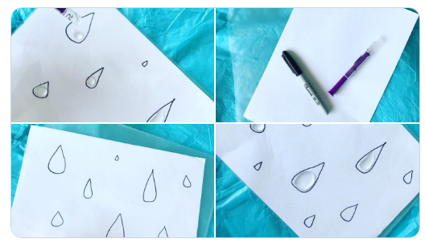

Geography
Look at the clouds in the sky. Can you identify the different types of clouds?
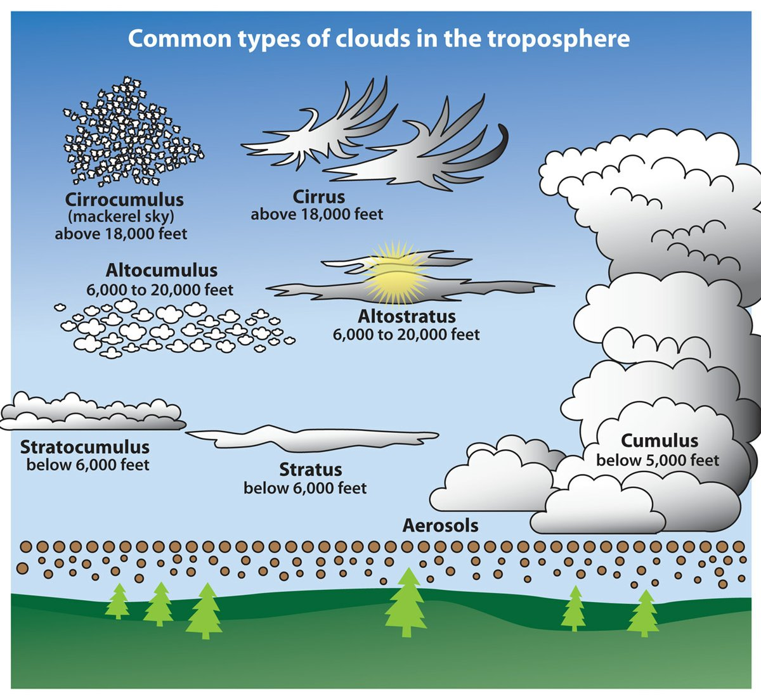

Art
Task 1 (2 x 20 min sessions)
Look out of your window today. Can you draw/paint a picture of what you can see that clearly shows what the weather is like?
Use these for ideas:
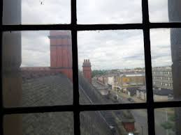
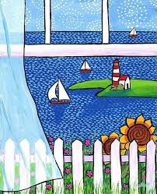

Task 2 (20 min)
Make a spinner to hang in the garden
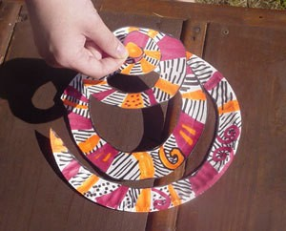

Supplies:
- paper plates
- crayons
- scissors
- stickers, optional

Instructions:
- Colour a paper plate.
- Carefully cut around and around the paper plate until you get to the center.
- Then tie a piece of yarn or ribbon to the center to hang it up with.
You can tie more pieces of ribbon to the sides for a cascade effect.

Task 3
Try some shadow art
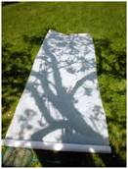

Computing
https://www.rodocodo.com/

