27.04.20
Good morning Simone Biles
How are you all? Well, I hope. I have posted some ideas to help you with your learning. Our topic this week is ‘The Weather’.
This is a suggestion of how much learning to do over the day. These slots add up to 2½ hours of learning split into small chunks with breaks. It would also be good to ensure you fit in some active time; many children are enjoying Joe Wicks live on YouTube at 9am (though you can always watch the video later in the day).
The work listed below is more than enough for this suggested timetable so choose the tasks that you would prefer to do.
am 20 min | Maths activity
am 20 min | English activity
10:30 approx | Snack time
am 30 min | TT Rockstars / Rodocodo / Nessy / BBC bitesize / Topmarks / etc
am 20 min | Reading  AR quizzes can be done between 08:45 and 15:15 at this exact website  https://ukhosted43.renlearn.co.uk/2152328/default.aspx
12:30 | Lunchtime
pm 30 min | Activity of child’s choice, ideally something creative. This would be a great time to do something together, or if there are siblings for them to work together on something.
pm 30 min | An activity from general activities list

Maths
Please can you practise the following skills on a daily basis. Choose only one or two to practise each day:
Number - count from 0 in multiples of 4, 8, 50 and 100
Times tables - recall and use multiplication and division facts for the 3, 4 and 8 multiplication tables
Measures - measure items in m/cm/mm kg/g ml/l

Money - add and subtract amounts of money to give change,

Time - tell and write the time from an analogue clock, including 12-hour and 24-hour clocks
know the number of seconds in a minute and the number of days in each month, year and leap year
Task 1 - Create a rain gauge
MATERIALS:
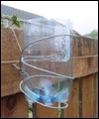
- Milk bottle
- Scissors
- Decorative items
- Pipe cleaners or something similar
- rulers
Instructions
- Cut the milk bottle in half.
- Using the bottom half of the bottle, pierce a hole near the top but not too close with a hole puncher.
- Put the pipe cleaner through the hole to create a hook.
- Your rain gauge is now ready; all you need to do now is decorate it
- Once it has been decorated, use blue tac/tape to stick a ruler to it on the outside.
EXPLANATION:
The rain gauge will collect the rain water and the ruler will help you measure how much rain has been collected.
You have now created a rain gauge
Task 2
Once you have done this, collect the data/measurements of how much rain has fallen today and for the rest of the week. (Data collection should take no more than 5 minutes). Alternatively, if the weather is dry, complete the following questions linked to the pictogram. Answer half today and the other half as your task 5.
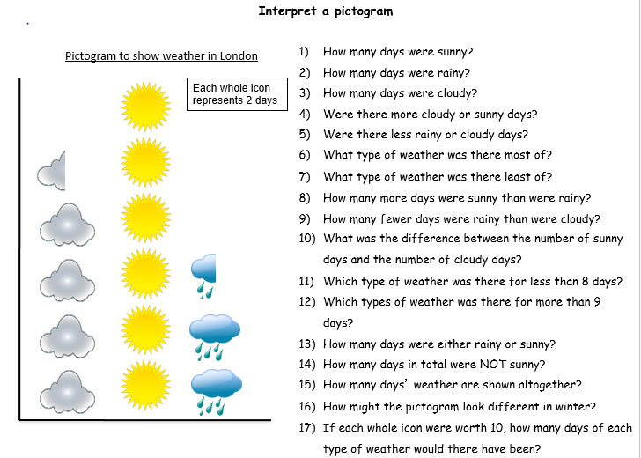

Task 3
Find out what time the sun comes up and the sun sets. Write down these times for a week. Are the times always the same?

Task 4 – Create a sun dial
If you haven’t already made one, create a sun dial.

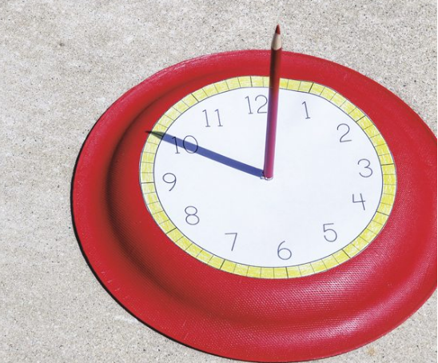

- Paint a paper plate if you wish or leave it blank
- Draw a clock face with even intervals or print off a template if you can
- In the centre, pierce a hole so that you can stand you pencil upright (ask an adult for help)
- Now use it to tell the time. Can you tell the 12 and 24 hour time?

Remember to position the sundial with the ‘12’ pointing north to determine the current time

Task 5
Plot the rainfall for each day on a bar graph/chart. On which day did most rain fall? Find the difference between the most rain that fell and the least rain that fell. Alternatively, complete the other half of the pictogram questions (see task 2).

English
Remember to read every day
Task 1 (20 min)
Write what you know about the sun. I have written a few facts about the rain that you could use as a guide:
You have to wear waterproof clothes. Rain is needed for plants so they can grow. Animals and birds need shelter from the rain. The rain fills up rivers and reservoirs with water that we can use in our homes and drink. In some places in the world, it rains much more than here, such as rainforests. In some places in the world it doesn’t rain at all, such as deserts
Task 2
Write a poem about the weather. You can choose one weather system or the weather in general
An acrostic poem might be fun:
Whistling in the tress
Inspecting all nooks and crannies
Naughty and noisy
Daring and bold

Task 3
Write about snow. See task 1

Task 4
Read a poem (about weather if you can), learn it and perform it to your family

Task 5 (if you have a password 3 x 20 min)
Nessy https://www.nessy.com/uk/

Science:
Task 1 – Make a wind sock
Materials needed
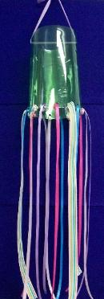
Scissors
Bottles
Glue
Decorative objects
Ribbon
Stapler
Hole puncher
Pipe cleaners

Instructions
- Use scissors to cut out the centre of a bottle.
- Decorate the bottle
- Staple the ribbons to bottom of the bottle
- Hole punch two holes at the top of the bottle, one on one side and another directly opposite.
- Feed a pipe cleaner/ribbon through one hole and then through the other side to make a handle.
You have now created a wind sock

Task 2 - Make a tree speak
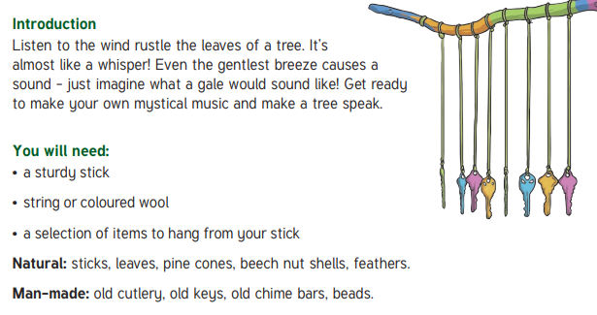
Music
Find some ‘instruments’ around the house to create storm music. Can you make music for a sunny day, rainy day?
Art
Draw, sketch, paint, create a collage of a weather scene. It could be a storm, thunder and lightning, a parched desert. Think about the colours you would use in each scene and why?
General
- Go out to the garden or look from a window and look up at the sky. Observe all the different clouds. How do they look? Can you tell which direction they are moving? Do any of the clouds resemble anything?

- Think about the following question:
What would happen if the weather never changed? What if it was always sunny, stormy? How would it change the world around us? You could write a paragraph or draw a picture to show your ideas.

