Dear Year 6,
It was really lovely to talk to your parents last week and to hear a little bit about what you have been getting up to. Most importantly, I was pleased to hear that you are all safe and well – long may that continue.
We are keeping the suggested timetable on our blogs this week; many of you said you had found it very useful. Now would be a good opportunity for you to practise organising your time and working more independently (if you are not already doing so) – these will be important skills when you move on to secondary school.
As before, the following pages detail some of the tasks that you might want to do for each of the sessions in the timetable. The colours in the timetable match the colours of the headings to help you work out what’s what!
The theme of our learning this week is: Weather.
Have fun and take care of each other.
Mrs Masters x

Suggested Timetable:

45 mins | PE/Walk/Cycle Ride
45 mins | Maths Activity
10.30am | Break
45 mins | English Activity
45 mins | Online Learning Games/Activities
12.30am | Lunch
30 mins | Reading
45 mins | General Activity

Important things to remember are:
- we all work best when we have short sessions with regular breaks
- every day does not have to be the same – it doesn’t really matter what order you do the activities in
- these ideas are suggestions to provide support; you will need to do whatever works best for your own families
- these activities are just ideas – you may have different (better!) ideas – try to do things that you are interested in and motivated by
- some of the tasks will take more than one session – just fill the time and roll activities onto the next day (as we would if we were in school)

Maths Activities
The areas of Maths that you need to practise every week are listed below. You do not need to do them all every day; pick one or two per day. These will be ongoing and you can complete them in any fun ways you can. Some ideas are suggested in brackets for you to try.

Number:
- read, write, order and compare numbers up to 10 000 000

(practise reading and writing large numbers; put large values in order, e.g. house prices – which is the most expensive?)

Times Tables:
- know multiplication and division facts up to 12 x 12

(use online apps and websites such as Hit the Button and Times Tables Rockstars; have a ‘table of the week’ and put post-it notes up around the house with this table on them – constantly recite and practise them and then get an adult to test you – reward yourself with a treat if you get them all right; time yourself to write out or recite your tables – can you get faster each week?)

Measures :
- convert between different units of metric measure - kilometre and metre; centimetre and metre; centimetre and millimetre; gram and kilogram; litre and millilitre
- convert between miles and kilometres
(a great excuse for lots of cooking and baking – convert the values given in recipes; plan a day trip out for when lockdown is over – how far will you travel in miles/km?)

Money:
- estimate costs, add and calculate change in £ and p
- when shopping, calculate 10%, 20%, 25% and 50% off amounts

(use an online grocery website to plan a week of family shopping – can you stick to a budget? Can you use estimation to predict what your final bill will be? How much of your budget would be left over?; Plan a family holiday – where would you like to go? Plan a budget for travel, accommodation & food. Add up the total cost of your holiday.)

Time:
- tell the time using analogue, digital, 12 and 24 hour clocks.
- read and interpret a variety of timetables including, bus, train and TV guides

(practise telling the time, all the time! – work out how long it will be until TV time/bedtime; plan a train journey from St Neots – use online timetables to work out the times of your trains, where you would need to change trains and how long you would have to wait at each station?; plan a family 12-hour telethon using the TV planner – what could you watch and when?)

Task 1:
Over the last 60 years, the temperature in Cambridge has been recorded every week.
The data is shown in the table below:
 | Temperature (measured in °c)
Year | Week 1 | Week 2 | Week 3 | Week 4 | Mean
1960 | 9.5 | 9.6 | 9.7 | 10.0 | 9.7
1970 | 6.9 | 7.2 | 7.4 | 6.9
1980 | 8.0 | 8.4 | 8.6 | 9.0
1990 | 12.1 | 11.9 | 12.4 | 11.6
2000 | 11.1 | 11.2 | 11.3 | 11.2
2010 | 10.2 | 11.1 | 11.1 | 11.2
2020 | 11.1 | 11.1 | 11.2 | 11.0

Remember: you calculate the mean of a set of values by adding them up and then dividing them by the number of values.
For example, in 1960, the mean temperature was:
9.5 + 9.6 + 9.7 + 10.0 = 38.8
38.8 ÷ 4 = 9.7°c
- calculate the mean temperatures for all the other years. Add them to the table.
- draw a graph to show the change in the mean temperature over 60 years. Think about which type of graph would be best – how would you arrange the axes?
- write a couple of sentences to describe any patterns you can see on your graph. Do you think there is any evidence for Global Warming in this data?
If you want to explore more patterns in this data, you can look at the website:
https://www.metoffice.gov.uk/research/climate/maps-and-data/historic-station-data

Task 2:
Kites are commonly flown on windy days. Many people design and make their own kites but they have to use lots of Maths to make sure that their kite will fly successfully.
Kites have to be symmetrical – there is an activity attached to the blog that you can use to explore symmetry and to practise reflecting shapes over a mirror line (the answers are included as well).
You could create symmetrical patterns or even design (and build!) your own kite to fly when we are allowed back into parks and on beaches again.

English Activities
Task 1:
Continue with your daily journal to capture what you are doing during these unprecedented times.
In your daily journal, you could write:
- How you are feeling.
- What you have done at home - this might be any of the work you have done from the blog or anything else that you have done with your family.
- What you have enjoyed about each day.
You might want to include photographs and drawings to decorate your writing.
We will be sharing these with the rest of the class when we return to school. You could use a notebook or make your own scrapbook. You could write your journal on the computer – it is up to you!

Task 2:
Earlier in the year, we learnt about Charles Darwin and his voyage around the world in his ship, ‘The Beagle’. One of the countries he visited was Mauritius.
Find out about the current weather conditions in Mauritius. Can you write a script for a weather report in Mauritius? You might even want to video yourself presenting your weather report – you could also create weather maps/charts to use during your video.
If you can’t research the weather in Mauritius, write a script for a weather report in Buckden or wherever you are now instead.

Task 3:
In the children’s story, The Wizard of Oz, a tornado carries a young girl, Dorothy, and her dog, Toto, to the magical land of Oz. Here, Dorothy follows the yellow brick road all the way to the Emerald City to meet the Wizard of Oz who she hopes will help get her home.
Read the following passage from the book. Can you explain what the highlighted words mean?
Hour after hour passed away, and slowly Dorothy got over her fright; but she felt quite lonely, and the wind shrieked so loudly all about her that she nearly became deaf. At first she had wondered if she would be dashed to pieces when the house fell again; but as the hours passed and nothing terrible happened, she stopped worrying and resolved to wait calmly and see what the future would bring. At last she crawled over the swaying floor to her bed, and lay down upon it; and Toto followed and lay down beside her.

In spite of the swaying of the house and the wailing of the wind, Dorothy soon closed her eyes and fell fast asleep.

She was awakened by a shock, so sudden and severe that if Dorothy had not been lying on the soft bed she might have been hurt. As it was, the jar made her catch her breath and wonder what had happened; and Toto put his cold little nose into her face and whined dismally. Dorothy sat up and noticed that the house was not moving; nor was it dark, for the bright sunshine came in at the window, flooding the little room. She sprang from her bed and with Toto at her heels ran and opened the door.

Task 4:
Write a story in which a character (maybe you) is lifted by a tornado into a different world. What would it be like there? Who would live there? How would your character get home again?

Task 5:
Continue to practise the Year 5/6 spellings (the sheet is attached to the blog to remind you what they are).

Online Learning Games/Activities

Times Tables
https://ttrockstars.com/
https://www.timestables.co.uk/

Power Maths
https://www.activelearnprimary.co.uk/login?c=0
All the activities for Year 6 are now unlocked and available.
Remember the password is: year6 and the school code is: kmm7

French (you can also use this to practise spellings and vocabulary in English)
https://www.linguascope.com/
Username - Buckden Password – Starfish

ICT
Have a go at learning a bit of touch-typing!
https://www.bbc.co.uk/bitesize/topics/zf2f9j6/articles/z3c6tfr

Coding
https://www.rodocodo.com/
All the activities are now unlocked and available. Remember the password is Radcliffe.
You might also want to look at:
https://scratch.mit.edu/

Reading
It is really important that you try to read every day. Regular reading is one of the most important skills that will help you in your transition to secondary school.
Remember you can read silently to yourself, listen to audiobooks or ask your parents to read to you.
This website allows you to download unlimited audiobooks for 30 days for free:
https://www.allyoucanbooks.com/catalog/children?gclid=EAIaIQobChMI4Yi8tfnx6AIVb4BQBh0mog6-EAAYAyAAEgIoaPD_BwE

AR Quizzes
I have looked at and updated your reading targets on AR. Well done to those of you who have taken quizzes
The login for you to take AR quizzes is accessible for you from home and is:
https://ukhosted43.renlearn.co.uk/2152328/default.aspx
You will need your login and password which you should know. Email the office if you can’t remember them and I will send them out to you.

General Activities

Mind-Up:
Mind-Up have released these resources to support you and your parents at this time. There are lots of activities which link to the Mind-Up work and the Brain Breaks that we do in class.
https://mindup.org.uk/families/

Science:
Task 1:
Can you grow a rainbow?!
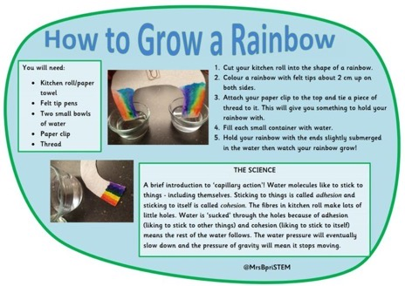

Task 2:
Reflect a rainbow!
What you need: glass of water, sheet of white paper, sunlight.
What to do: Fill the glass all the way to the top with water. Put the glass of water on a table so that it is half on the table and half off the table (make sure it doesn’t fall!). Then, make sure the sun can shine through the glass of water. Next, place the white sheet of paper on the floor. Adjust the piece of paper and the glass of water until a rainbow forms on the paper.

How does this happen? It is called refraction. White light is actually made up of lots of different colours which make the rainbow.
We would have been learning about refraction at school this term. See if you can find out a bit more about it – you may want to research Isaac Newton and what he discovered about refraction.

Task 3:
Investigate shadows – can you make up an investigation about shadows?
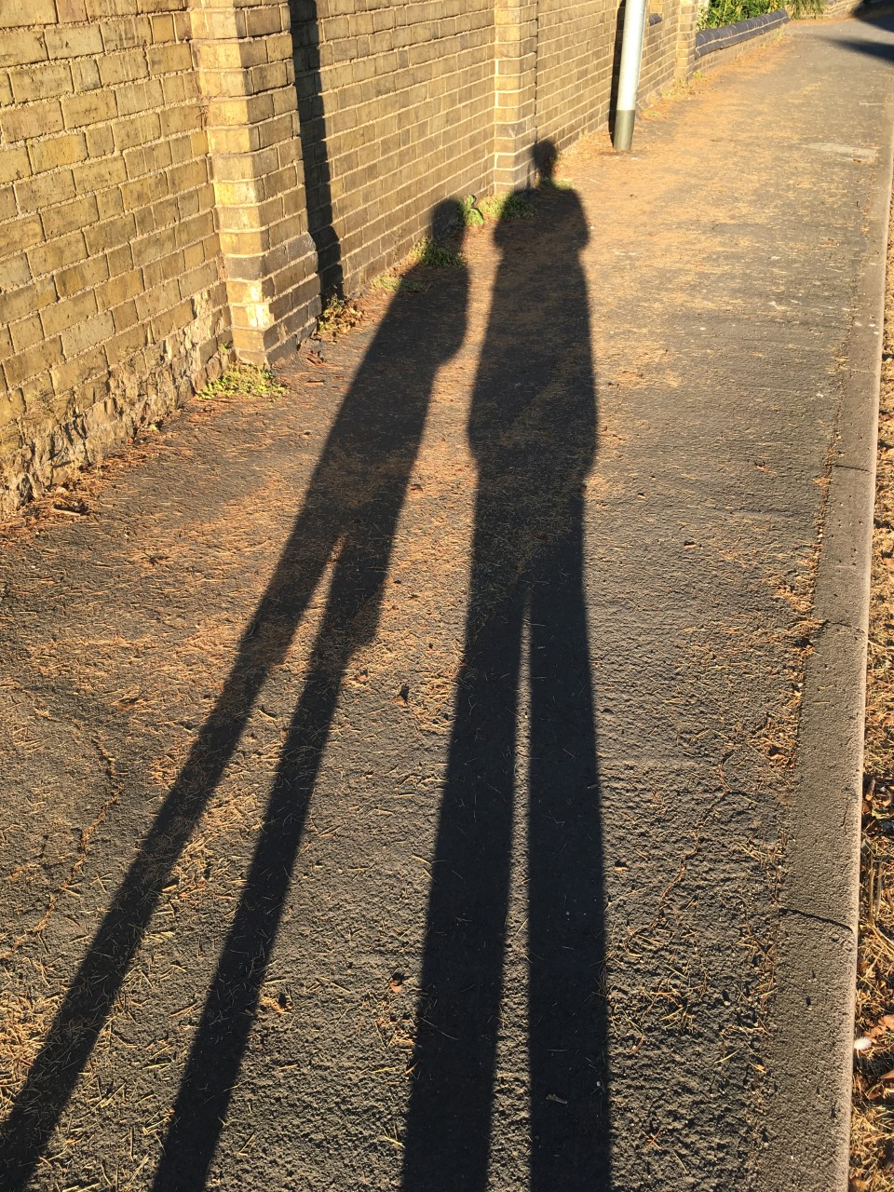
You might want to find out what happens to the size of shadows throughout the day, or think about how you could move objects closer to or further away from the light source to see what happens? Think about making predictions and how you will record your results? What can you discover?
Art:
Task 1:
Shadow Art – use objects to create shapes and patterns which you can then trace onto paper. You could try to create abstract patterns or clearly defined objects. How could you shade and colour your drawings to make them appear three-dimensional?
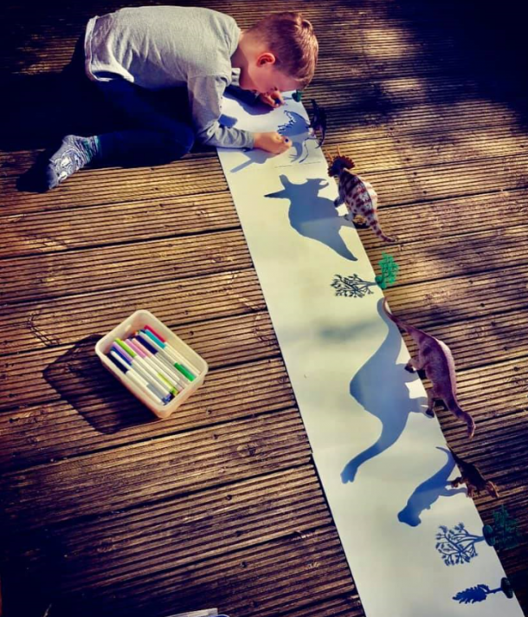

Task 2:
Draw a tree in each of the four seasons (the picture below suggests one way you might do this). Think how the weather conditions might be different in each season and how that might affect your tree’s appearance.
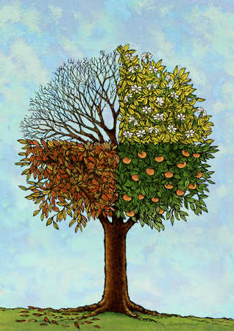

History:
Task 1:
Find out about the Beaufort Scale which is used to measure wind-speed. When was it devised? How was it used? Design a poster to summarise your findings. Can you use the Beaufort Scale to record the wind speed outside every day?

Task 2:
Find out about devices and machines that have been used throughout history to measure weather conditions. Think about those that measure air pressure (barometers), wind speed (anemometers), temperature (thermometers) and also those devices that measure wind direction or rainfall. When were they first used? Who invented them? How have they changed over the years?

Geography:
Task 1:
We would have been studying India this term. You might want to find out about monsoons. Where and when do they happen? You could present your ideas alongside a map of India – mark the main cities, rivers and surrounding countries on your map.
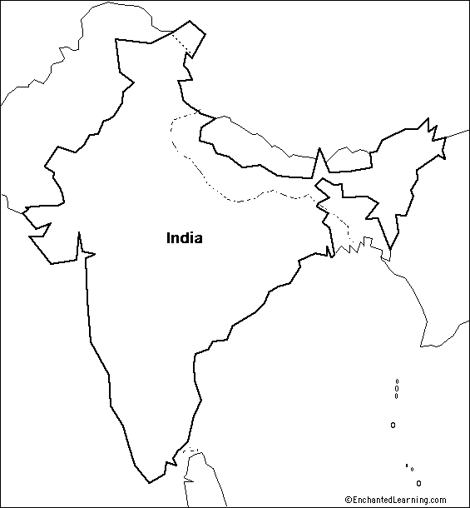
PE:
Create your own sports circuits in your garden or as part of your daily exercise. Think about the different activities you could do – jumping, stretches, runs - do each one for a minute and then move on. Can you set yourself weekly challenges to improve your speed? Or to improve the number of each activity you can complete in a minute?

