27.04.20
Good Morning Usain Bolt,

This week’s theme for our learning is Weather. Make sure you have fun!

Task 1 | AM 20 min | Maths activity
Task 2 | AM 20 min | English activity
10:30 Snack time
Task 3 | AM and PM 2 x 20 min | TT Rockstars/Rodocodo/SPAG
12:30 Lunchtime
Task 4 | PM 20 min | Art activity
Task 5 | PM 20 min | Global learning activity
Task 6 | PM 20 min | Skills Builder/French
2:00 Snack time
Task 7 | PM 20 min | Science
Task 8 | PM 20 min | This could be finishing an activity from earlier or an activity from the general list.
Daily journal and reading

Mathematics Task 1 (20 min)
The activities listed below are key Mathematical areas that the children need to practise every week, they do not need to do them all every day, but pick one or two per day. These will be ongoing and you can complete them in any fun ways you can.
Key Mathematical areas;
Number - count in multiples of 6, 7, 9, 25 and 1000
Times tables recall multiplication and division facts for multiplication tables up to 12 × 12
Measures - Convert between different units of measure - kilometre to metre; hour to minute]
Money - estimate costs, compare costs and calculate amounts in £ and p
Time - read, write and convert time between analogue and digital 12- and 24-hour clocks
convert from hours to minutes; minutes to seconds; years to months; weeks to days.
Make sure you are practising your timestables as much as you can, make your own board game with timestable calculations.
https://www.topmarks.co.uk/maths-games/7-11-years/times-tables
https://www.timestables.co.uk/
In your design of your sun dial or weather station, write the measurements needed to create it.
Create a graph to record your data from your sun dial/ weather station experiment. Plot your data for the day or over the week and join them to create a line graph.
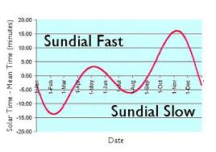
Abacus - The children can access this resource via the website https://www.activelearnprimary.co.uk
The password is year4 and the school code kmm7 in the bottom box.
Choose a city in the United Kingdom or within Europe (maybe you could use one of the countries we have had a text from within our DIALLS lessons). Then, compare the temperatures of your chosen city to a city within another part of the world, perhaps choose a country where there will be minus temperatures. See if you can record the temperatures across the week using the weather forecasts and make a poster displaying the thermometer readings for each day, in each country. What were the differences in the readings on each day?
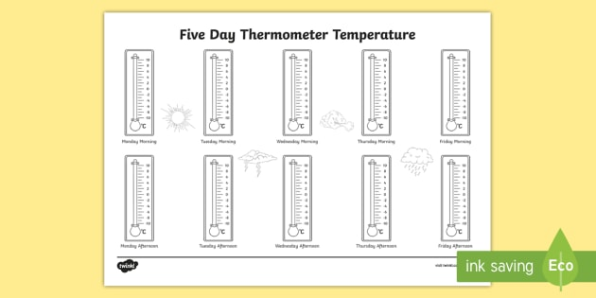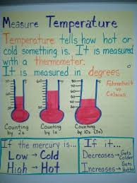
If you have a thermometer at home, you could take a reading in the morning and in the afternoon and see if you can spot any patterns within your data.
English Task 2 (20 min)
Watch a weather report and take notes of the key vocabulary you will need.
Plan your weather report and look up definitions for your key vocabulary.
Become a news and weather reporter, write a weather report for your region and across the world.
If possible, you could ask an adult to record you.
Self-evaluate your report and assess ways you could make improvements. You could further develop your report by preforming it again, using these changes.
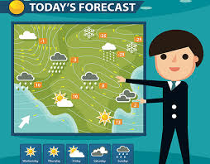
Reading
Remember to read EVERYDAY.
The Accelerated Reader (AR) programme is also accessible from home during this time too, so once you’ve finished your books make sure you log on and take a quiz. https://ukhosted43.renlearn.co.uk/2152328/default.aspx
Task 3 (20 min)
Time Tables Rock Star - https://play.ttrockstars.com/auth/school/student/76329
Rodocodo - https://game.rodocodo.com/
SPAG - https://www.topmarks.co.uk/english-games/7-11-years/spelling-and-grammar
Art/DT Task 4 (20 min)
Create a weather map for your weather report.
Design a sun dial or weather station.
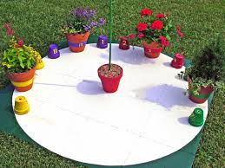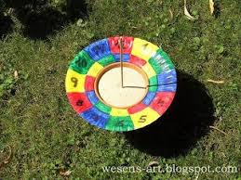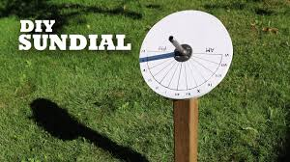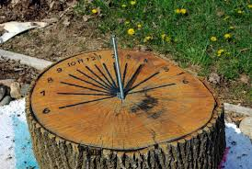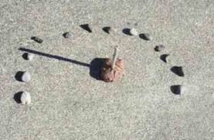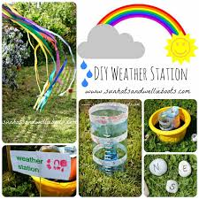
Make a sun dial.
Global learning Task 5 (20 min)
Research about different climates across the world.
Keep a daily weather record and compare our country’s climate to others around the world.

Find out about different cloud types.
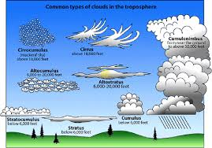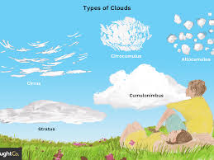

Task 6 (20 min)
Skills builder
https://www.skillsbuilder.org/homelearning
French
Find out some weather vocabulary in French, can you use your opinion vocabulary we have previously learnt and write a statement about which weather you like or dislike.
(Log in – Username - Buckden Password – Starfish)
https://www.linguascope.com/
Science Task 7 (20 min)
Write up your sun dial or weather station experiment. Include; equipment, predictions (when the sun will be the highest in the sky, what will happen to the shadow), method, results (what you found out) and conclusion (why you think those results happened).
General activities
Remember to keep active!
- Yoga
- PE - Join Joe Wicks for a PE lesson. He is on YouTube every weekday.
https://www.youtube.com/watch?v=lEWcBIvqjDk
- Make up a dance or gymnastic routine
- Get in touch with a friend or family member
- Have a reusable fashion show (Make your outfit out of recycling materials)
- Be mindful, lay down on the ground and see what shapes you can see in the clouds.
- Make a paper fidget spinner
https://www.redtedart.com/ninja-fidget-spinner-diy/?cn-reloaded=1

You could also try these; https://www.youtube.com/watch?v=bZ8PShMOXps 

In your journal you write:
- How you are feeling,
- What you have done (this can be any of the work you have done from the blog and anything that you have done whilst at home),
- What you have enjoyed each day.

