20.04.20
Welcome back, I hope you all had a very enjoyable Easter.
Each week as a school we will have a different theme to our learning, this week is Plants and Animals. This is a suggestion of how much learning to do over a day with a year 4 child. These slots add up to 3 hours of learning, split into small chunks with breaks. Of course what is important is that you do what works best with your family. The work listed below is more than enough for 5 days of 3 hours of learning, so choose the tasks that you would prefer to do. Short learning bursts are more productive for your working memory, make sure you have fun with your learning too!
Task 1 | AM 20 min | Maths activity
Task 2 | AM 20 min | English activity
10:30 Snack time
Task 3 | AM and PM 2 x 20 min | TT Rockstars/Rodocodo/SPAG
12:30 Lunchtime
Task 4 | PM 20 min | Art activity
Task 5 | PM 20 min | Global learning activity
Task 6 | PM 20 min | History
2:00 Snack time
Task 7 | PM 20 min | Science
Task 8 | PM 20 min | This could be finishing an activity from earlier or an activity from the general list.
Daily journal and reading

The school would love you to start a journal to capture what you are doing at home during this time, these will be share with me and your peers. In your journal you write:
- How you are feeling,
- What you have done (this can be any of the work you have done from the blog and anything that you have done whilst at home),
- What you have enjoyed each day.
I can’t wait to see your journals!

Mathematics Task 1 (20 min)
The activities listed below are key Mathematical areas that the children need to practise every week, they do not need to do them all every day, but pick one or two per day. These will be ongoing and you can complete them in any fun ways you can.
Key Mathematical areas;
Number - count in multiples of 6, 7, 9, 25 and 1000
Times tables recall multiplication and division facts for multiplication tables up to 12 × 12
Measures - Convert between different units of measure - kilometre to metre; hour to minute]
Money - estimate costs, compare costs and calculate amounts in £ and p
Time - read, write and convert time between analogue and digital 12- and 24-hour clocks
convert from hours to minutes; minutes to seconds; years to months; weeks to days.

Make sure you are practising your timestables as much as you can, you can do this using chalks on the path, making spinners, do an obstacle course and answer the calculations as you go over each obstacle or multiplication bingo.
Code-cracking games – Make your own code cracking games linking to plants and animals. Remember the codes we learnt at Bletchley Park.
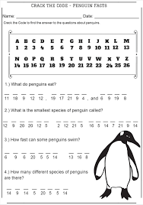
Cooking with your child is an excellent way to practise and talk about key maths skills – counting eggs for a cake recipe, measuring and weighing ingredients together. Best of all, you both get to enjoy a tasty treat at the end!
Have a look out of a window or in your garden and observe the birds or insects that you find over a period of about 15 minutes. Create a tally of what you see. Then, plot your result into a graph, to extend this you could do this at a variety of different times of the day on different days and compare your findings.
English Task 2 (20 min)
Watch the live cameras at some zoos around the country and write a diary entry as the animal.
https://www.zsl.org/london-zoo-webcam?gclid=EAIaIQobChMIyt6vrZLv6AIVKYBQBh2SEgF_EAAYASAAEgJDGfD_BwE&gclsrc=aw.ds
https://www.zsl.org/whipsnade-zoo-webcam
https://www.chesterzoo.org/virtual-zoo/
Make up your own crossword puzzles or word searches with a plant and animal theme, see if you can challenge your family to play them.
Play around with anagrams to help with patterns and spelling. For example, make as many words as you can out of Constantinople (1697 apparently!). Research the longest plant and animal names and see how many words you can make.
Reading
Remember to read EVERYDAY.
The Accelerated Reader (AR) programme is also accessible from home during this time too, so once you’ve finished your books make sure you log on and take a quiz. https://ukhosted43.renlearn.co.uk/2152328/default.aspx
Play Junior Trivial Pursuit which requires lots of reading and develops general knowledge at the same time (you can create your own or find a virtual version).
Don’t forget that games like karaoke require on-screen reading and a performance too.
Task 3 (x2 20 min)
Time Tables Rock Star - https://play.ttrockstars.com/auth/school/student/76329
Rodocodo - https://game.rodocodo.com/
SPAG – https://uk.ixl.com/ela/topics?partner=bing&adGroup=Search%20-%20ELA%20-%20General%20-%20Exact%20-%20UK+Spelling%20Activities&msclkid=d23454f24612198b48640a6bf8353bbb&utm_source=bing&utm_medium=cpc&utm_campaign=Search%20-%20ELA%20-%20General%20-%20Exact%20-%20UK&utm_term=spelling%20games&utm_content=Spelling%20Activities
Art Task 4 (20 min)
Learn the art of origami, see how many different animals you can make.
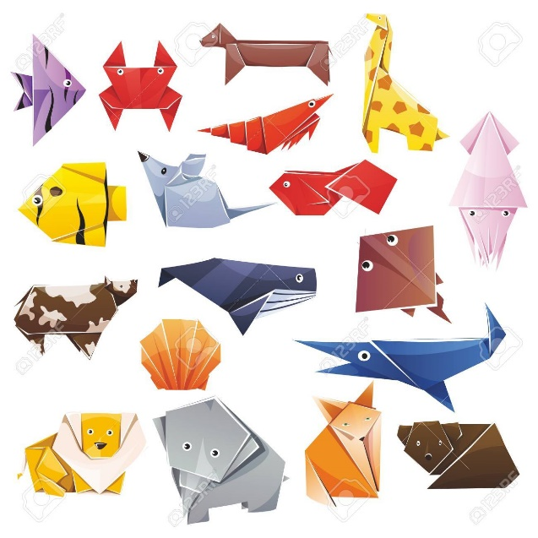
https://www.origamiway.com/origami-animals.shtml
Learn to draw one of the animals you have found out about. http://www.robbiddulph.com/draw-with-rob https://www.youtube.com/watch?v=0IAJKTE20cM&vl=en-GB
Design your own animal or artwork using lots of different medium, this could include natural materials too. Research about the artist Andy Goldsworthy and Martin Ridley.
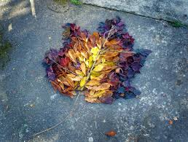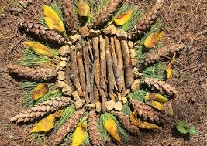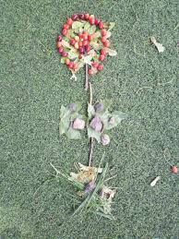

Global learning Task 5 (20 min)
Take a virtual tour of a museum and learn something new about a prehistoric animal. https://www.nhm.ac.uk/visit/virtual-museum.html?gclid=EAIaIQobChMIgND7o7bv6AIV34BQBh0c6QAaEAAYASAAEgIrX_D_BwE
Pick a country and research what animals and plants are native to it. Learn about their habitats and diets, creating an animal and plant fact file using all your new facts.

History Task 6 (20 min)
Create your family tree.
Make a time capsule to open in 10 years’ time remember to include your favourite animal, colour, song, television program and plant.
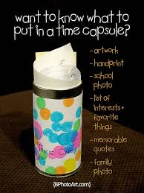
Science Task 7 (20 min)
Build the tallest tower with natural objects. Can you build it taller than you?
Make ice cubes from various liquids and compare how long each one takes to freeze. Experiment to see if adding any natural items like flowers or grass affects the melting point.
Plant a seed and watch it grow. If you can plant it in a clear cup/glass or pot, to see if you can watch the roots. If you are unable to do this you can observe what happens to a bean through this link; https://www.youtube.com/watch?v=pg92cspLy0I

General activities
Remember to keep active!
- Yoga
- PE - Join Joe Wicks for a PE lesson. He is on YouTube every weekday.
https://www.youtube.com/watch?v=lEWcBIvqjDk
- Make up a dance or gymnastic routine
- Make a wind chime
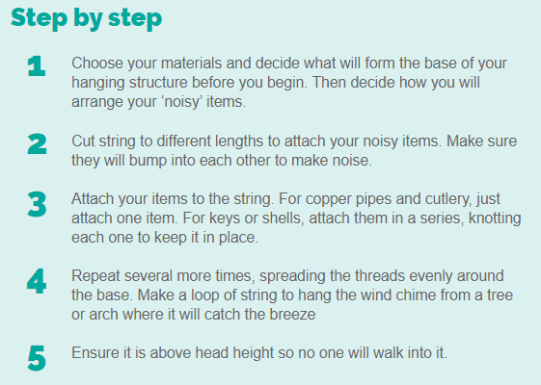
- Make a teddy zip wire
https://www.science-sparks.com/teddy-zip-wire/
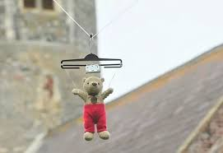
- Get in touch with a friend or family member

