20th April
Dear Kenny class,
Hello everyone! We are really missing you all but I really hope you are having a good time whilst you are at home. Here are some ideas for you to be working on whilst you are at home this week.
The school would love you to start a journal to capture what you are doing at home during this time. The journal could be some kind of notebook or a scrap book or even stapled paper is fine.
In your journal you write:
- How you are feeling
- What you have done. This can be any of the work you have done from the blog and anything that you have done whilst at home.
- What you have enjoyed each day.
I can’t wait to see your journals!
Take care and stay safe
Hopefully I will see you all soon
Mrs Woodward and Mr Palmer
x
This is a suggestion of how much learning to do over a day with a reception child. Aim for a maximum of 2 hours focused learning interspersed with play based learning and physical activity. Of course what is important is that you do what works best with your family. The work listed below is more than enough for 5 days of learning so choose the tasks that you would prefer to do.
am 30 min | Sports/ physical activity- Joe Wicks as a suggestion
am 20 min | Maths activity – Exploring patterns
am 20 min | Fine Motor control activity- like lego, puzzle, drawing, writing, cutting.
10:30 | Snack time- can you help prepare it?
am 2 x 20 min | Reading/ Sharing a story/ Phonics online game- see ideas below  Focus on – sk pt nt st xt (these all appear at the end of words)
12:30 | Lunchtime
pm 1 hour or longer if you are having fun! | An activity from the ideas below and/or independent learning through play time where your child makes choices.
Pm 20 min | Complete your journal for the day- draw and or write

What animals and plants live in the local environment?
Idea 1
Grow a plant and measure it every day (A runner bean seed on tissue in a plastic bag will allow you to measure the roots growing too!). You could make a bean diary and draw the bean each day. Use whatever seed you have.
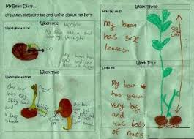
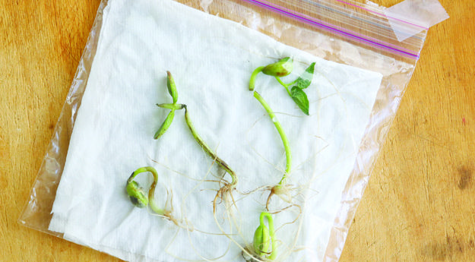

This is a video of a bean growing https://www.youtube.com/watch?v=pg92cspLy0I

Idea 2
Nature detective time! Dig, search, explore and observe plants and creatures in your garden or outdoor space. Can you name any of them? How can you find out more about the things you find? Did you know all insects have 6 legs, a head, a thorax and an abdomen?


Idea 3
Tally chart- can you record how many of each item you can find using a tally chart like this:
Plant/ Creature | Tally | Total
Ant | IIII | 4
Daisy | II | 2
Bird | III | 3

Which item did you find the most of? Which was least frequent?

Idea 4
Online learning sites www.phonicsplay.co.uk,
www.phonicsbloom.co.uk, www.topmarks.co.uk, www.ictgames.co.uk www.readingeggs.co.uk (free subscription available) www.teachyourmonstertoread.com,

Idea 5
This is a link to some more maths information on the WhiteRose maths site. This is a scheme of work that we use in school https://whiterosemaths.com/homelearning/early-years/ It’s free to parents to use if you wish. Also, www.topmarks.co.uk has a wide range of counting, adding and subtracting games in suitable in the early years section.

Idea 6
Can you design a new animal? Look at the pictures below to remind yourself of just how different animals can be. Draw a picture of your new animal (if you have some play dough you could make a model). Think about how many legs and arms you want it to have. Do you want your animal to have fur or scales? What colour is the animal? Remember it’s totally up to you it can look very different to any animal that already exists!
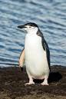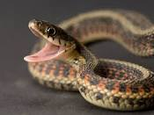

Idea 7
When you are happy with your drawing can you label it to describe it? Don’t forget to use adjectives before a noun to really describe your animal, e.g. It has purple, fluffy fur. What is your animal called?
Idea 8
Write a sentence or words to describe how your animal moves. Pretend to be your animal and decide if it slides on its belly, or walks elegantly with tall legs or maybe it jumps like a springy frog.
Idea 9
Answer these questions (try to use because, but or if in your answers).
- Is your animal vicious or gentle?
- What does your animal eat?
- Where does your animal live?
- Do you think your animal might have a predator? What would that look like?
Idea 10
Use a crayon to do some rubbings of leaves. Can you find out which plant the leaves are from?
Idea 11
Make a collection of nature- can you sort it into categories- hard/ soft, green/ not green, living/ not living.

Idea 12
Could you draw an animal (any animal) and make it into a collage? You can use old magazines for the coloured paper.
Use these for ideas:
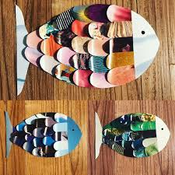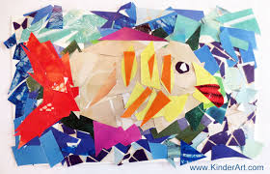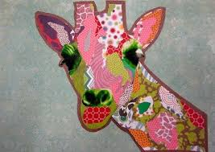
Idea 13
Can you make a home/ habitat for a creature using some items from your recycling bin?
Idea 14
Can you use items like leaves, stones, sticks to make a pattern or even a picture?
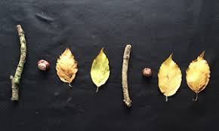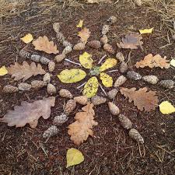

Idea 15
Can you be a nature pirate? Find a little box and see how much tiny treasure you can put in it.
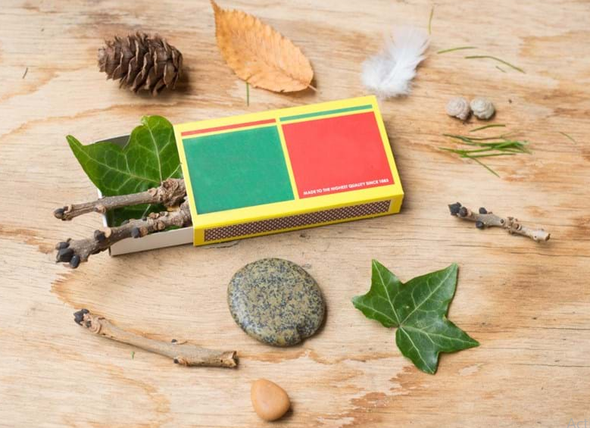

Idea 16
Life cycle of the caterpillar. A lovely thing to do is watch this first hand and you can buy kits to do this from https://www.insectlore.co.uk/butterflies/live-butterfly-kits/butterfly-garden-with-3-5-live-caterpillars.html if you want to try at home.


