20th April
Dear Simone Biles Class,
Hello everyone! I’m really missing you all but I really hope you are having a good time whilst you are at home. Here are some ideas for you to be working on whilst you are at home this week.
The school would love you to start a daily journal to capture what you are doing at home during this time. These will be shared together with me and the rest of the class once we return to school. In your journal you should write:
- How you are feeling?
- What you have done? This can be any of the work you have done from the blog and anything else that you have done whilst at home.
- What you have enjoyed each day?
I can’t wait to see your journals!
Take care and stay safe,
Hopefully I will see you all soon
Mr Burfiend

This is a suggestion of how much learning to do over a day with a year 3 child. These slots add up to 2½ hours of learning split into small chunks with breaks. Of course what is important is that you do what works best with your family. It would also be good to ensure you fit in some active time; many children are enjoying Joe Wicks live on YouTube at 9am (though you can always watch the video later in the day).
The work listed below is more than enough for this suggested timetable so choose the tasks that you would prefer to do.
am 20 min | Maths activity
am 20 min | English activity
10:30 approx | Snack time
am 30 min | TT Rockstars / Rodocodo / Nessy / BBC bitesize / Topmarks / etc
am 20 min | Reading  AR quizzes can be done between 08:45 and 15:15 at this exact website  https://ukhosted43.renlearn.co.uk/2152328/default.aspx
12:30 | Lunchtime
pm 30 min | Activity of child’s choice, ideally something creative. This would be a great time to do something together, or if there are siblings for them to work together on something.
pm 30 min | An activity from general activities list

Can the same plants and animals grow in different places?

Maths
As well as attempting some of the Tasks, please ensure all of these skills are practised during each week. These are to reinforce what your child has already learned and will probably remain the same each week.
Number - count from 0 in multiples of 4, 8, 50 and 100
Times tables - practice multiplication and division facts for the 3, 4 and 8 times tables
Measures - measure items in m/cm/mm kg/g ml/l
Money - add and subtract amounts of money to give change,
Time - tell and write the time from analogue, 12-hour and 24-hour clocks
- know the number of seconds in a minute and the number of days in each month, year and leap year

Task 1 (20 min to set up, then 5 min a day to measure and plot on a graph)
Grow a plant and measure it every day (A runner bean seed on tissue in a plastic bag will allow you to measure the roots growing too!). Can you plot a graph to show the plant growing? You could make a bean diary and draw the bean each day. Use whatever seed you have.
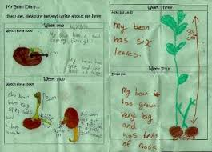
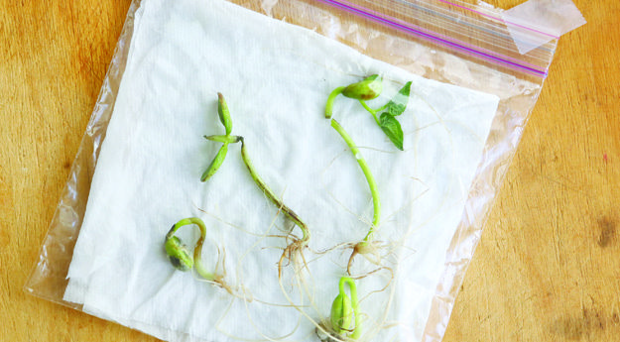

This is a video of a bean growing https://www.youtube.com/watch?v=pg92cspLy0I

Task 2 (20 min)
Throw a hoop on the grass and count the different plants in the hoop or can you count different plants in your garden? How could you use this to help guess how many plants are in the whole garden?
If it’s raining can you count the different flowers in this picture? Write a list of the number of plants that you found.


Task 3 (2 x 20 min)
Word problems (draw pictures to help you!)
- There are 6 rows of carrots with 5 carrots in each row. A rabbit eats 13 of the carrots. How many carrots are left?
- If three flowers each have 6 petals and 4 other flowers have 5 petals each, how many petals are there in total?
- There are a total of 64 cabbages growing in 4 rows. How many cabbages are in each row?
- a) I buy 3 roses and the total cost is £6.30. How much did each rose cost?
b) I pay for the roses with a £10 note. How much change do I get?
c) What combination of coins might the shop keeper give me to make the correct change? Try and make 3 different sensible combinations of coins.

Task 4 (2 x 20 min per week)
TT rockstars https://ttrockstars.com/

English
Remember to read every day
Task 1 (20 min)
Can you design a new animal? Look at the pictures below to remind yourself of just how different animals can be. Draw a picture of your new animal (if you have some play dough you could make a model). Think about how many legs and arms you want it to have. What habitat does it live in? Do you want your animal to have fur or scales? What colour is the animal and why? What does it eat? Remember it’s totally up to you; it can look very different to any animal that already exists!
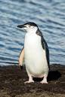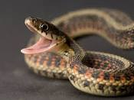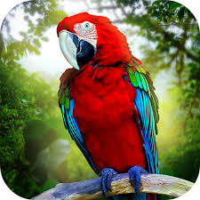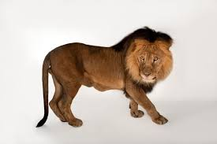

Task 2 (20 min)
When you are happy with your drawing can you label it to describe it? Don’t forget to use noun phrases to really describe your animal, e.g. It has purple, fluffy fur under its belly. What is your animal called?

Task 3 (20 min)
Write a paragraph to describe how your animal moves. Use adverbs to describe the movement and describe the environment it’s moving through. Pretend to be your animal and decide if it slides on its belly, or walks elegantly with tall legs or maybe it jumps like a springy frog.

Task 4 (20 min)
Answer these questions in full sentences (try to use connectives such as because, but or if in your answers).
- Is your animal vicious or gentle?
- What does your animal eat?
- Where does your animal live?
- How is your animal suited to where it lives?
- Do you think your animal might have a predator? What would that look like?

Task 5 (if you have a password 3 x 20 min)
Nessy https://www.nessy.com/uk/

Science
In your maths tasks you have observed where different plants are growing and at school we were learning about what plants need to live. Where a plant grows is its habitat. Animals are suited to the place that they live e.g. seals have blubber to keep them warm in the cold sea, giraffes have long necks to reach leaves on tall trees.
Task 1 (2 x 20 min sessions)
Try and find out about the life cycle of a flowering plant. In particular find out what the words pollination, fertilisation, seed dispersal and germination mean. Which of these 4 terms is the flower (the flower part of the flowering plant) important for?

Task 2 (20 min)
Make a poster, a powerpoint or a factfile about the different way seeds can be dispersed. Maybe you could act out these ways?

Task 3 (20 min)
You already know that animals are adapted to the place that they live e.g. seals have blubber to keep them warm in the cold sea, giraffes have long necks to reach leaves on tall trees.
Many plants are also adapted to their habitats. Find out about how some plants are adapted to their habitats. It might be there size, the length of their roots, the type of leaves they have or anything.

Task 4 (20 min)
Can you design a new plant to live in one of these habitats: the rainforest, the desert, a tall mountain, the Arctic, under the sea.
What adaptations make it suited to living there?

Art
Task 1 (2 x 20 min sessions)
Could you draw an animal (any animal) or plant and make it into a collage? You can use old magazines for the coloured paper.
Use these for ideas:
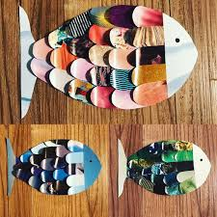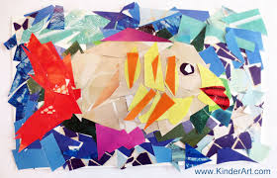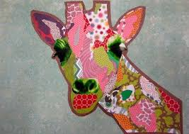

Task 2 (20 min)
If you want to you could add its habitat.

Task 3 (20 min)
Use this website: Rob Biddulph draw with Bob http://www.robbiddulph.com/draw-with-rob
to draw an animal of your choice. This site is a lot of fun.
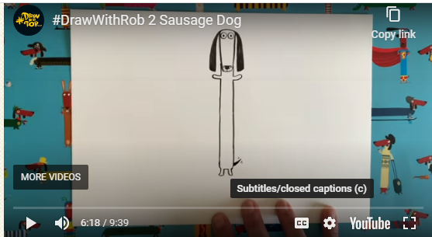

General ideas
https://www.rodocodo.com/
Make some ice lollies
Can you be a nature pirate? Find a little box and see how much tiny treasure you can put in it.
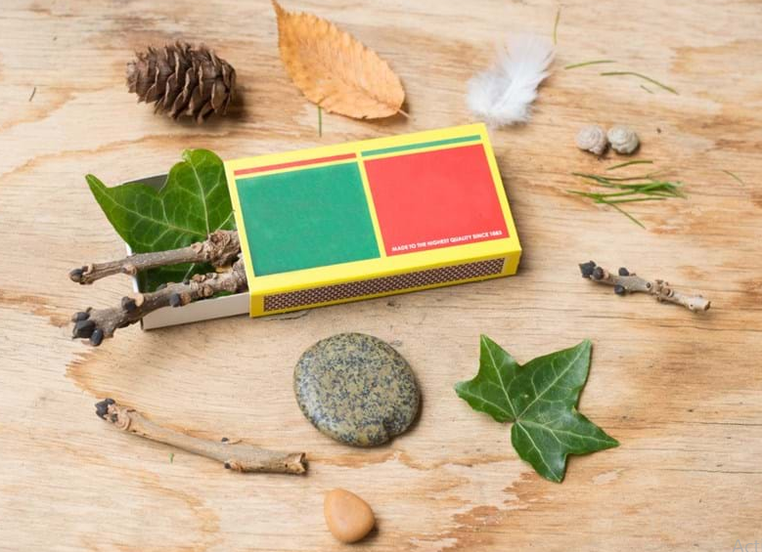

Make a wind chime
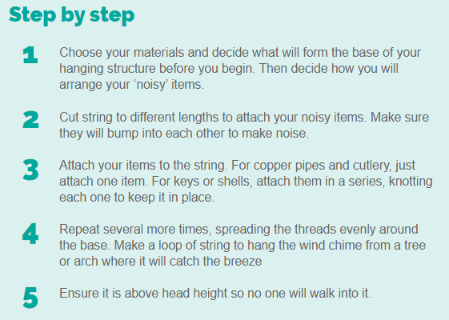
Make a teddy zip wire https://www.science-sparks.com/teddy-zip-wire/


