Hi everyone, we hope you and your family are well and staying safe and that you managed to enjoy the lovely weather we have been having.
Here are some ideas for you to be working on whilst you are at home this week.
The school would love you to start a daily journal to capture what you are doing at home during this time. In your daily journal you write:
- How you are feeling.
- What you have done. This can be any of the work you have done from the blog and anything that you have done whilst at home.
- What you have enjoyed each day.
Below is a table suggesting how much learning to do over a day with a year 5 child. These slots add up to 4 hours of learning, split into small chunks with breaks. Of course what is important is that you do what works best with your family. The work listed below is more than enough for 5 days of 4hr learning so choose the tasks that you would prefer to do.
Please also ensure that you include some daily physical activity, Joe Wicks uploads a PE lesson on YouTube every day, these are good fun and you can access these when you would like to.
We also expect that you read daily, whether this be a story, magazine, information book or poetry. You can complete AR quizzes using this link: https://ukhosted43.renlearn.co.uk/2152328/default.aspx
am 45 min | Maths activity
am 45 min | English activity
10:30 | Snack time
am 2 x 30min | TT Rockstars/Rodocodo/Nessy
12:30 | Lunchtime
pm 45 min | Something unfinished from the morning or maybe some art
pm 45 min | An activity from general activities list

Please see below your home learning for this week.
Plants and Animals
Maths
Task 1 (45 min)
Bird spotting – record using a tally chart the different birds that you spot in your garden. Put this information into a graph. What questions can you ask about the information found in the graph.
Maybe you could do this for 2 or 3 days, or at different times of the day, what did you notice about the different birds you spotted?

Task 2 (45 min)
Uncle Raj has three children. Next year, when they've had their birthdays, Naomi will be 5, Alex will be 6 and Chris will be 7. The family has decided on something rather unusual for part of their presents.
All three children have their birthday in the late spring and since they are keen on gardening they are going to buy some plants for the garden, one for each year they have been alive.
Here is the plan of their house and garden:
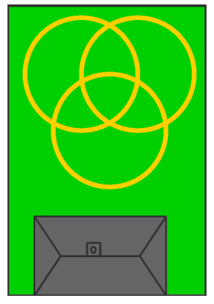
You notice that there are three circular paths that cross over each other. Each child is to have a circle but there will be some bits that are shared, around the middle.
When the time comes, the four of them go off to the garden centre to choose the plants. They do not have a lot of money so they're looking for special offers. They find a very special offer which gives a good discount if you buy ten plants altogether. This is their idea:
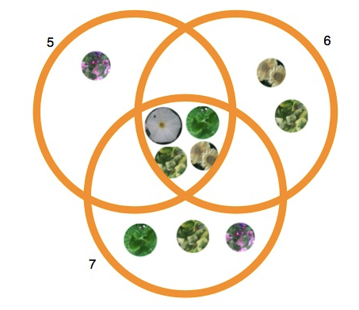
Well now it's your turn to have a go and find some different solutions.
REMEMBER:- You must use exactly ten plants (no more, no less)
REMEMBER:- The circles must contain 5, 6 and 7 plants (no more, no less).
As you try, you may find that you are developing a system for getting the next one. If so, we'd love to hear about it. You might like to try to find them all, and write about all the things you notice about each solution.

Task 3 (45 mins)
Animals of the African Savannah: Measurement Factsheet

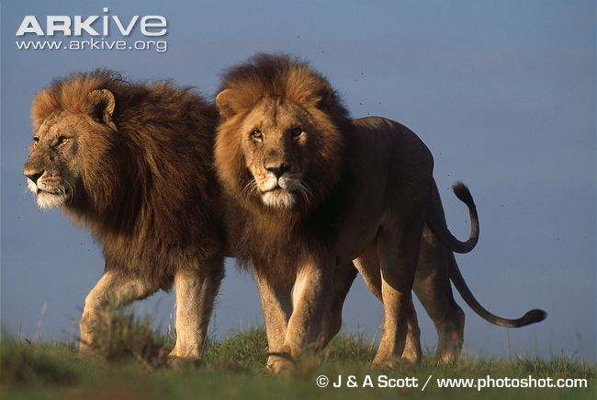 | 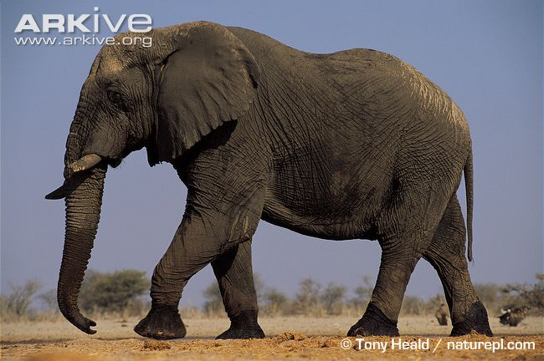 | 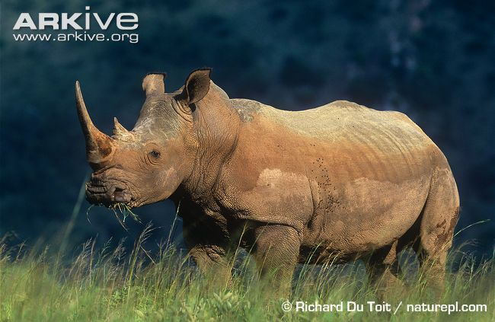
Lion  (Panthera leo)  Height: 1.2 m  Length: 2.1 m  Weight: 195 kg | African elephant  (Loxodonta africana)  Height: 3.3 m  Length: 6.75 m  Weight: 6,000 kg | White rhinoceros  (Ceratotherium simum)  Height: 1.78 m  Length: 3.85 m  Weight: 2,300 kg
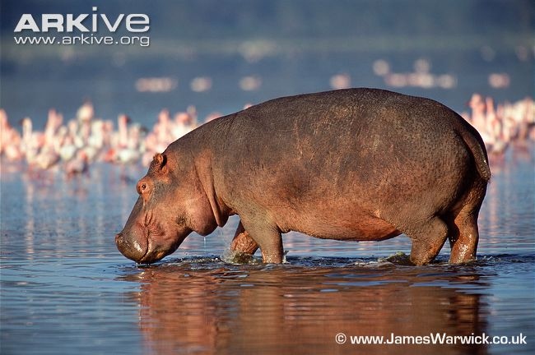 | 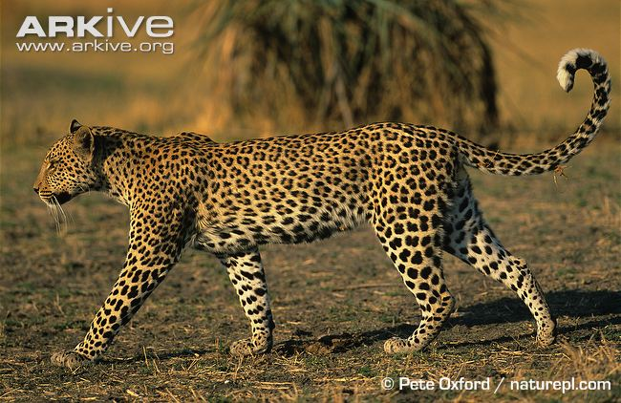 | 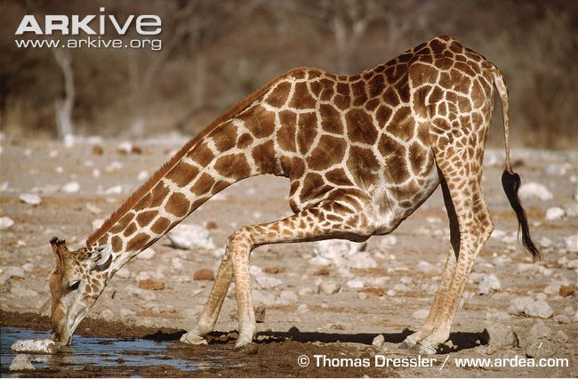
Hippopotamus  (Hippopotamus amphibius)  Height: 1.5 m  Length: 4.2 m  Weight: 2,400 kg | Leopard  (Panthera pardus)  Height: 0.63 m  Length: 1.45 m  Weight: 50 kg | Giraffe  (Giraffa camelopardalis)  Height: 5.3 m  Length: 4.25 m  Weight: 1,516 kg
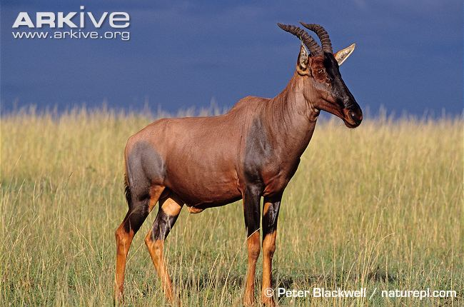 | 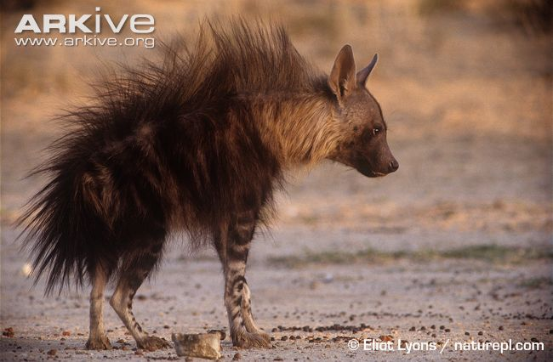 | 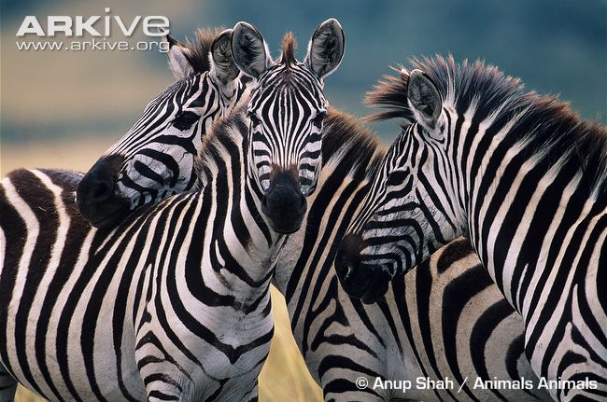
Topi  (Damaliscus lunatus)  Height: 1.15 m  Length: 1.78 m  Weight: 118 kg | Brown hyaena  (Hyaena brunnea)  Height: 0.75 m  Length: 1.18 m  Weight: 48 kg | Plains zebra  (Equus quagga)  Height: 1.28 m  Length: 2.32 m  Weight: 280 kg

1. Fill in the table below with the height, length and weight of each of the species on the ‘Animals of the African Savannah: Measurement Factsheet’.

2. The measurements are given in metres (m). Can you convert them into centimetres (cm) and add them into the table?

 | Height |  | Length |  | Weight
 | Metres (m) | Centimetres (cm) | Metres (m) | Centimetres (cm) | Kilograms (kg)
African elephant
Hippopotamus
Giraffe
White rhinoceros
Plains zebra
Topi
Brown hyaena
Leopard
Lion

Task 4 (2 x 30 min per week)
TT rockstars https://ttrockstars.com/
Power Maths

English
Remember to read every day
Task 1 (45 min)
What is your favourite animal? Create an information page all about that animal, include the habitat that it lives in and explain how it has adapted to this environment.

Task 2 (45 min)
Choose an animal from the maths worksheet above, create a poem about one of those animals. Think about how they move, hunt for food, take care of their young.

Task 3 (45 min)
In the news there have been reports that many plants from garden centres will go to waste as they are closed. Do some research about this and create a newspaper report about this problem. Think carefully about the features you need to include in the article.
Task 4 (45 min)
Read the text below, what do the words in red mean? Remember, don’t use a dictionary straight away, what do you think they mean first, use the sentence it is in to help you. Then create questions you could ask about it.
Sir David Attenborough – Naturalist and Presenter
As the world's most famous naturalist, Sir David Attenborough has brought amazing wildlife to television screens for over 50 years. From series such as Life on Earth to Frozen Planet, his documentaries have inspired generations to learn more about the natural world.
Early Years
Born in 1926, David Frederick Attenborough into a well-off family with two brothers, John and Richard. During World War II, his parents took in two Jewish girls who had fled the Nazis and they were treated like family. His brother Richard went on to great success as an actor and film-maker, starring in Hollywood blockbuster films such as Jurassic Park.
David became fascinated by natural history in his early childhood. In fact, by the age of seven he had already created his very own "museum" of bird eggs, old stamps and ancient fossils.
University and Early Career
After school, David studied natural sciences at Cambridge, but was reluctant to become an academic, disliking the idea of being stuck in labs and lecture theatres all his life. On finishing his studies, David joined the Royal Navy hoping to see the world, but didn't get very far; he was posted to North Wales and Scotland.
Family
In 1950 Attenborough married Jane Elizabeth Ebsworth Oriel; she died in 1997. The couple had two children, Robert and Susan. Robert is a senior lecturer in bioanthropology for the School of Archaeology and Anthropology at the Australian National University in Canberra.
Joining the BBC
David joined the BBC in 1952. His boss at the BBC initially told Attenborough he shouldn't actually work in front of the cameras as his "teeth were too big" but he had always wanted to present wildlife documentaries and after several years he started to make a name for himself, making the successful Zoo Quest series. By 1965 he was elevated to the post of Controller of BBC2, where he oversaw the introduction of colour TV to Britain, and only a few years later was made Director of Programmes for BBC1 and BBC2.
Wild World
David returned to his first love of making natural history documentaries in 1973. Several successful years of making wildlife programmes peaked with his series Life on Earth in the late nineteen seventies, at the time the most ambitious series the BBC had ever produced.
The Working Process
David begins any series with a general outline of the questions he wants to ask and answer, followed by a dialogue over many months with the prospective programme's researchers and producers. Once a massive file of notes has been accumulated, only then does David begin his travels.
What is David like to work with?
David writes all his own scripts and has won literary prizes for his books. The great presenter is no Prima Donna, always travelling economy class with his film crew, only accepting offers for airline upgrades if it extends to his crew as well. A modest David has been quoted as saying, "People assume I do all the work. I keep having to tell them, it was the cameraman, not me".
Quite apart from the extensive travel to often dangerous regions, David is willing take risks for his shows. He let himself be attacked by military ants in Africa, abseiled down a rainforest tree his late 60s and is the oldest person to set foot on the North Pole! In fact the plucky presenter has only two aversions: rats, and anywhere (like dark caves) where there might be rats.
A National Treasure
David Attenborough was named as the most trusted celebrity in Britain in a 2006. He has also been named among the 100 Greatest Britons alongside Winston Churchill, Princess Diana and Charles Darwin. At the age of 88, he is still producing natural history and films and has no intention of stopping. He said,, “I just wish the world was twice as big and half of it was still unexplored”

Task 5 ( 3 x 20 min)
Use Nessy if you have the password for it: https://www.nessy.com/uk/
If you don’t use Nessy in school, please access spelling zone, they have free games that you can play related to year 5 spellings here.

Science
Task 1 (45 min sessions)
Research about the different habitats 5 different animals live in, e.g. Lion, Penguin, Koala, Badger, Orang-utan. Find out what these habitats are like and how the animals have adapted to live here.
Task 2 (45 min)
Research about the different parts of a flowering plant, you can use this to fill in the different parts of the plant.
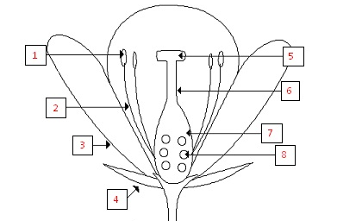

Task 3 (45 min)
Research the life cycle of a flowering plant, create a poster to show this.

Task 4 (45 min)
You can use this link to learn all about classification, it will tell you how they are classified. When you’ve watched it, create a chart to show how you would classify some animals. https://www.bbc.co.uk/bitesize/topics/zn22pv4/articles/z3nbcwx
Art
Task 1 (2 x 45 min sessions)
Observational drawing: draw and animal of your choice, you must make it as life like as possible, take your time to do this. Remember to press very lightly with you pencil so that you can make changes as you need to.
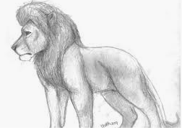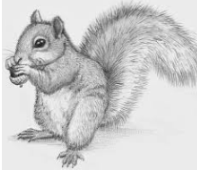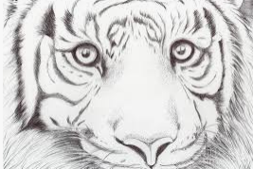

Task 2 (45 min)
Gather some lovely bits from nature, wither from your garden (ask first) or when out for your daily walk and create collage of what you have gathered. You could create a garden, animal from the items you have gathered.
Task 3 (45 min)
Use this website: Rob Biddulph draw with Bob http://www.robbiddulph.com/draw-with-rob
to draw an animal of your choice. This site is a lot of fun.
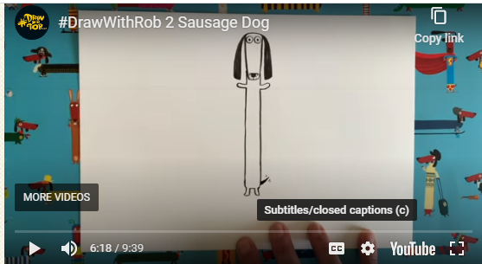

General ideas
https://www.rodocodo.com/
Make healthy snack that you can all enjoy.
Create a bug hotel or an area in your garden to attract bees, butterflies etc.

