Maths
Task 1 - Compare capacity
Find different containers from around your house and use 1 cup to fill them up. Guess how many cups you will need to fill each and put them in order of how much you think each container will container. Then have a go. Were you right? Did anything surprise you?
From White Rose:
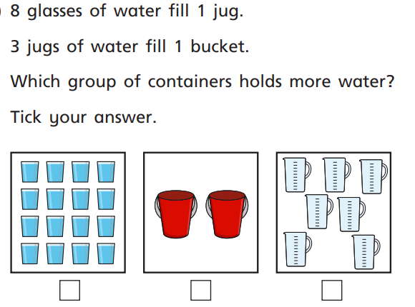
Task 2 - Count in 10s
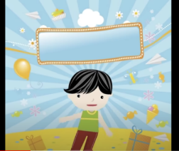
Find objects from around your house (you could use lego, coins, buttons, teddys) and place them in groups of 10. Can you count in 10s how many you have?
https://www.youtube.com/watch?v=uYRTtwZGwj8
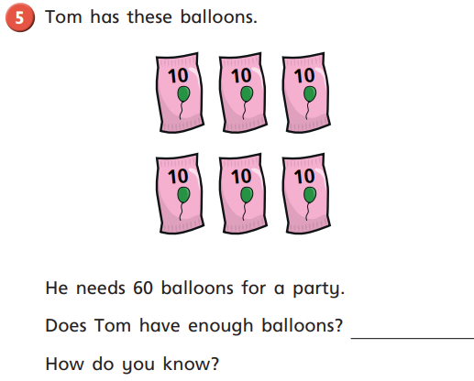
Task 3 - Make equal groups
Use some of the objects you found yesterday. Find a few teddies and see if you can share your objects equally with them and then say this sentence out loud (with your own groups) “There are 3 equal groups of 4.”
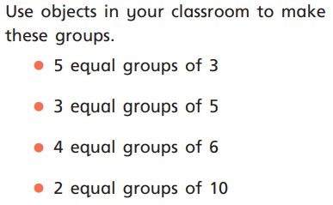
Can you make these:

Task 4 - Add equal groups
Make 3 equal groups of 2 with objects from around your home.
We can add these together to find out how many objects there are altogether.
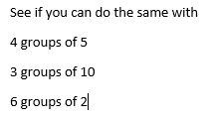
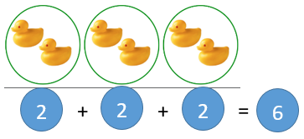
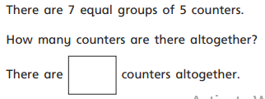
Task 5 - Make arrays
What is an array? An array in maths is an arrangement of objects, numbers or pictures in columns or rows. The purpose of an array is to help children understand multiplication and division.
https://www.bbc.co.uk/teach/class-clips-video/maths-ks1--ks2-how-to-use-arrays-to-multiply/zrks382

