20^{h} April
Dear Brownlee class,
Hello everyone! I’m really missing you all but I really hope you are having a good time whilst you are at home. Below are some ideas for you to be working on whilst you are at home this week.
The school would love you to start a daily journal to capture what you are doing at home during this time. In your journal you write:
- How you are feeling
- What you have done. This can be any of the work you have done from the blog and anything that you have done whilst at home.
- What you have enjoyed each day.
I can’t wait to see your journals which will be shared upon our return to school with your classmates!
Take care and stay safe
Hopefully I will see you all soon
Mrs Jaynes
x
This is a suggestion of how much learning to do over a day with a year 2 child. These slots add up to 2 hours of learning, split into small chunks with breaks. Of course what is important is that you do what works best with your family. The work listed below is more than enough for 5 days of 2hr learning so please choose the tasks that you would prefer to do with your child. Also don’t forget to do some exercise and read every day!
am 20 min | Maths activity
am 20 min | English activity
10:30 | Snack time
am 2 x 20 min | TT Rockstars/Rodocodo/Nessy
12:30 | Lunchtime
pm 20 min | Something unfinished from the morning or maybe some art
pm 20 min | An activity from general activities list

Can the same plants and animals grow in different places?

Maths
Task 1 (20 min to set up, then 5 min a day to measure and plot on a graph)
Grow a plant and measure it every day (A runner bean seed on tissue in a plastic bag will allow you to measure the roots growing too!). Can you plot a graph to show the plant growing? You could make a bean diary and draw the bean each day. Use whatever seed you have.
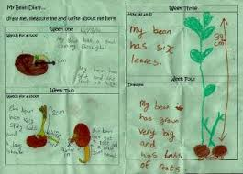
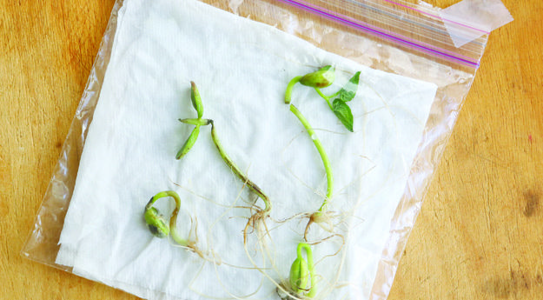

This is a video of a bean growing https://www.youtube.com/watch?v=pg92cspLy0I

Task 2 (20 min)
Throw a hoop on the grass and count the different plants in the hoop or can you count different plants in your garden? If it’s raining can you count the different flowers in this picture? Write a list of the number of plants that you found.


Task 3 (2 x 20 min)
Word problems (draw pictures to help you!)
- If there are 6 rows of carrots with 5 carrots in each row, how many carrots are there in total?
- If three flowers each have 6 petals, how many petals are there in total?
- If 22 cabbages are growing but 17 get eaten, how many cabbages are left? (draw a picture or use a numberline).
- 41 cherries are on a tree and a greedy bird eats 28, how many cherries are left?
- A child plants 37 lettuce plants one day and 27 lettuce plants the next day, how many plants are now growing altogether?
- One tree grows 36 apples and another tree grows 29 apples, but a bird eats 17 apples, how many apples are left?

Task 4 (2 x 20 min per week)
TT rockstars https://ttrockstars.com/

Task 5 (20 min a day)
The following activities are ongoing tasks and should be practised every week at times that would suit you best. You do not need to do them all every day, put to pick one or two per day.
Year 2 -
Number - count in steps of 2, 3, and 5 from 0, and in tens from any number, forwards and backwards
Know number bonds to 20
Times tables - recall and use multiplication and division facts for the 2, 5 and 10 multiplication tables
Time - tell and write the time to five minutes, including quarter past/to the hour (on an analogue clock)
Know the number of minutes in an hour and the number of hours in a day.
Money - Recognise different monetary coins, find different combinations of coins that equal the same amounts of money
Measure - measure items in cm/m, kg/g, l/ml

English
Remember to read every day
Task 1 (20 min)
Can you design a new animal? Look at the pictures below to remind yourself of just how different animals can be. Draw a picture of your new animal (if you have some play dough you could make a model). Think about how many legs and arms you want it to have. Do you want your animal to have fur or scales? What colour is the animal? Remember it’s totally up to you it can look very different to any animal that already exists!
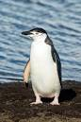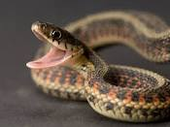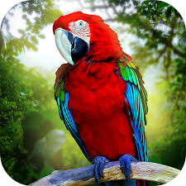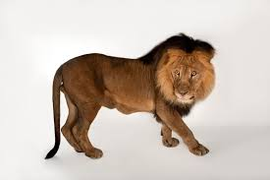

Task 2 (20 min)
When you are happy with your drawing can you label it to describe it? Don’t forget to use adjectives before a noun to really describe your animal, e.g. It has purple, fluffy fur. What is your animal called?

Task 3 (20 min)
Write 3 sentences to describe how your animal moves. Pretend to be your animal and decide if it slides on its belly, or walks elegantly with tall legs or maybe it jumps like a springy frog.
Use this word bank: quickly, slowly, lazily, powerful, quietly, stealthily, effortless, rapidly.

Task 4 (20 min)
Answer these questions (try to use because, but or if in your answers).
- Is your animal vicious or gentle?
- What does your animal eat?
- Where does your animal live?
- How is your animal suited to where it lives?
- Do you think your animal might have a predator? What would that look like?
Task 5 (if you have a password 2 x 20 min)
Nessy https://www.nessy.com/uk/

Science
In your maths tasks you have observed where different plants are growing. Where a plant grows is its habitat. Do you remember that Zeraffa Giraffa lived on the plains of Africa? The plains of Africa were Zeraffa’s habitat. Zeraffa liked to eat Acacia leaves so she needed a long tall neck to be able to reach the trees. Zeraffa has a long tongue to be able to rip those leaves from their tree. Animals are suited to the place that they live e.g. seals have blubber to keep them warm in the cold sea.
Task 1 (2 x 20 min sessions)
Pick an animal e.g. polar bear, camel, lion, hippo, snake, lizard, fish and think about where it lives- its habitat, what it eats, what temperature it is in its habitat, what plants grow in its habitat. You could research on the internet at this site to help you: https://www.bbc.co.uk/bitesize/topics/zx882hv
Do you have any books that you could look up your chosen animal in to learn about its habitat.? Could you interview somebody in your family to find out about your animal.

Task 2 (20 min)
Now draw a picture of the animal in its habitat.

Task 3 (20 min)
Look at your picture have you remembered to include the sun, a plant, your animal, the landscape and the animal’s predator. Add in anything you need to.

Task 4 (20 min)
In your English task 1 you designed an animal. Can you now think about where your made up animal might live? If he is furry perhaps he lives somewhere cold. If it is white perhaps it lives in the snow. If it is short perhaps its food is on the floor. If it has gills it would live in water. If it is really colourful does it live in a flowerbed or a tropical rainforest? Draw a picture of the habitat that your made up animal lives in.

Art
Task 1 (2 x 20 min sessions)
Could you draw an animal (any animal) and make it into a collage? You can use old magazines for the coloured paper.
Use these for ideas:
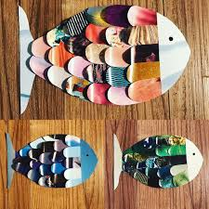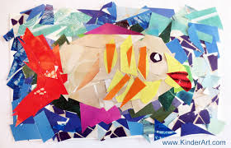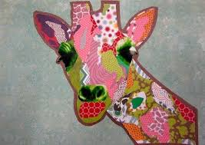

Task 2 (20 min)
If you want to you could add its habitat.

Task 3 (20 min)
Use
this website: Rob Biddulph draw with Bob http://www.robbiddulph.com/draw-with-rob
to draw an animal of your choice. This site is a lot of fun.
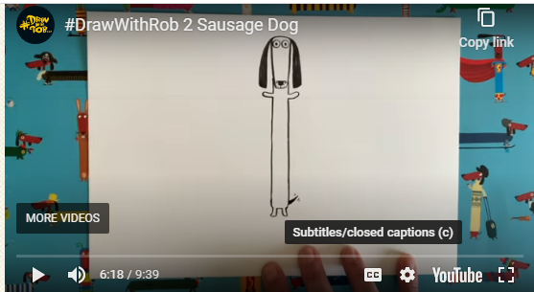

General ideas
https://www.rodocodo.com/
Make some ice lollies
Can you be a nature pirate? Find a little box and see how much tiny treasure you can put in it.
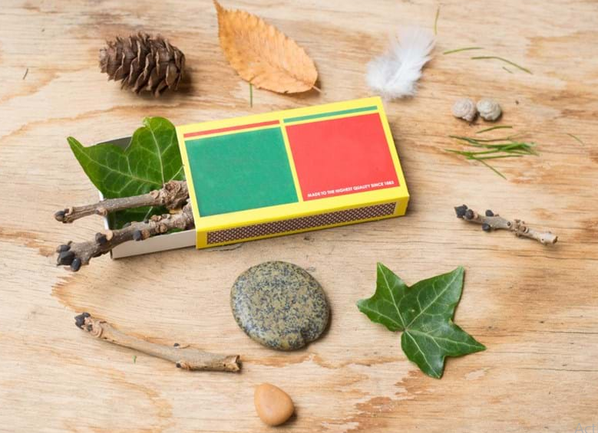

Make a wind chime
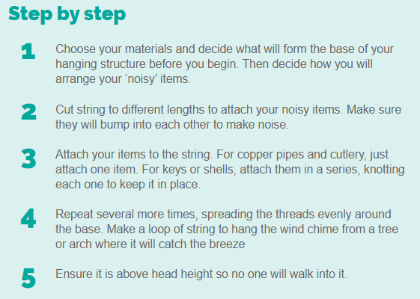
Make a teddy zip wire https://www.science-sparks.com/teddy-zip-wire/


