Week beg 19.06.23
Talk homework: Reflect on your day at Hinchingbrooke and tell your adults about the experience.
This week has been a very interesting week.
Seb enjoyed Science. He really relished our visit from our expert, where we learned about interesting animals and plants. He was then able to create a piece of art and a fact file to complement his learning. Jack echoed this and enjoyed the freedom to create an entire new species. Aiden said, “I enjoyed creating the Bio Art because we were able to draw the skeletal system and write an interesting fact file on our chosen animal.”
Hussain enjoyed our visit to Hinchingbrooke and thoroughly enjoyed eating and sharing his cheesecake. They had a great day and visited the Art, DT and Cookery department. They designed and made their own packaging before cooking a cheesecake to put in it. One pupil remarked that she wished she could skip Year 6 and go straight to Hinchingbrooke next year.
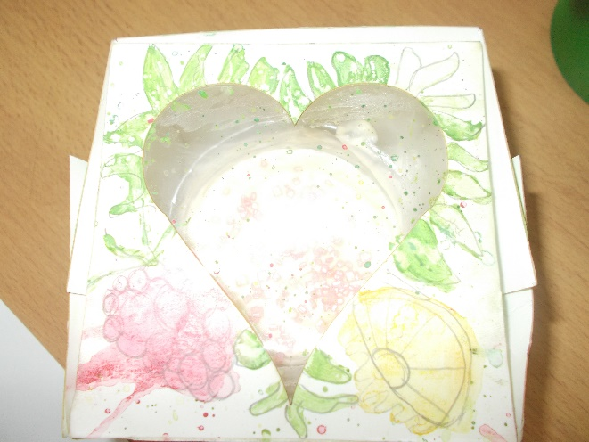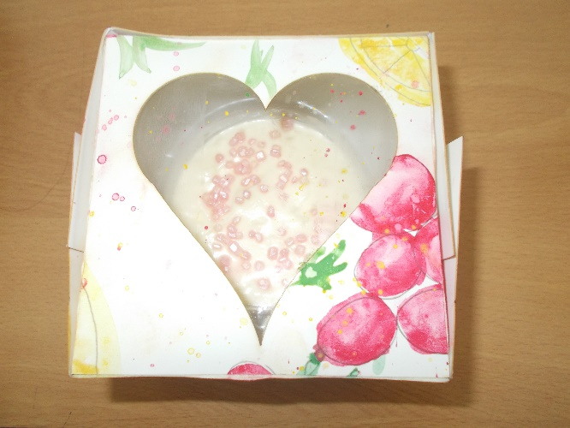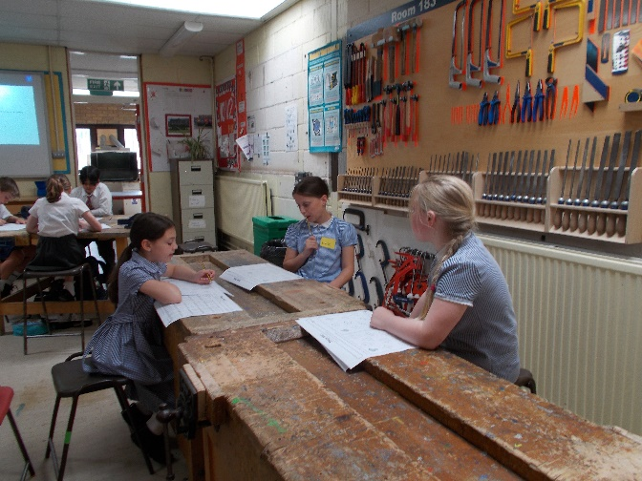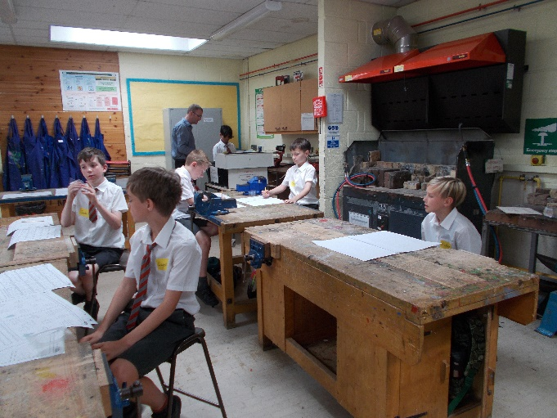
Annabelle enjoyed Geography with Mrs Butcher. They are about to embark on a project and they divided roles and responsibilities this week.
In PE, we have been honing our skills ready for sports’ day.

We hope you have a restful week.

Bluebell Class

