Week beg 20.02.23
This week we have enjoyed English as we tried to predict what our new book will be about. We also had the opportunity to respond to text and be illustrator.
We have also worked hard in Maths, learning about equivalent fractions. We found it quite straightforward – as long as we knew our times tables!
Remy enjoyed taking part in the fitness session with Sean Rose – a Paralympian who came to see us this week. He was so inspirational and taught us never to give up.
We also had the opportunity to visit Year 3 and share our learning from Spring 1. We talked about our Art and DT projects and took them up to our gallery.

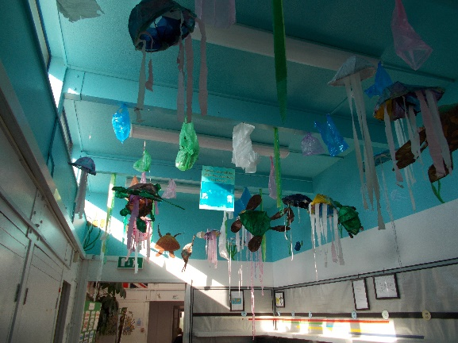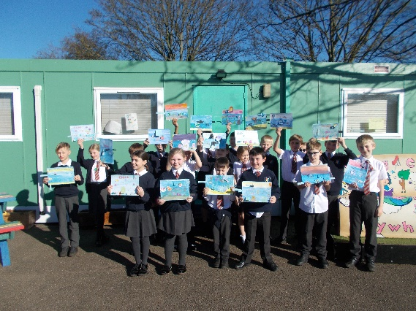

We had fun in RE this week as we did freeze frames of The Easter story with Mrs Butcher. We were able to share our thoughts and ideas as Mrs Butcher read key events from the story.
We are looking forward to a hard earned rest this weekend.

Bluebell class

