Tuesday 28.06.22
Physics day,
Today started with a very exciting visit from some parents. All 8 work within STEM in one way, shape or form. We had lots of fun in assembly quizzing each parent before they revealed their profession. The pupils were so inspired by the variety of jobs out there.
We then had a day of physics exploration, including setting up our own experiment to explore how energy and matter relate to one another. The pupils had some very creative ideas. It was great fun.
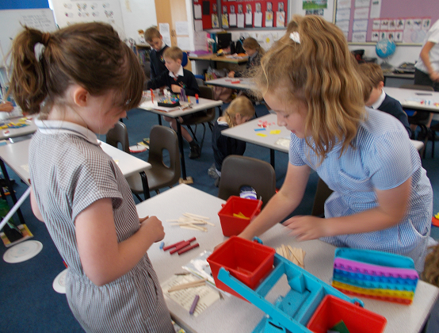
We also built a sundial so that we could see the earth’s rotation.
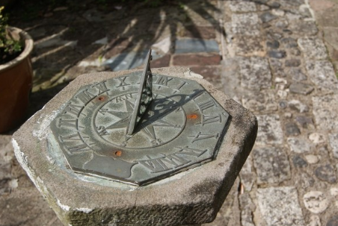
Hawthorn class

