Science week: 27.06.22
Biology,
Today has been a fantastic day. We started the day with a fabulous assembly with lower school where we took part in a range of different science experiments. When we got back into class, we discussed what STEM careers are and tried to name a few.
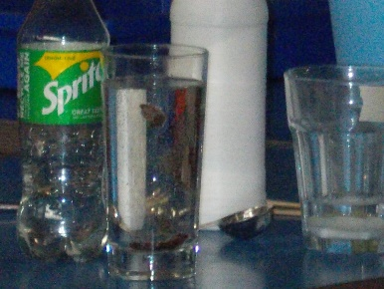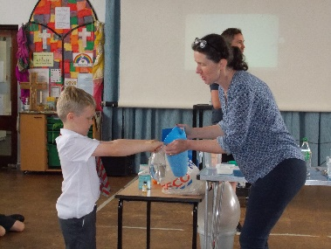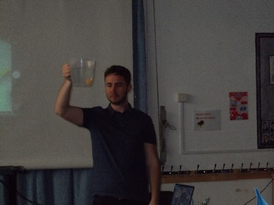

Our topic for the day was plants. We researched plants from all over the world. We looked for patterns in nature, similarities and differences. We also looked at how plants have adapted to their environments in order to survive.

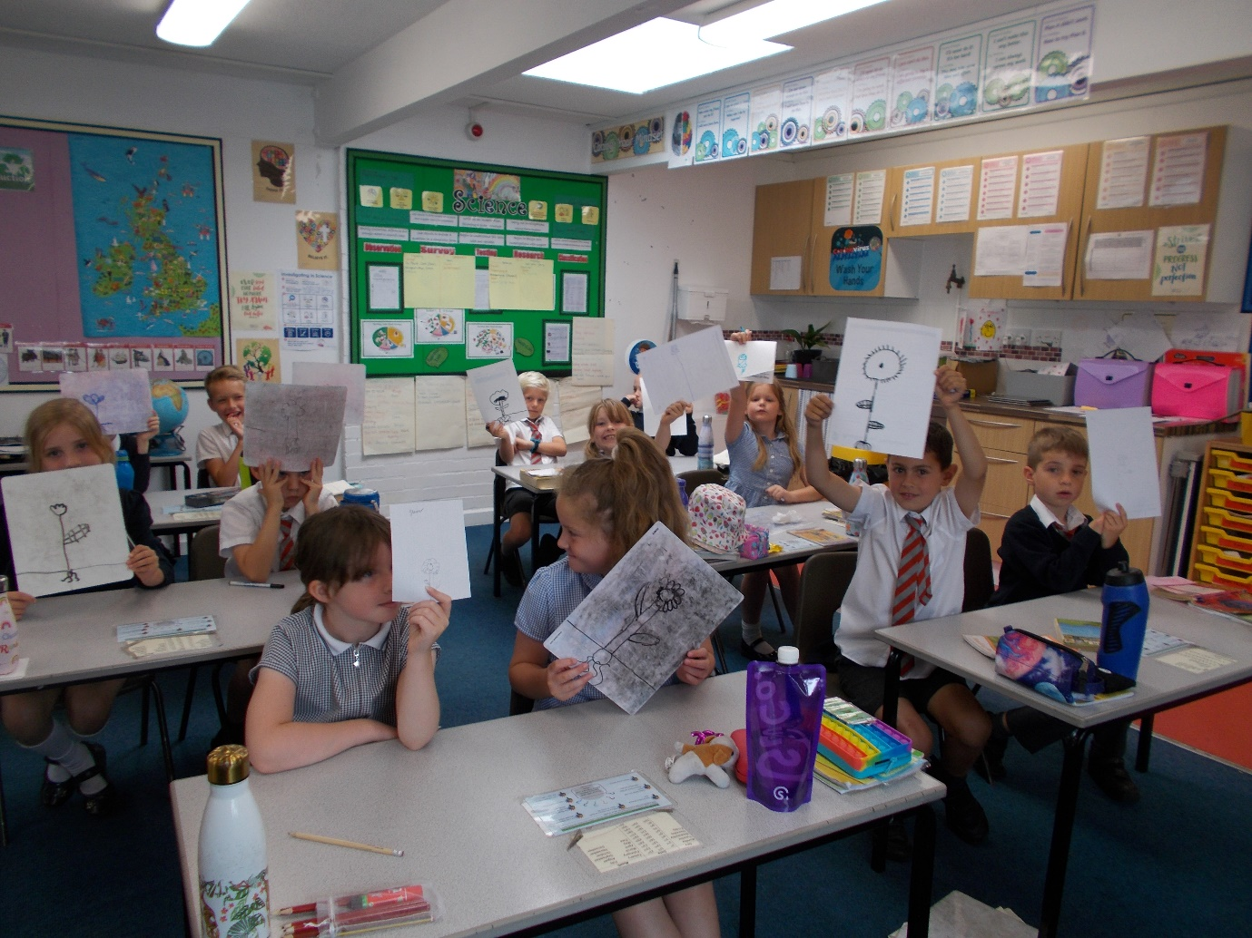
Once we had chosen our favourite plant, we were tasked with creating a plant using only 4 sheets of paper and scissors. We were given an hour to complete this challenge.
We then finished the day looking at the role of a marine scientist and the attributes required to succeed.
We are looking forward to another day of science tomorrow.
Hawthorn class

