This week’s learning 28.03.22
Monday
Maths – Comparing length – complete the attached sheet.

English – Read your favourite book and talk about the character, what do you know about them, are they the main character, are they good or bad?

Science – Create your own materials experiment.

Phonics – Play a phonics phase 4 and 5 game on phonics play.
https://www.phonicsplay.co.uk/resources/phase/5/buried-treasure
Tuesday
Maths – Comparing weight – complete the attached sheet.
English – Create a new character for your favourite book. Draw a picture of it and write sentences about them. You could describe their physical features and their personality.
Global Learning – Have a look on google maps at Buckden Village, list the things you find.

Phonics – Play a phonics phase 4 and 5 game on phonics play.
https://www.phonicsplay.co.uk/resources/phase/5/buried-treasure
Wednesday
Maths – Measuring weight – collect a variety of items around your house and use your kitchen or bathroom scales to weigh them. Don’t forget to estimate the weight of each item first.
English – Now write a new ending for your favourite book including your new character.

French - https://www.youtube.com/watch?v=pfkQ9e10sT0
Phonics – Play a phonics phase 4 and 5 game on phonics play.
https://www.phonicsplay.co.uk/resources/phase/5/buried-treasure

Thursday
Maths – Comparing weight using measuring. If possible, cook or bake something you can measure and compare the amounts of each ingredient. If not, you could look at the weight of items in the kitchen on the packs of foods and compare they heaviest to the lightest.

English – Complete the attached comprehension. Read the text and answer the questions.

RE – Watch the Easter story, what can you remember about why it is such an important event for Christians. https://www.youtube.com/watch?v=Wnbo2AmS3OI

Phonics – Play a phonics phase 4 and 5 game on phonics play.
https://www.phonicsplay.co.uk/resources/phase/5/buried-treasure

Friday
Maths – Practise your maths skills by playing some games on your Abacus account. There are lots to choose from! https://www.activelearnprimary.co.uk/login?c=0 (Log ins are in the children’s reading diaries and the school code is kmm7).

Phonics – Play a phonics phase 4 and 5 game on phonics play.
https://www.phonicsplay.co.uk/resources/phase/5/buried-treasure

English – (SPAG) Practice your handwriting using the year 1 common exception words and/or high frequency words.
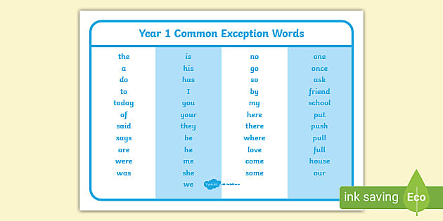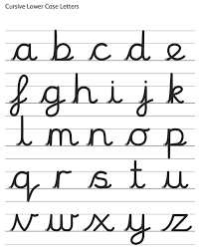
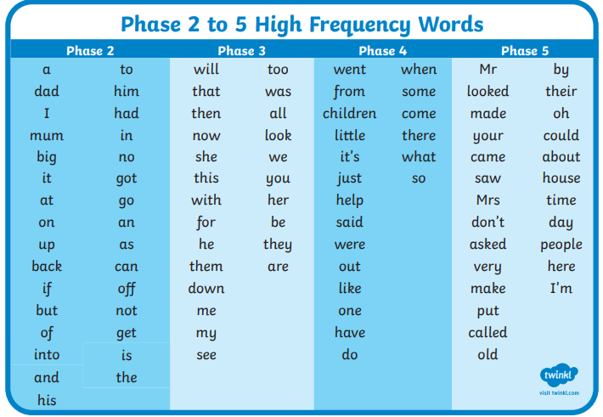
Daily
Abacus - https://www.activelearnprimary.co.uk/login?c=0 (Log ins are in the children’s reading diaries and the school code is kmm7).
Keep reading!
Read a magazine/newspaper article.
Arithmetic (20 minutes a day) – Count to 100 aloud whist doing body percussion, challenge yourself and now count in tens.
Phonics – Play a phonics phase 4 and 5 game on phonics play.
https://www.phonicsplay.co.uk/resources/phase/5/buried-treasure

Practice your typing skills
https://www.bbc.co.uk/bitesize/topics/zf2f9j6/articles/z3c6tfr

PE
Visit Youtube and do a session 5 times a week of Joe Wicks/Go Noodle/Cosmic Kids Yoga.

